Entrepreneurship Bootcamp (part one)
Section 4

Instructor
Dr. Wedad Alsaad

Group
Huda AL-Falah (22220033)
Ahmad AL-Maghaireh (23110205)
Laith Jawabreh (23110140)
Mousa Ereiqat (23110138)
Obada AL-Halaybeh (23110107)
Date: (15/01/2025)
Table of Contents
PART ONE 4
1. How you and your team are developing an entrepreneurial mindset (e.g., growth mindset or agile thinking) while exploring market problems and opportunities? 4
• Explain why this mindset is important for understanding users, identifying opportunities, and shaping ideas into viable, human-centered solutions. 4
• Identify the key entrepreneurial skills you are practicing (e.g., creativity, empathy, communication, problem-solving). 4
• Explain how these skills complement one another as you progress toward defining your project idea. 4
2. Analyze the Political, Economic, Social, and Technological (PEST) environment in Jordan. 4
• How each factor shapes people’s needs, behaviors, and challenges. Use real examples and evidence from your research to explain how these external factors might reveal opportunities for innovation or problem-solving. 4
3. Compare different types of entrepreneurships (e.g., commercial vs. social, traditional vs. technological) and explain which approach—or combination of approaches—best aligns with the kind of impact or value your team aims to create. 5
• Justify your reasoning using your team’s goals, target users, and available resources. 5
4. Prepare a SWOT analysis that integrates your learning so far: 5
Strengths: internal advantages such as creativity, collaboration, or research ability. 5
Weaknesses: internal challenges such as limited experience, resources, or time. 5
Opportunities: external trends or unmet needs that could inspire a viable project. 5
Threats: external barriers such as competition, regulations, or shifting user priorities. 5
5. Conduct research to identify a real and meaningful challenge faced by your target users that will form the foundation of your business idea. 5
• Describe your data collection methods (e.g., interviews, surveys, or observations) and how you analyzed user needs, pain points, and experiences. 5
• Present both your initial and refined challenge statements and explain how feedback from research guided your refinement process and your understanding of the problem. 5
6. Provide a clear description of your target market segment, outlining key demographic and behavioral characteristics. 6
• Explain why this segment is relevant and directly connected to your identified challenge. 6
• Develop a detailed user persona that represents your target audience. Include information such as demographics, specific needs, motivations, behaviors, and main pain points that your proposed business will aim to address. 6
7. Present your proposed business solution and explain how it directly addresses the core needs and problems identified during your research. 6
• Discuss why this solution is realistic and valuable for your target market. 6
8. Develop a clear value proposition that explains the unique benefits your product or service offers to your target audience. 6
• why they should choose it over existing alternatives? 6
9. Present the initial version of your prototype, highlighting its main features and benefits. 6
• Explain how your prototype responds to user needs and ensures ease of use for your intended audience. 6
10. Design a testing plan for your business solution and prototype. Outline the testing steps, target users, feedback tools (e.g., surveys, interviews), and success metrics you will use to evaluate performance and gather insights for further improvement. 7
References: 8

PART ONE

How you and your team are developing an entrepreneurial mindset (e.g., growth mindset or agile thinking) while exploring market problems and opportunities?

Explain why this mindset is important for understanding users, identifying opportunities, and shaping ideas into viable, human-centered solutions.
- Developing an Entrepreneurial Mindset as a Team
At the start of the Entrepreneurship Bootcamp, our group chose to see the project not just as theory, yet as a practical startup experience. Rather than sticking to abstract concepts, we focused on building skills through action. By blending adaptable habits with continuous learning - key points from class - we approached challenges differently. This helped us test ideas, learn from setbacks, explore customer needs in Jordan, while turning the background-verification idea into something realistic and user-focused.
- Growth Mindset: Turning Failure into Learning
In class, a growth mindset meant skills grow from practice, coaching, or study - not set traits. We saw it ourselves.
We began without a fixed plan, instead letting customer demand shape our direction. The group came up with multiple concepts, using feedback to refine them a digital marketplace for household support solutions, a system for gathering water by means of conical tanks, a digital system linking shoppers with people moving goods, a micro investment tool for property markets.
One didn't work due to legality issues; another had poor financial logic. Some were simply hard to carry out in real conditions - others raised moral questions. Rather than viewing them as losses, we used every attempt to gain insight
We explored regulatory limits in Jordan - these apply to logistics or small-scale investing.
We found the concept didn't hold up well when water costs shifted or rain amounts changed - so it lost strength under those conditions because real-world factors disrupted its base assumptions.
We realized that just because an idea seems intriguing doesn't mean it's actually a pressing issue for people who use the product.
This matches the slides precisely - entrepreneurs need to keep going despite rejection, draw lessons from setbacks, pay close attention to feedback, make constant improvements, while adjusting to unpredictable markets. Each time an idea failed, we intentionally questioned ourselves:
This thinking ultimately opened a bigger chance - a background check and open-source intelligence tool addressing actual HR issues like favoritism, fake credentials, along with compliance needs under the recent data privacy regulations.
- Agile Thinking: Iterative, Flexible and Market-Driven
The course covered agile methods, using brief work phases called sprints - each followed by review and tweaks. As a result, our group began applying this way without much effort.
Rather than spend weeks refining a single concept, we used short, flexible rounds - each building on the last through quick feedback loops instead of lengthy delays
Think of a concept fast.
Try it using simple PEST analysis, check legal aspects, also run a research.
Think together about the dangers, what users want, or possible solutions.
Choose if you’ll continue, change direction, or let go of the concept.
This resembles the Build–Measure–Learn cycle from the Lean Startup approach mentioned in lecture. Instead of sticking to one concept, we developed rough ideas during talks; then tested those against actual market conditions and regulations. As a result, we identified paths worth dropping. That kept us focused on solving the real/needed issue - rather than getting attached to a single solution without studying the problem that caused it.
Our flexible mindset helped us stay focused on users. After settling on the background check concept, we began considering it through a different lens:
- What does an HR manager actually need in Jordan today?
- What problems are they facing, fake CVs, and digital behavior?
- How could we deliver a simple, early prototype that they can react to?
This reflects the agile and MVP cases discussed in class - like Airbnb or Zappos - which began with basic versions, tried them out, yet refined things using actual user input.

- Why This Mindset Matters for Understanding Users and Finding Opportunities
This way of thinking wasn't merely positive - it shaped how we saw user needs, spotted chances, or crafted answers.
- For understanding users:
Growth mindset made curiosity natural - so rather than guess what HR faced, we simply said, "Our knowledge is limited." That honesty led to interviews with workers, deeper reading on recruitment issues in Jordan, while also reflecting on local dynamics such as community-based trust.
- For identifying opportunities:
Agile thinking made it easier to see which ideas worked in today’s world - some didn’t fit at all. The background-check concept, however, lined up well with ongoing shifts like digital tools, new privacy laws (PDPL), job market struggles, and people depending more on their online presence. Looking at the 3M framework from class, our mindset sharpened how we understood customer needs. It also pushed us to face financial limits head-on, leading to a simpler, service-focused approach instead of heavy investment.
- To design people-focused answers:
By focusing on users, the idea shifted - from a standard background check to a practical tool addressing actual HR challenges: lack of trust, influence from connections, anxiety about bad hires, also cultural fit concerns. The aim isn't just confirming papers - but offering a balanced, honest view of who's behind them.

- Entrepreneurial Skills Developed Along the Way
While practicing this approach, the entrepreneurial abilities shown in the course became more developed - using real examples helped improve them steadily. Each activity built confidence slowly, yet clearly boosted practical understanding over time.
Vision plus curiosity means looking into new thoughts while questioning possibilities. It involves imagining alternatives instead of sticking to what’s known. Wondering "what could happen?" drives this mindset forward
- Innovation: designing a new type of OSINT-based service for HR in Jordan.
- Determination with resilience: moving forward even when ideas didn't work.
- Flexibility plus quick responses: shifting direction if a concept broke rules or lacked strength.
- Collaboration and clear communication - assigning tasks, discussing ideas calmly, also reaching choices as a group.
- Ongoing learning means studying regulations - also diving into data protection rules, workplace policies - with attention to open-source intelligence techniques.
- Such abilities grew stronger - especially when tied to our responsibilities
- Ahmad managed coordination while checking legal and technical details. He handled oversight, ensuring compliance through review procedures.
- Laith linked studies with PEST analysis - then tied both to SWOT when shaping choices.
- Mousa prioritized building connections through direct interaction with users.
- Obada examined whether the tech would work, while also identifying limitations.
- Huda turned concepts into clear visuals or relatable character profiles.

Individual Reflections on Developing a Growth Mindset
Huda – Learning to Adapt Fast & Turn Ideas Into Visuals
Before this bootcamp, I used to think that once an idea looked good in my head, it should work. But after going through multiple failed concepts, I realized how important it is to stay flexible and not get attached to the first idea. Every time we hit a dead end, I learned to step back, rethink the user’s perspective, and translate the team’s ideas into something visual. This helped me grow a lot. I now see mistakes as part of the design process, not a reason to start over. The group’s feedback didn’t discourage me; instead, it taught me how to improve my prototypes and represent user needs more clearly. For me, the growth mindset came from learning that ideas are not art pieces — they are living things that must evolve.

Ahmad – Developing Resilience, Leadership & Letting Go of “Perfect Plans”
At the beginning, I used to treat our ideas like something we had to protect. I would try to refine a concept deeply before moving on. But after a few rounds of feedback, I learned that entrepreneurs cannot fall in love with their ideas — they must fall in love with the problem. That shift helped me grow as a leader. I became more open to criticism and more focused on helping the team adapt quickly rather than pushing for one ‘perfect’ solution. Each time we had to pivot, I learned to guide the group calmly, ask the right questions, and break the problem down so we could rebuild something stronger. This mindset helped me personally become more confident and less afraid of failure.

Laith – Growing Through Research, Logic & Challenging Assumptions
For me, a growth mindset appeared through research. I realized early that my job was to challenge our assumptions, even when the idea sounded exciting. When our first concepts collapsed due to legality or weak financial logic, it was frustrating, but it pushed me to dig deeper into the Jordanian market and understand what is actually possible. Every time I discovered something new — regulations, PEST factors, behavior trends — I saw how important it is to learn continuously. I became more comfortable with uncertainty, and I learned that research is not about being right; it’s about staying curious and letting new information shape the direction. That’s how I developed adaptability and confidence in my role

Obada – Turning Technical Challenges Into Opportunities to Learn
What developed my growth mindset was dealing with the technical side of each idea. Many of the concepts the team came up with sounded great until I started analyzing their feasibility. At first, I felt like the ‘negative person’ who kept pointing out limitations. But over time, I learned how to turn technical problems into learning opportunities. Instead of saying something won’t work, I began suggesting simpler alternatives or explaining which parts could work with modifications. This helped me grow not only in problem-solving but also in communication. I learned that being flexible with solutions — instead of sticking to one technical path — is what makes an idea survive.

Mousa – Building Empathy & Comfort With Talking to Real Users
When i started reaching out to the HR managers, the applicants, and even a therapist, I realized how much courage it takes to communicate with the people you don’t know. At the beginning I felt nervous about asking the questions or bothering people, but with each conversation my confidence grew. I learned to listen more deeply, avoid the assumptions and actually try to understand what the people were struggling with. This whole process also changed the way that I think about the problems instead of jumping straight to the solutions, I started focusing more on the root problem and what users truly need.
Talking to the real users made me better at the pitching too.I paid attention to the instructor’s reactions during the presentations and noticed which parts of the idea she found interesting and which parts she didn’t.I found myself observing a lot her expressions, the questions she asked, and even the silence. This helped me try to understand more what makes an idea strong and what still needs work.
I was also communicating with the other teams in the bootcamp, sharing the ideas and giving each other the feedback. It felt like a small community where everyone was trying to help each other improve. And every time an idea failed, I reached out again to our target audience to check what was wrong and what direction made more sense. Even with our final idea, I kept contacting the people to make sure it wasn’t just something we liked, but something that the people actually needed. All of this helped me grow a lot in terms of the empathy, confidence, and understanding how to talk to the real users.”

The conclusion, building an entrepreneur-style attitude - based on adaptability and continuous learning - shifted our focus from casually chasing trendy concepts to methodically spotting actual market gaps in Jordan. This allowed us to:
- Understand users more deeply.
- Spot a fitting chance right now.
- View failure as a signal - so you can adjust - not as an end. Use it to shift direction instead of stopping altogether.
- Adapt quickly to changing information.
- A solution should work well - focused on people, shaped by actual market demands.
This approach will shape our work during the upcoming stages, when we start building prototypes, running tests, while improving the background-check along with OSINT features. Though focused on practical steps, each phase will follow this initial direction without shifting priorities or adding unrelated goals.

Identify the key entrepreneurial skills you are practicing (e.g., creativity, empathy, communication, problem-solving).
Identifying the Key Entrepreneurial Skills We Are Practicing
During this bootcamp, each one of us practiced entrepreneurial skills in a slightly different way. Even though we worked as a team, every member had their own role, their own strengths and their own way of dealing with the challenges. This made the experience feel individual not just group based. As we moved from one idea to the other or next, we could see how each person naturally developed certain skills through the tasks they handled and the mistakes that they learned from.
- Ahmad – Creativity & Leadership
Ahmad’s biggest skills were the creativity and the leadership. He often encouraged us to rethink our ideas when something wasn’t actually working and pushed us to look at the problem from a new angle and to look at the root problem. Whenever the instructor gave us the tough feedback, he helped redirect the team instead of letting us get stuck. His leadership did show through the guiding discussions, keeping us focused and reminding us to base the decisions on user needs instead of personal opinions.
- Laith – Research & Critical Thinking
Laith practiced research and analytical thinking the most. He spent time using tools like PEST, SWOT, and challenge statements to help us understand the environment around our idea. He broke big problems into smaller parts and made sure we considered legal and social factors like PDPL. His critical thinking helped us rely more on facts and less on assumptions, which made our decisions stronger.
- Mousa – Communication, Empathy & Teamwork
Mousa did focus heavily on the communication and the empathy. He took charge of reaching out to the people, doing interviews and gathering the honest feedback from the HR managers and the job applicants and even a therapist. He improved at asking the better questions and really listening to what the other people said. He also supported the teamwork by sharing the updates clearly and helping the group stay organized. On top of that, he contributed to some of the research by noting patterns in user responses and helping us understand their pain points.
- Obada – Problem-Solving & Technical Thinking
Obada practiced problem-solving and technical thinking. He evaluated whether our ideas were actually doable from a technical point of view and helped us avoid unrealistic directions. He pointed the out hidden challenges early and suggested the simple solutions when we felt stuck. This helped him connect the technical logic with the practical decision-making and made our idea more grounded in reality.
- Huda – Design Thinking, Prototype Design & Team Support
Huda practiced the design thinking and the visual communication. She organized our rough ideas into clear personas, UI sketches and the report layouts. She played a key role in the prototype design, helping us imagine what the final service might look like and how the users would actually interact with it. Her visual work made the complicated ideas easier to understand, which did support the whole team during the discussions and the presentations.
Conclusion
In the end, this bootcamp showed us that entrepreneurial skills grow differently for each person, but become truly valuable when combined as a team. Ahmads creativity guided our direction, Laiths research gave us a strong foundation, Mousas communication connected us to real users, Obadas technical thinking kept our ideas realistic, and Hudas design turned our thoughts into something visual and usable.
Together, these skills shaped the direction of our project and helped us respond to the challenges more confidently. We learned that building a business idea is not just about having one good skill it’s about how everyones strengths do support and compliment each other. This experience made our idea stronger, clearer and more connected to the real user needs.

Explain how these skills complement one another as you progress toward defining your project idea.
How These Skills Complement Each Other While Defining Our Project Idea
The way These Skills Complement Each Other. As we continued the project idea definition process we began to notice that each of the skills that we were drilling was not independent of each other. One skill assisted another, and that is the reason why we did not stand still but rather advanced. The less the project was similar the more we understood how those skills were intertwined and mutually relied during various times of the bootcamp.
- Creativity + Problem-Solving
The collaboration of creativity and problem solving was more than we had anticipated. Creativity was also used to make us think of new ideas or look at the problem in a new perspective, particularly when nothing was going on. However, without solving problems, such ideas would remain in their forms as ideas and have no definite path. Problem-solving assisted us in knowing how to figure out what was wrong, what had to change, as well as how we could repair it. Whenever the instructor criticized our concept, creativity made us reconsider the solution and problem-solving made me deconstruct the solution and make it practical. The two skills were in fact mutually supporting and sustaining one another rather than a give up.
- Empathy + Communication
There was also the complementing of empathy and communication. Empathy allowed us to realize what the job applicants and the therapist are really experiencing and what frustrates them when we spoke to the HR managers. It was possible to make that understanding useful and become more engaged in better conversations because of communication. Had we not empathized, we would not have known the actual pain points and had we not communicated, we could not have acquired the appropriate information. They all assisted us in creating a project that was more humanistic and not merely founded on our own assumptions.
- Adaptability + Leadership
Adaptability and leadership were also demonstrated where we needed to shift gears at least two or more times. Flexibility allowed us to accommodate that certain ideas did not work and the leadership made the group remain structured throughout the changes. Adaptation would have been a sloppy process without leadership, and without the ability to change, the leadership would not have worked since we would have remained stuck at the same idea. The two skills co-operated to ensure that the team was not stressed but rather motivated.
- Teamwork + Communication
Communication was relied on to get teamwork. Due to the continuous development of the project, we had to communicate rapidly, redefine tasks and know what everybody was doing. Communication facilitated team work, and team work made communication relevant. This relationship allowed us to resolve issues faster and remain on track even in case of confusion.

Conclusion In general, these competencies were complementary at all the stages of outlining our project idea. Creativity provided new paths, problem-solving helped us stay down to earth, empathy and communication provided us with the actual user insight, flexibility and leadership kept the team on track and teamwork connected it all. A combination of these skills allowed us to create a more solid, better defined and more realistic project idea than any of us could have constructed separately.

The summarizer for part 1:
In this part of the bootcamp, our team mainly learned how to think like the entrepreneurs instead of just students following simple steps. We experimented with different ideas, learned from our failures and slowly understood the real problems happening in the market, especially in the HR in Jordan. By using a growth mindset, we didn’t treat our failed ideas as wasted time. Instead, each one taught us something new about legality, financial issues, user behavior, or what the people actually need. This helped us shift from the random ideas to a problem that made sense: the lack of trustworthy background checks and OSINT-based insights for HR.
Agile thinking also played a huge role. Instead of sticking to one idea for weeks, we followed the short cycles build something small, check if it makes sense, then either change it or drop it. This made us more flexible and user-focused, because every decision was based on the feedback, not guesswork. By talking to the HR managers, the applicants, and even a therapist, we started seeing the root problems more clearly: fake CVs, wasta pressure, the risky behavior online, and the challenges HR faces when hiring.
At the same time, each team member has developed different entrepreneurial skills. Creativity, research, communication, empathy, leadership, problem-solving, technical thinking and the design thinking all grew in different ways. What made this powerful is how these skills worked together — creativity needed problem-solving, the teamwork needed communication and adaptability needed leadership. Because of this mix, our project idea became more realistic and more human-centered.
Overall, Part One showed us that an entrepreneurial mindset is not just thinking of the new ideas — it’s listening, changing the direction when needed, testing quickly, and learning nonstop. This mindset is what helped us shape a meaningful solution for the HR market and prepare for the next stage, where we start building and testing our prototype.

Analyze the Political, Economic, Social, and Technological (PEST) environment in Jordan.

How each factor shapes people’s needs, behaviors, and challenges. Use real examples and evidence from your research to explain how these external factors might reveal opportunities for innovation or problem-solving.

PEST Analysis of the Jordan environment.
This section is an analysis of the Political, Economic, Social, and Technological (PEST) environment in Jordan and how each environment influences the needs, behaviours, and challenges of the people. Knowing these external forces assists in exposing the innovation opportunities and the possible threats that should be taken into consideration by the startups when developing solutions in the Jordanian market.

- Political Factors
Important Political Environment in Jordan.
Personal Data Protection Law (PDPL, 2023) was introduced.
Jordan PDPL sets explicit guidelines on the process of personal data and it requires:
  - Informed consent
  - Legal reason of data gathering.
  - Secure storage
  - Transparency and accountability
A key goal of the programme is to increase employment opportunities, which in turn will reduce joblessness and unemployment.One of the objectives of the programme is to generate more jobs, which will ultimately lead to the minimization of joblessness and unemployment.
Impact on behaviours & needs:
- In the present case organizations can no longer afford to conduct informal, unregulated background checking, but instead should be conducted in a legal, structured, documented manner.
- The employees and job seekers are becoming more demanding on the visibility of their data processing.

Digital Transformation Strategy of the country.
Jordan is fast becoming digitized in terms of services, which include:
  - Passport Department /Civil status.
  - business registration
  - court services
  - regulatory licensing systems.
Impact:
Employers and citizens are demanding faster and digital traceable processes as opposed to manual or paper-based processes.

Goods and Services Compliance in Industries.
The industries that should adhere to stringent rules to safeguard: banking sector, telecommunications sector and healthcare sector.
  - sensitive information
  - workplace integrity
  - financial assets
  - organizational reputation
Impact:
Companies require verifiable screening and due diligence, particularly to positions of high trust.

Opportunities (Political)
- High national drive of controlled and legal data behaviors produces pressure on certified reporting instruments.
- Online government websites make more official government information available, which allows safer verification procedures.
- PDPL promotes the development of consent-based, privacy-sensitive solutions.
- The industries are strict compliance (banks, telecommunication, aviation, etc.), and are in demand of structured hiring-risk tools.

Threats (Political)
- The existence of strict PDPL will render any unregulated or vague data practice dangerous to start-ups.
- Access to information available to the public may be restricted by altering government systems.
- Adoption of new verification services can be slowed by delays in regulatory clarification.
- Digital businesses have high standards of compliance that make their operations costly.

- Economic Factors
Unemployment and Competitive Labor Market is high.
Jordan experiences one of the worst cases of youth unemployment in the region. Research shows that unemployment among young people is at 41-42 percent in the recent past.
Impact on behaviour:
  - Job seekers can overestimate experience or qualification.
  - HR teams are given huge volumes of CVs and they lack adequate tools to authenticate those.
  - It puts greater risk to the company when recruiting a non-qualified individual.

SME-Dominated Economy
Most Jordanian companies are SMEs that usually have:
  - small HR teams
  - limited time
  - restrained operational budgets.
Impact:
SMEs require low-cost, easy-to-use tools so as to minimize recruitment errors without having to invest in a high-end system.

Misplaced hiring costs a lot of money.
The company can lose in case of a wrong hiring decision:
  - 2-3 times the wages of the employee per year.
  - productivity loss
  - re-hiring and training costs.
  - internal disruption
This is a major risk with the economy in Jordan with tight margins.

Remote Work and Freelancing Development.
Greater numbers of firms employ remotely, even outside their employing countries.
Impact:
  - Difficult to identify and reputation.
  - High possibility of counterfeit online personalities.
  - More reliance on internet information.

Opportunities (Economic)
- An aggressive employment market is a demand of the credential verification and the fraud detection.
- SMEs require cheap, quick, dependable screening methods.
- Digital trust and identity services have developed a market due to remote hiring.
- Verification is an investment that can save a company a lot of money by reducing hiring errors, which would constitute a cost.

Threats (Economic)
- Small SME budgets can delay the use of new digital services.
- Economic instability can make companies reduce expenditures including HR tools.
- The fact that more people are unemployed makes the process of verification more difficult and time-consuming unless automated.

- Social Factors
Young, Super-digitalized Population.
Jordan is among the youngest states in the world: 63% of the population is below 30.
The youth are extensively active online in:
  - Facebook
  - TikTok
  - Instagram
  - LinkedIn
  - X
Impact:
A lot of individuality, communication style and behaviour is shown through the digital footprint of an individual.

The Competition of Jobs Influences Behaviour.
The stress to find a job triggers some job seekers to:
  - over-polish CVs
  - use AI-generated resumes
  - inflate experience
  - suppress poor previous behaviour on internet.
Impact:
HR departments have a hard time distinguishing between the legitimate candidates and those that fake themselves.

Increase in Value of Ethics and Culture-Fit.
The companies are placing more importance on:
  - professionalism
  - communication manner
  - ethical conduct
  - cultural compatibility
Impact:
The HR departments are not only examining the technical abilities but attempt to evaluate the behaviour, personality, and values.

Increasing Sensitivity to Privacy Rights.
Increased public sensitivity to: has been brought about by PDPL and global trends of digital-awareness.
  - data misuse
  - surveillance fears
  - non-consentual background checking.
Impact:
Applicants require the transparency and equity in the hiring procedures.

Opportunities (Social)
- Large social media presence = abundant digital footprints of legal OSINT.
- Existence of good demand to have fair, unbiased processes to facilitate hiring of professionals.
- Businesses are putting more emphasis on professionalism and behaviour gauging tools rather than CV data.
- Employees of the younger generation are at ease with online assessment systems.
- Privacy laws accepted by the general population will result in a niche in the market of the qualified, compliant verification services.

Threats (Social)
- The misunderstanding of OSINT can lead to fear among the candidates (spying issues).
- Online communication is culturally alert and may be misconstrued in case of not handled with care.
- Certain subgroups (population of older adults, rural population) are not very digital.
- Backlash by the populace can also occur in case a service can be perceived as intrusive or judgmental.
- There will be those who gain some advantages in informal practices and therefore will be resistant to objective verification tools.

- Technological Factors
Large Internet and Smartphone Penetration.
Internet penetration in Jordan is high (59-88% according to the source) as well as smartphone penetration.
Impact:
The presence of most working-age adults on the web makes OSINT and digital verification much easier.

HR Digitalization Trends
Organizations are becoming more and more used to:
  - e-recruitment platforms
  - HR management systems (HRMS)
  - online onboarding processes.
Impact:
Companies are more inclined to use digital tools that do not need additional HR systems.

Rich Public Digital Sources
Jordanians professionals usually possess:
  - LinkedIn profiles
  - portfolios
  - GitHub accounts
  - posted remarks or posts which are publicly visible.
  - referrals in news or community groups.
Impact:
Lawful cross-checking of professional history and behaviour has much public information available to it.

Fraud and Verification are made possible through technology.
AI simplifies the production of:
  - fake CVs
  - fake references
  - deepfake photos
  - constructed online personae.
Meanwhile, technology allows:
  - anomaly detection
  - behaviour analysis
  - inter-platform identity checking.

Opportunities (Technological)
- Active usage of the digital space promotes OSINT-based insight services.
- The HR digital transformation generates a demand of platform integrations.
- The multi-layer checking is possible due to the availability of several sources of public data.
- The development of AI applications generates the need of AI-resistant verification systems.

Threats (Technological)
- Social platforms may reduce access to public information, limiting OSINT.
- Cybersecurity threats are high for services handling sensitive data.
- AI-generated identities may become more difficult to detect.
- Strict PDPL compliance requires advanced security, increasing operational costs.
- Uneven digital footprints limit accuracy for certain demographics.

- Conclusion: What the PEST Analysis Reveals
Across Political, Economic, Social, and Technological dimensions, the Jordanian environment shows persistent challenges related to:
- verifying identity
- assessing behaviour and professionalism
- reducing hiring risks
- respecting legal boundaries
- navigating intense job competition
- managing digital reputations
- adapting to AI-generated content
These conditions create clear opportunities for innovation in trust, verification, digital behaviour analysis, and compliant OSINT-based services.
This is the environment that makes solutions like Chosen Elites relevant—because organizations in Jordan need structured, legal, transparent, and modern ways to understand the people they hire in an increasingly digital and competitive market.

According to the Ministry of Digital Economy and Entrepreneurship (2023), over 400 government services have been digitized.

Impact:
This expansion supports efficient verification and improves data reliability in professional settings. Regulatory Pressure for Integrity and Compliance Across sectors such as finance, education, healthcare, and telecommunications, organizations must:

Verify employee identities , Maintain workplace integrity ,Protect confidential data , Comply with industry guidelines Regulations increasingly require documentation and traceability, making structured verification important. Emphasis on Transparency and Anti-Corruption Jordan has strengthened national efforts toward fair governance, transparency, and anti-corruption practices (Integrity and Anti-Corruption Commission Report, 2022).

Impact:
Organizations seek reliable, evidence-based methods to support ethical and transparent recruitment processes.

The summarizer for part 2:
PEST analysis reveals that the environment in Jordan is very influential in terms of how the organizations recruit, the behavior of job seekers, and the market tools that the market is willing to embrace. Politically, the launch of the PDPL (2023) and the national impetus of the country to digital-transformation implies that companies will not be able to afford to use informal or non-documented background checks anymore. They now require criminal, open, and consent-based authentication. Such industries as banking, telecom, aviation, and healthcare are under pressure even more, thus providing obvious need in organized and reliable screening tools.
High unemployment among young people (41-42), as well as the congested job market, force a large proportion of job seekers to overstate their qualification, and the majority of SMEs do not have time and resources to authenticate data. One poor recruitment results in significant financial loss, and this aspect makes cheap and speedy verification more and more useful.

Socially, the youthful and highly online population of Jordan has massive online footprint on the social sites such as Facebook, Tik Tok, LinkedIn, and Instagram. Businesses are considering behaviour, ethics and culture-fit besides technical skills. Meanwhile, the increased awareness of the right to privacy necessitates open, respectful, and consent-based procedures.
The high level of internet use and the prevalence of HR digitalization make OSINT-based tools feasible technologically. However, AI generated resumes and fake identities are on the rise, and this requires more serious and verifiable checks.

Reflection:
In all four dimensions, there is evident discontinuity in terms of trustful, compliant, and modern verification solutions in Jordan. These external forces are the direct reasons as to why a service such as Chosen Elites is of relevance to help organizations mitigate the risk of hiring, comply with privacy regulations, and make evidence-based and informed decisions in a very digital labor market.

Compare different types of entrepreneurships (e.g., commercial vs. social, traditional vs. technological) and explain which approach—or combination of approaches—best aligns with the kind of impact or value your team aims to create.

Justify your reasoning using your team’s goals, target users, and available resources.
- Traditional vs. Technological Entrepreneurship
Traditional Entrepreneurship
The traditional business ventures tend to concentrate on physical services, manual tasks or non-digital operations.
This is not the case with us since:
- Quick digital tools are required by HR departments.
- Verification manually is too slow and unreliable.
Digital footprints and patterns of behavior cannot be examined by traditional methods.

Technological Entrepreneurship
Technological entrepreneurship uses innovation, automation, data, and digital tools to create new forms of value.
Our project falls in this category since:
- We are dependent on the OSINT tools, analysis of data and digital workflows.
- This is all constructed on the technology, automation, and information processing.
- HR managers would require tools that can be linked to the current digital systems.
Conclusion for This Pair
We are definitely a technological entrepreneurial venture.
We are based on digital intelligence, automation, and online behavioral analysis.

- Why This Combination Fits Our Team, Users, and Resources
Alignment with Our Team
- Technical skills:
Obada and Huda can support prototype logic and UI/UX.
- Research and analysis:
Laith handles PEST/SWOT and problem analysis.
- Networking and fieldwork:
Mousa gathers real interviews and data.
- Vision and leadership:
Ahmad leads ideation and OSINT logic.
The technology-based business is supported by our skill set and not manual or traditional based business.

Alignment with Our Target Users (HR Managers in Jordan).
HR managers want:
- fast, reliable information
- insight to the actual behavior of a candidate.
- risk-reducing and hiring decision-making tools.
- compliance with PDPL
- one of the ways to stop hiring a person, who damages the reputation or culture.
This requirement suits a business technological solution of social good.
Matching with Our Resources at Hand.
- It is possible to develop a lightweight OSINT prototype.
- Public data can be legally accessed by us.
- It is possible to test the concept on real HR respondents.
- We do not require a huge amount of money to kick off.
Our resources align perfectly with a tech-first, low-cost, scalable service.
- Final Positioning
We are a start-up that can be characterized as:
A social-interest technological commercial business.
With this mixture we are able to:
- build a scalable digital service, which is profitable,
- and enhancing equity, integrity, and ethical recruitment in Jordan.
It reflects:
- our team’s strengths,
- our target users’ needs,
- and the possibilities uncovered on our PEST and challenge analysis.

The summarizer for part 3:
This part outlines the entrepreneurial typology represented by the startup through a comparison of incongruent models. It explains why Chosen Elites is best described as a technologically-focused business venture that equally provides significant social value. The assessment highlights that the service is based on digital tools, open-source intelligence techniques, and automation, as a contrast to traditional operation paradigms. Moreover, it explains how this methodological orientation is consistent with the competences of the team, the demands of human-resources practitioners in Jordan, and the available resources, hence developing a scalable and consequential solution to maintain ethically based and knowledge-based recruitment.
Considering the current circumstances of the Jordanian labour market, namely, the high rates of unemployment, the strict demands of the Personal Data Protection Law (PDPL), the proliferation of digital recruitment services, and increasing pressure on organisations to implement ethical and evidence-based decision-making activities, it will become evident that the technologically driven form of commercial entrepreneurship that integrates the social-impact aspect is the most suitable entrepreneurial orientation in the given project. The traditional business model would not be suitable, as the human resources departments need quick and data-driven authentication tools instead of manual ones. Similarly, a strictly socially oriented business would not meet the demands of HR managers, who would expect a reliable and scalable tool that would help to streamline the hiring process and, at the same time, earn the company income. This strategic direction is also supported by the internal capabilities of the team, including high-technical skills, research experience, and access to publicly accessible digital data sets, which makes a lightweight technological solution an affordable option, which does not presuppose significant investments. Simultaneously, the project also supports a social goal directly, i.e., the increased fairness and transparency in the recruitment process, which is in line with national priorities and market gaps, determined in the PEST analysis. A commercially viable technology-driven solution that conveys explicit social value is, therefore, the most vocal and plausible entrepreneurial way forward of the Chosen Elites business.

Prepare a SWOT analysis that integrates your learning so far:

Strengths: internal advantages such as creativity, collaboration, or research ability.
Before identifying our strengths, we first looked at what a SWOT analysis is meant to do. SWOT helped us reflect on ourselves as a team and understand what are the internal advantages as we naturally developed throughout the bootcamp. To find our strengths, we reviewed our progress, the feedback we received from the instructor, and how we reacted to the challenges like having to change ideas, researching the new topics, and interviewing some real people. Through this reflection, we were able to see the skills and the qualities that supported us the most while shaping our project idea.
1. Creativity in Developing and Adjusting Ideas
One of our biggest strengths is our creativity when dealing with the new challenges. Each time an idea didn’t work or the instructor asked us to rethink something, we were able to come up with fresh approaches instead of getting stuck. This helped us explore some different angles of the problem and the build solutions that were more practical and relevant. Our creativity also helped us simplify the concept of OSINT and make it understandable within a hiring context.

2. Strong Collaboration and Team Communication
Another major strength is how well we communicate and work together. The project changed direction several times, and the only reason we stayed organized was because we kept sharing updates and supporting each other. We learned how to divide tasks based on ability, listen to different opinions, and fix misunderstandings early. This made teamwork smoother and helped us move faster, even when the project became confusing or stressful.

3. Solid Research and Analytical Thinking
Our team became very strong at research and analysis. Using tools like PEST, SWOT, interviews, and challenge statements helped us understand the market and user needs more clearly. We also learned how to analyze legal factors like PDPL and the behavior of HR managers in the real world. This ability to think critically and base decisions on facts made our idea much more realistic and grounded.

4. High Adaptability and Willingness to Pivot
Adaptability is another strength that shaped our project. We changed the ideas many times because of the legal issues, financial concerns, or the user feedback. Instead of treating these changes as the failures, we used them to improve what we were doing. This made us more open minded and flexible, and it helped us focus on what does actually matters in the market instead of being attached to one idea.

5. Balanced Mix of Skills Within the Team
A final strength is the variety of the skills we have inside the team. We combine the technical thinking, design understanding, the analytical thinking, and the communication skills. This mix helped us imagine how the product could work, how it should look, and how to communicate it to users in a simple way. It also made interviews easier because different members contributed different strengths, giving us a more complete and user-centered project.

Weaknesses: internal challenges such as limited experience, resources, or time.

After highlighting all the advantages our project has in store, our team has managed to design and develop a background check application with a multi-faceted approach. The internal factors within our project and its SWOT analysis assessment identify our internal strengths and weaknesses within our project that define its development stage. Upon conducting our SWOT analysis within our project, we identified our many weaknesses, mainly focusing on its technical, operating, and multi-disciplinary approach to develop our project solution. By internalizing our many project weaknesses on every front within our project, we are ensuring its realistic development approach to our project idea.

The current project weaknesses are:
1. Restricted Access to Some Non-Public Information in Jordan.
Although our application is based on OSINT techniques, much valuable information in Jordan such as government documents or classified civil documents is not open to everyone. As we do not have access to these non-public sources, our team can be limited to using publicly available data only. This is a natural limitation to the extent to which we can do verifying, and requires us to create more sophisticated analysis tools to extract as much out of what we are able to access.
2. Requirement of Expertise out of our technical background.
Despite the fact that our team is well in Computer Science and Cybersecurity, OSINT needs more than technical skill. There are aspects of this project, which require the knowledge of human behavior, values, psychology, ethics, and even the simplest interpretation of the law. We do not have professionals in these disciplines in our team, so we need to put in addition time researching, educating and getting referrals. This is a weakness in terms of lack of multidisciplinary knowledge since proper interpretation of digital behavior extends well past code and technical tools.
3. Time and Resource.
The typical time required to come up with an app that carries out the OSINT processing, issues the reports, data analysis, and a clean user interface is lengthy. However, we are short of time, resources, and various activities running simultaneously. Due to this, it is hard to construct a complete polished version. It is necessary to focus on what should be done now and what should be done later.
4. Lack of a Legal Specialist in the Team.
Though our team is quite technical in nature, we lack a member with expertise in the field of law, indeed regulations of privacy, or data-handling regulations. This implies that we have to take additional time to research on legal requirements and ensure that we do not get anything wrong. In the absence of a legal expert to do it on our behalf, it will be a weakness that will demand more effort on our part to get the app in its entirety.

Opportunities: external trends or unmet needs that could inspire a viable project.
There are several external opportunities that support the growth and usefulness of our OSINT-based background intelligence service. These trends in Jordan show the clear gaps that Chosen Elites are able to fill.
  - Increasing need for deeper background intelligence (not just CV checks)
So many organizations now realize that basic checks are just not enough. They desire to know how a candidate actually behaves, thinks, and interacts online. And this creates a strong opening for our service, since we offer the exact kind of deeper insight.
  - High social-media usage creates rich digital footprints
Most people in Jordan are very active online. This means there is a lot of public information showing their communication style, online behavior, values, and professionalism.
This helps our OSINT analysis become more accurate and meaningful.
  - PDPL encourages legal and structured background checking
As PDPL becomes more enforced, companies need proper, compliant ways to review candidates—not informal checking.
This makes Chosen Elites as the safer and more trustworthy choice.
  - HR is focusing more on culture fit and behavior
Companies nowadays care so much more about the ethics, professionalism, and the cultural alignment.
Our behavioral and personality analysis directly supports these needs.
  - Fake CVs and AI-generated profiles are increasing
Because of new AI tools, many candidates can easily write perfect CVs or even create fake online personas. This increases the demands for advanced verification methods, especially OSINT.
  - HR departments are becoming more digital
More organizations use digital recruitment systems and HRMS tools. This makes it a lot easier for our service to fit into the organizations workflow.
  - Lack of local competitors specializing in OSINT behavioral intelligence
There aren’t any strong competitor in Jordan that offers deep OSINT-based personality and behavior analysis. This allows us to enter the market early and define the category.
  - High-trust sectors need stronger screening
Banks, law firms, schools, and government contractors need to know if someone is discreet, loyal, and responsible. This gives us the chance to create specialized OSINT packages for these sectors.
  - Younger HR professionals trust digital solutions
Newer generations working in HR are more comfortable with digital tools, reports, and data-driven decisions. This makes adoption of our service easier.
  - HR needs objective data when dealing with social pressure
We are not solving Wasta, but the HR sometimes faces pressure when they have to make difficult hiring decisions. So, adding objective and evidence-based insight into a candidate’s real behavior helps them make clearer, more confident decisions. This gives our service a practical and valuable role.

Threats: external barriers such as competition, regulations, or shifting user priorities.

The external environment faces various challenges that might impact the efficiency as well as the adoption of our background intelligence service based on OSINT. The risks are caused by government regulations, technological constraints, economic factors, and behavioral shifts.

Tougher enforcement of the PDPL and rising concerns about privacy

In a situation where the government of Jordan enhances its Personal Data Protection Law (PDPL), there may be less leniency from organizations regarding data processing. The misconception of understanding OSINT as spying might bring about reluctance from the applicant or the human resource department.

Limitations of public digital data sources

Social media sites, public databases, and online registries can also change their privacy settings from time to time and can also restrict access. All this can affect the availability of open-source information and the results of the OSINT reports.

Cybersecurity and data-breach risks

This is because the nature of our service involves the processing of sensitive data regarding users' behavior and personal information, which might result in trust being lost and legal action being taken due to a cyber-incident under the regulations of the PDPL.

The Rising Deception of ‘Digital Realities’

The emergence of AI-created resumes, fake online profiles, and deceptive digital information (deepfakes) has made the job of verification even more difficult. This has accentuated the need for constant advancements in detection and validation tools.

Inadequate or Imbalanced Digital Footprints

Candidates who may be less active online or do not have access to the internet might not have an internet footprint at all. This increases the limitations of the results of the OSINT-based analysis.

International and automated verification software competition

International background check services and automated OSINT solutions could enter the market in Jordan to create competition concerning price, speed of delivery, and technological sophistication.

Cultural Sensitivity and Misinterpretations

Analyzing online behavior can be culturally sensitive. A misinterpretation of political, religious, or social information can provoke a negative response, and individuals might feel uneasy about being scrutinized through their online behavior even when this happens in clear and legal ways.

Economic pressure shifting HR priorities

In the case of economic downturns or hiring freezes, certain organizations might opt for quicker and less expensive hiring practices and might cut down on the usage of background verification.
Conclusion table
Strengths | Weaknesses
The team demonstrated strong internal capabilities throughout the bootcamp project. Creativity allowed us to transform unclear or failing ideas into practical solutions, especially when simplifying OSINT concepts for HR use. Collaboration and communication ensured smooth progress even after multiple pivots, while our solid research and analytical skills grounded the project in real user needs and legal constraints. Our adaptability helped us refine the idea repeatedly without losing momentum, and the mix of skills within the team—technical, analytical, and communication—created a well-rounded foundation for building a realistic and user-centered OSINT solution. | Internal limitations include restricted access to non-public data in Jordan, which reduces how deep OSINT verification can go. The project also requires multidisciplinary expertise—law, psychology, ethics—which extends beyond our technical background and demands more time for learning. Limited time and resources make it difficult to build a complete polished version, and the absence of a legal specialist increases the risk of misinterpreting regulations. These weaknesses highlight the need for focused scope, expert consultation, and careful compliance planning.
Opportunities | Threats
The growing demand of deeper and more ethically-minded background intelligence, the greater activity of social-media, which offers deeper digital footprints, stronger enforcement of PDPL, greater emphasis on behavioral and cultural fit by human resources, increasing prevalence of fake CVs that demand more advanced authentication, digital transformation of human resource systems, absence of local competitors in the OSINT market, higher-stakes hiring situations necessitating stronger screening, greater acceptance of digital tools by younger human resource personnel, and the need to provide objective insight in socially pressured hiring, all provide solid potentials to Chosen Elites to expand and deliver real value. | External risks such as stricter PDPL enforcement, reduced access to public digital data, cybersecurity threats, increasing digital deception, cultural sensitivity, economic pressures, and competition from global verification tools may limit adoption and challenge the effectiveness of our OSINT check service.

The summarizer for part 4:
The SWOT analysis assisted the team to view the project in a realistic manner and what we can be confident in and what we should take care of. It challenged the team to assess the concept using evidence, rather than enthusiasm, and demonstrated how internal strengths and external factors influence the project.
Strengths
The key strengths of the team are creativity, good communication skills, and well-researched skills. These assisted the team when they started to grieve over failed ideas, process feedback, and comprehend the actual HR requirements in Jordan. The flexibility facilitated fast turns without being lost and the combination of technical, analytical, and design expertise developed a balanced ground to design a user-friendly OSINT solution.
Weaknesses
There are a few internal constraints on the project: limited access to non-public information, insufficient multidisciplinary knowledge (law, ethics, psychology), limited resources and time, and no legal expert to inform PDPL compliance. The weaknesses compelled the team to reduce the scope and concentrate on what is achievable in an MVP.
Opportunities
Outside forces are influential in favour of the concept. HR departments should go beyond the CV checks, social-media usage forms rich digital tracks, PDPL promotes formal validation, and counterfeit CVs are becoming increasingly popular. Jordan does not have any OSINT-behavioral competitors, and this has an obvious gap in the market.
Threats
The main risks are involved in the stricter enforcement of PDPL, less access to open data, cybersecurity threats, cultural sensitivity to online screening, the economic burden on the HR budgets, and possible rivalry with international verification tools.
Reflection
The SWOT helped to understand that the project has its strong points, the team should be attentive, and why the solution is relevant to the Jordanian market. It helped the team to be focused, design with responsibility and construct a solution that is not only feasible but in line with the actual user needs.

Conduct research to identify a real and meaningful challenge faced by your target users that will form the foundation of your business idea.

Describe your data collection methods (e.g., interviews, surveys, or observations) and how you analyzed user needs, pain points, and experiences.

Research and Identifying the Challenge
To understand the real problems our target users face, we decided to talk to different people who might use our service or benefit from it. We didn’t want to make the mistake of assuming things, so we used real conversations instead of just theory. We ended up doing three interviews: one with an HR manager, one with a normal job applicant, and one with a therapist who deals with people’s behavior. All three interviews gave us different views, and together they helped us see a meaningful challenge that has a real impact.

Data Collection Methods
- Interview with an HR Manager
The first interview was with an HR manager who works in a medium-sized company. We just asked simple open questions and let her talk freely. She explained how she deals with pressure, fake CVs, and candidates who look professional on LinkedIn but behave totally differently on other social media. She also mentioned something important: for jobs like sales, she needs to know if someone is respectful to all customers and not racist or aggressive online. She said she doesn’t want to discover these things after hiring the person because it can damage the company’s reputation. She told us she wishes there was a legal and straight-forward way to understand someone’s online attitude early in the hiring process because she doesn’t have enough time to check every platform by herself.
2. Interview with a Potential User (Job Applicant) The second interview was with a job applicant who has applied to many companies recently. He explained that fake CVs make HR doubt even the honest people, which makes the process stressful for him. He also said it actually feels powerful when you can know who you’re dealing with without having to ask too many personal questions. He admitted that even he sometimes checks people online before working with them or trusting them, so he understands why companies would want something like this too. From his side, he felt that a fair and legal OSINT report could help honest applicants stand out more.
3. Interview with a Therapist The third interview was with a therapist. She told us that many people act one way in therapy sessions but show their real patterns online without realizing it. She said that looking at someone’s digital behavior can help her understand their communication style, emotional health, or potential issues faster. A tool that helps her quickly see a patient’s online personality would save her a lot of time and help her adjust her approach. She also believed that this kind of background understanding can prevent misunderstandings later on.

How We Analyzed User Needs and Pain Points
After doing the interviews, we wrote down everything and compared the answers. We looked for patterns instead of just random comments. Surprisingly, all three people talked about the same core issue but in different ways:
- The HR manager talked about the risk of hiring someone with hidden behavioral problems.
- The applicant talked about the stress of being misjudged or not trusted.
- The therapist talked about the difficulty of understanding someone fully in a short time.
We grouped the insights into a few categories that made the challenge clearer:
- It’s hard to know someone’s “real” behavior.
- People behave differently online vs. in person.
- HR doesn’t have time for deep checks.
- Some online behaviors (like racism, hate, or aggressiveness) could create big problems if ignored.
- Both professionals and normal individuals want safer, more confident decisions.
All of this helped us understand the core challenge:
People need a safe, legal, and simple way to understand someone’s real online behavior and personality before making an important decision — whether it’s hiring them, working with them, or helping them in therapy.

Present both your initial and refined challenge statements and explain how feedback from research guided your refinement process and your understanding of the problem.

Initial and Refined Challenge Statements
How research feedback improved our understanding of the real problem
- Initial Challenge Statement (Before Research)
When we first started, our challenge was very broad and not well defined. We assumed the main issue was:
Companies struggle to verify whether a candidate’s background information is real.
This statement focused mostly on:
- verifying CVs
- checking certifications
- confirming past experience
We thought the main pain was fake documents, but this was our own assumption — not something grounded in real user feedback.
- What We Learned From Research
After interviewing:
- an HR manager
- a job applicant
- a therapist
we discovered that the real challenge was not only about verification, but something deeper and more human:
“People struggle to understand the true behavior and personality of others before making important decisions.”
This insight changed everything.
Each interview gave us a different perspective:
HR Manager’s Insight
She was not worried only about qualifications.
Her real fear was hiring someone who:
- behaves aggressively online
- has discriminatory attitudes
- posts unprofessional content
- reveals confidential information publicly
She emphasized:
“A wrong hire can hurt our company reputation more than fake experience.”
Job Applicant’s Insight
He shared frustration because:
- honest applicants get doubted due to the behavior of others
- he wished there was a fair way to show that he is trustworthy
- he already checks people online before working with them
He told us:
“I want HR to trust me, not question everyone because of fake CVs.”
Therapist’s Insight
She explained that:
- digital behavior reveals many psychological patterns
- people express their real self online
- understanding this early helps her avoid misunderstandings
She said:
“Online behavior is a window into how someone thinks and communicates.”

- Refined Challenge Statement (After Research)
After reviewing all interviews and organizing the insights, we reformulated the challenge into a more accurate and meaningful problem:
Refined Challenge Statement
“People need a safe, legal, and efficient way to understand someone’s real online behavior, personality, and communication style before making important decisions—especially when hiring, working together, or providing professional help.”
This refined statement captures:
- behavioral risk
- personality alignment
- professionalism and ethics
- legal compliance
- digital patterns
- user trust
And most importantly, it reflects what real people actually struggle with, not what we assumed at the beginning.
- How Feedback Guided the Refinement Process
Here’s how each type of feedback shaped the improved challenge:+
- HR Manager → Focus on Behavioral Risks
Her feedback shifted our attention from:
- “Is the CV real?”
to
- “Is the person’s behavior safe and compatible with the job?”
This helped us understand that the emotional and reputational risk is bigger than the document verification problem.
- Job Applicant → Focus on Fairness and Trust
He helped us realize:
- good people are being doubted
- honest candidates want a fair system
- background checking should NOT feel like spying
This made the challenge more human-centered instead of HR-centered.
- Therapist to Focus on Digital Personality Patterns
She expanded our understanding by showing that:
- people reveal their real selves online
- personality traits are visible digitally
- early understanding prevents future psychological conflict
This helped us refine the solution toward behavioral intelligence, not only verification.

- Final Refined Challenge Statement
After combining all insights, we reached our final and strongest version:
Final Challenge Statement
“How might we help decision-makers legally and ethically understand a person’s real digital behavior and personality so they can make safer, more confident, and more human-centered decisions?”
- Why This Refined Statement Is Stronger
Compared to the initial version, the refined challenge:
- focuses on a real human need
- is grounded in evidence from interviews
- includes emotional + practical pain points
- matches the Jordanian context
- connects to PDPL compliance
- addresses a problem shared by multiple user types
- opens multiple innovation opportunities
- fits the vision of Chosen Elites perfectly
It transforms the problem from technical verification to human understanding, which is exactly what design thinking aims for.

The summarizer for part 5:
In this part, we focused on finding a real problem that people actually face, instead of relying on our early assumptions. We interviewed an HR manager, a job applicant, and a therapist to get three different points of view. All of them, in their own way, showed us that the main issue isn’t just fake CVs — it’s the difficulty of knowing someone’s true behavior and personality before making an important decision.
The HR manager talked about the risk of hiring someone with hidden negative behavior. The job applicant showed us how stressful it is when honest people get judged because of others. The therapist explained how people reveal a lot of their real communication style online. After comparing all the feedback, we noticed the same pattern: people want a safe and legal way to understand who they’re dealing with.
We started with a very basic challenge statement about verifying backgrounds, but the interviews helped us refine it into something deeper and more meaningful. The refined version focuses on understanding digital behavior, personality, and communication style — not just checking documents. This shift happened because user feedback pushed us to see the emotional and human side of the problem, not just the technical side.
In the end, the research helped us shape a stronger challenge that fits real needs in Jordan, aligns with privacy laws, and supports the whole purpose of our project.

Provide a clear description of your target market segment, outlining key demographic and behavioral characteristics.
The target group of the Chosen Elites project will be comprised of HR recruiters in the Jordanian corporate sector. The target group will be closely related to the problem the research project aims to solve. They are the ones who encounter numerous challenges when trying to identify the genuine behavior of job applicants, especially concerning their online behavior, personal values, and warning signs not evident in the resume and job interviews. The target group can be described this way:
- Demographic Characteristics:
- Gender: Male and Female
- Age Group: 24-48 years
- Job Title: Recruiters, HR Specialists, Talent Acquisition Officers
- Level of Education: bachelor’s or master’s degree in the field of Human Resources or Business Administration.
- Income: Average to High
- Geographic Location: In the case of the Kingdom of Jordan, the firms are mostly based in the capital city of Amman and also in the larger cities of the state.
- Company Size: The firms targeted are of medium and large sizes and work in the sensitive industries.
- Behavioral Characteristics
- Recruiters depend on sites such as LinkedIn and job search sites to obtain the first information about a job seeker. However, they do not have the necessary tools needed to professionally evaluate the applicant’s online behavior. The same applies to some firms that only conduct job interviews.
- They may be under considerable pressure to finish the recruitment procedure in short order and therefore might be looking for ways to obtain information efficiently without delays.
- They must make sensitive decisions concerning the quality of their teams and the security of information in the company, hence the need for relevant information to aid in their decision-making.
- They have a moderate level of digital awareness but do not have the advanced skills of analyzing digital footprints and using the principles of OSINT in selecting suitable employees.
- They are also concerned about the possibility of poor hiring choices because of the financial risks involved. Additionally, these risks affect the company’s culture.
- Target Group Motivations:
- To optimize the quality of the recruitment phase through the utilization of reliable data.
- To safeguard the company against risks posed by job applicants who display inappropriate electronic and behavioral footprints.
- To aid the management in making professional reports that will justify accepting and/or rejecting the applicants.
- To minimize the time used in manual verification and random online searches of staff information.
- Indication of Target Group:
- Their own tools to assist them in comprehending the real online behavior of the candidate.
- The challenge of identification of warning symptoms which might be evident only in personal accounts & online behavior.
- Dependence upon surface-level impressions from interviews and/or resumes, which can at times be deceptive and/or inadequate.
- The need to create a legal and ethical method of risk identification which doesn't infringe privacy laws.
- Why this group is directly affected by the problem?
This group needs the service of Chosen Elites the most because of the problem the project is trying to solve. This is because corporations greatly depend on the recruiters to be able to make the right choices regarding the speed of correct evaluation of the personnel requiring various levels of confidentiality. Recruiters were also unable to evaluate the crucial character traits of the applicants because of the unavailability of tools for evaluating behavior online.

Explain why this segment is relevant and directly connected to your identified challenge.
It has become clear that HR recruiters are the group most closely linked to the challenge that the Chosen Elites project seeks to address. This is because they are directly responsible for making hiring decisions that impact the quality of human resources and the safety of the work environment within companies. HR recruiters face daily difficulties in assessing the true behavior of applicants based solely on resumes and interviews. These traditional tools do not reveal the nature of online behavior, personal values, or warning signs that could pose a future risk to the organization.
Furthermore, this group suffers from significant pressure to complete the hiring process quickly, making them more prone to overlooking important aspects or relying on superficial impressions, especially given the lack of professional tools that help them systematically and accurately analyze applicants' digital footprints. As companies increasingly rely on digital platforms, the need to understand candidates' online behavior has intensified something that current traditional methods cannot provide.
Because recruitment officers are the first line of defense in protecting an organization from inappropriate or risky hiring, they are the most affected by the problem and the most in need of a solution like Chosen Elites. Chosen Elites provides an objective mechanism for analyzing a candidate's digital behavior, detecting warning signs, and delivering reliable information to help make accurate and secure hiring decisions. Therefore, this group is directly and fundamentally linked to the challenge the project addresses and is its primary beneficiary.

Develop a detailed user persona that represents your target audience. Include information such as demographics, specific needs, motivations, behaviors, and main pain points that your proposed business will aim to address.

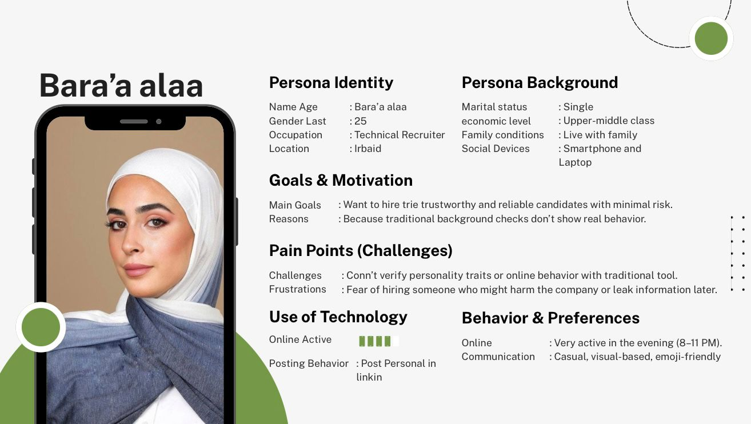

The summarizer for part 6:
Chosen Elites project is aimed at human resource recruiters of the corporate world of Jordan and specifically Amman and big cities. This is a cohort of people aged 24-48 and with bachelor and master degrees in HR or Business administration, who have difficulties in evaluating the online behavior and personal values of the job applicants. They also use websites such as LinkedIn but lack the means of assessing their potential employees thus making poor hiring decisions and the financial gains that come with it. These recruiters are under pressure to hire people faster and this urges them to have quick corroborations, thus they tend to use shallow observations to evaluate the appropriate candidates. Thus, Chosen Elites project will also respond to their requirement to have powerful means of analyzing digital footprints and making safe hiring decisions, which is why they are the main beneficiaries of the project.

Present your proposed business solution and explain how it directly addresses the core needs and problems identified during your research.
• Discuss why this solution is realistic and valuable for your target market.
Chosen Elites: A Human-Centered Digital Background Intelligence Service (Research-Backed)
Based on our interviews, research, and the design thinking process, we developed Chosen Elites, a PDPL-aligned digital background-intelligence service that helps HR managers and other decision-makers legally and ethically understand an individual’s real online behavior, non-clinical personality-related indicators, and communication style before making high-trust decisions. While traditional background checks verify documents, our solution verifies behavior, which users identified as a major blind spot in hiring. This aligns with a global shift from “credential-only verification” toward behavioral risk screening using OSINT + AI, as digital footprints can contain predictive signals that traditional tools often miss. [1]

Why our method is valid (what global solutions prove)
Global leaders show that OSINT-based online screening is already a real HR practice, especially to flag workplace misconduct risks such as harassment, intolerance, violence, and fraud. For example, Fama screens many public sources and classifies misconduct categories using AI, and its strategy evolved significantly when it acquired Social Intelligence—a strong signal that AI-only screening is not enough and that human review is necessary in high-stakes hiring. [2][3]
Meanwhile, fully automated providers such as Ferretly emphasize speed and automated risk scoring, but industry discussion highlights the risk of false positives when cultural nuance, sarcasm, or local context is not understood—especially in non-Western markets. [4][5]

How the Solution Works (End-to-End Flow)
Chosen Elites provides a structured, legal, consent-based digital report that analyzes a person’s publicly available digital footprint and converts it into decision-ready insights:
1) Request & Consent (HR Input)
HR submits the candidate’s name/identifiers and confirms lawful purpose. We use PDPL-compliant consent forms and transparency statements as a trust mechanism and documentation layer. The service is designed around Jordan’s Personal Data Protection Law requirements (purpose limitation, transparency, and controlled handling). [6]
2) Information Gathering (Tools + OSINT Specialists)
We gather information using OSINT techniques limited to publicly available data from platforms such as LinkedIn, X, public TikTok/Facebook content, public web pages, and news references. Automated collection supports scale, while OSINT specialists ensure correct sourcing and evidence handling.
3) Organizing the Collected Data (Evidence Structuring)
We structure collected information into evidence groups to reduce noise and improve reliability, such as:
- identity consistency across platforms
- timeline/activity patterns
- professional credibility signals (e.g., LinkedIn/GitHub/portfolio consistency)
- public engagement and communication behaviors
- job-relevant risk indicators (misconduct-related)
4) Analysis Methodology (Turning Data into Wisdom) — AI + Human-in-the-Loop
Chosen Elites is built as Augmented Intelligence: AI supports humans, not replaces them—consistent with market reality where leaders have moved toward hybrid systems because hiring decisions are high-impact and context-dependent. [2][3]
Our analysis is designed in three layers:
- Layer A: Automated detection (AI / NLP + patterning)
AI helps identify patterns in public text and behavior such as tone stability, repeated hostility, harassment-like language, hate speech indicators, threats, or oversharing confidential content. Research supports that digital footprints can carry meaningful predictive signals related to workplace outcomes. [1]
- Layer B: Human verification (OSINT analyst review for fairness & accuracy)
A trained analyst validates AI-flagged items to reduce false positives and confirm context. This is critical because AI systems can misread context, sarcasm, and intent.
- Layer C: Local cultural calibration (Jordanian/MENA nuance)
Because Arabic dialects and cultural context can break Western-trained AI, we apply a local interpretation layer to avoid dangerous misclassification and unfair flagging. Research shows LLMs can demonstrate Western bias even when used in other languages, and moderation failures in the Middle East often come from cultural misunderstanding. [7][8]
Important ethical boundary: the report does not perform clinical diagnosis or claim mental health conditions. It focuses only on observable, workplace-relevant behaviors and communication patterns, consistent with ethical guidance on AI use in psychology-related contexts. [10]
5) Reporting (Structured, HR-Friendly Output)
We generate a decision-ready report designed for HR workflows, including:
- public online behavior (tone, communication style, consistency)
- digital footprint across platforms (where they are active and how)
- professionalism signals
- potential risks (aggression, hate speech patterns, harassment signals, confidentiality oversharing)
- alignment with role/company culture (non-clinical, job-relevant)
- credibility patterns across LinkedIn, GitHub, and public communities
- PDPL transparency: what sources were used, what was excluded, and why

Behavioral Intelligence Engine: Data Analysis, AI Use, and Ethical Boundaries
The contemporary landscape of human capital management faces a critical challenge: misalignment between static, curated candidate data (CVs, interviews) and the dynamic reality of workplace behavior. Chosen Elites addresses this by transforming OSINT into structured insights using a scientifically grounded methodology that identifies job-relevant behavioral signals while neutralizing biases found in unstructured digital screening. This engine is built around four pillars: (1) technical validity of OSINT-to-signal conversion, (2) HITL reliability and explainability, (3) boundaries vs psychometrics, and (4) embedded fairness controls. [1][9]
From OSINT Data to Behavioral Signals
Raw OSINT data is converted into actionable behavioral intelligence using feature extraction + NLP classification + evidence structuring. Unlike subjective “cybervetting,” the methodology quantifies behavioral signals associated with workplace risk (e.g., incivility, harassment, threats) and reports them as documented evidence rather than personal judgments. [1]
Key signal families include:
- Sentiment, emotion, and tone (e.g., repeated hostility, incivility patterns)
- Toxicity/harassment indicators (identity attacks, severe insults, hate speech patterns)
- Threat and aggression indicators (credible violent intent vs hyperbole after context review)
- Integrity and professionalism indicators (public disclosure of confidential info, persistent unprofessional attacks)
Critical output boundary: the system produces risk classifications, not diagnoses. Outputs are framed as workplace-relevant categories such as Safety Risk, Conduct/Cultural Risk, and Professionalism/Integrity Risk, grounded in observable content and verified context. [10]
AI-Assisted Analysis with Human-in-the-Loop Validation
AI provides scale, but exclusive reliance on algorithms in hiring is ethically and operationally risky. Chosen Elites therefore uses Human-in-the-Loop validation as a mandatory control: AI surfaces potential risks; trained analysts verify context and job relevance before any finding becomes reportable. This reduces false positives caused by sarcasm, quotes, activism, or culturally normal expressions that AI may misread—especially in Arabic/MENA contexts. [7][8]
This HITL model also enables explainability, because every report finding is tied to an evidence snippet and analyst rationale rather than an opaque score. [9]
Behavioral Indicators vs Psychometric Assessments
Chosen Elites enforces a strict distinction between:
- Psychometrics (standardized, consent-based instruments that measure latent traits), and
- Behavioral indicators (observable conduct signals from public OSINT).
OSINT should not be treated as a substitute for psychometric testing, and Chosen Elites does not infer clinical traits or mental health conditions from public content. Instead, it reports documented behaviors relevant to workplace safety, integrity, and professionalism. If a psychometric component is added in the future, it will be a separate, explicit consent-based module using validated tests—not covert inference. [10]
Ethical & Bias Controls Embedded in the Analysis Process
Because unstructured social media checking is bias-prone, fairness controls are embedded into the method:
- Structured screening (standard categories and consistent rules for all candidates) to reduce informal bias. [9]
- Data minimization (collect only what is relevant to defined risk categories). [6]
- Redaction of sensitive/protected attributes before HR receives the report, to limit demographic bias exposure. [9]
- Transparency and documentation so findings are explainable and defensible, reducing the risks of arbitrary “AI rejection.” [9][10]

How Chosen Elites Directly Addresses the Core Needs Identified in Research
1) HR managers need deeper insight, not just CV verification
Our interviews showed HR worries more about hidden behavioral risks than fake CVs. Chosen Elites addresses this by highlighting potential red flags early and revealing communication style and ethics—aligned with global online screening practices. [2][4]
2) Job applicants want a fair and transparent process
Applicants feel judged unfairly due to dishonest candidates and unstructured “manual stalking.” Chosen Elites increases fairness by using legal, consent-based data and a structured approach. Research on procedural justice supports that structured screening is fairer than informal social media checking. [9]
3) Professionals (like therapists) need early understanding of personality patterns
Therapists and other decision-makers benefit from early insight into communication style. Our approach summarizes behavioral tendencies as non-clinical observations, supported by research that online patterns can reflect stable tendencies without being medical diagnosis. [1][10]
4) The market needs a legal, structured method aligned with PDPL
PDPL requires documentation, purpose, controlled handling, and transparency. Chosen Elites is designed compliance-first, making it safer than informal HR checking that already happens without structure. [6]

Why the Solution is Realistic
Chosen Elites fits Jordan’s ecosystem because:
- high internet and smartphone usage creates rich public digital footprints
- employers already use digital HR systems
- SMEs need affordable tools that don’t require technical expertise
- remote work increases identity and trust challenges
- global tools prove feasibility of OSINT-based HR screening at scale, especially with hybrid review. [2][4]

Why It’s Valuable for the Target Market
Chosen Elites creates value by solving real HR problems today:
- lowers the cost and risk of bad hires (financial + reputational)
- supports culture-fit and ethical selection
- increases transparency and defensibility in hiring
- saves HR time by automating manual checking and reducing noise
- empowers decisions with evidence, not assumptions
- supports PDPL compliance
- provides measurable risk reduction
In short, Chosen Elites shifts hiring in Jordan from guessing someone’s personality based on a document to understanding workplace-relevant behavior using evidence-based, culturally aware, and legally aligned digital intelligence—powered by a Human-in-the-Loop model that reflects global best practice. [2][3]

References
- Annual Reviews – Implications of Social Media for a Changing Work Landscape: https://www.annualreviews.org/content/journals/10.1146/annurev-orgpsych-110721-041023?crawler=true
- Fama – Products overview (Fama Plus): https://fama.io/fama-plus
- Fama – Fama acquires Social Intelligence (hybrid/HITL validation): https://fama.io/press-releases/fama-acquires-social-intelligence
- Ferretly – Official site: https://www.ferretly.com/
- Ferretly – Human bias vs algorithmic signal: https://www.ferretly.com/blog/who-do-we-trust-to-decide-human-bias-vs-algorithmic-signal-in-screening
- Jordan PDPL (Official PDF): https://www.modee.gov.jo/EBV4.0/Root_Storage/EN/PDPD-En-v1.pdf
- Georgia Tech – LLMs generate Western bias: https://www.cc.gatech.edu/news/llms-generate-western-bias-even-when-trained-non-western-languages
- Middle East Institute – content moderation failures in the Middle East: https://www.mei.edu/publications/flaws-content-moderation-system-middle-east-case-study
- PubMed Central – Social Media Screening and Procedural Justice: https://pmc.ncbi.nlm.nih.gov/articles/PMC8055055/
- APA – Ethical guidance for AI in professional practice of health service psychology: https://www.apa.org/topics/artificial-intelligence-machine-learning/ethical-guidance-ai-professional-practice

Primary research
Key Insights and Knowledge Gained from HR Interviews

In the interviews we asked about both the prototype and the solution we have, first we asked if they are accepting the idea of a background check, and the ability to find deep details about the candidates. So we found that they did like the idea so we continued to the prototype testing.
The interviews with three HR professionals produced clear, consistent, and highly practical insights that reflect real hiring behavior and day-to-day decision-making. Their feedback confirmed that the true value of a background intelligence tool does not lie in technical sophistication, but in ethical design, clarity, and alignment with real HR workflows. Across all three interviews, HR professionals emphasized that any tool used in hiring must support professional judgment, ensure fairness, and remain defensible from both legal and organizational perspectives.

One of the strongest insights raised by all three HR professionals was the importance of control and flexibility. They stressed that having the ability to define the scope of background evaluation is critical. Being able to choose between reviewing professional background, personal background, or a combination of both allows HR teams to adjust screening depth based on job sensitivity, organizational policy, and risk level. This flexibility increases confidence in the tool and makes it usable across different hiring scenarios rather than forcing a one-size-fits-all approach.

Closely related to this was the need for clear ethical boundaries. All three HR professionals highlighted that the option to exclude specific platforms—particularly personal social media—significantly increases trust. They expressed discomfort with tools that feel intrusive or resemble informal “social stalking.” Clear boundaries help HR professionals maintain professionalism, reduce ethical concerns, and feel confident that their hiring decisions can be justified if questioned by candidates or management.

Fairness and time relevance also emerged as a shared concern. The HR professionals emphasized that people change over time and that outdated or isolated online behavior should not define a candidate’s suitability. The ability to limit how far back a background check looks was viewed as essential for responsible and fair hiring. Time-based controls help ensure that insights are relevant and prevent unfair judgment based on past behavior that no longer reflects the candidate.

Another consistent insight was that explainable risk flags are far more valuable than numerical scores. The three HR professionals preferred clear explanations of why a candidate is flagged rather than abstract risk ratings. Transparent reasoning supports professional judgment, enables internal accountability, and allows HR teams to clearly explain hiring decisions to senior management or other stakeholders. This reinforces the system as a decision-support tool rather than an automated decision-maker.

The HR professionals also emphasized that behavioral patterns matter more than isolated incidents. They expressed concern about unfairly judging candidates based on one-off posts or emotional moments. The ability to distinguish consistent, long-term behavioral trends from short-term or situational activity was considered one of the most valuable features, as it aligns closely with how HR professionals evaluate behavior in real workplace settings.

Additionally, topic analysis was viewed as a meaningful source of insight. Understanding the dominant topics a candidate discusses online helped HR professionals assess culture fit, communication style, and potential reputational risk—areas that are often difficult to evaluate through interviews alone, especially for leadership or public-facing roles.

Finally, all three HR professionals emphasized that non-technical clarity is essential for adoption. Simple language, structured reports, and visual summaries were considered critical for usability. They stated that if a tool feels complex or overly technical, it would not be used in practice, regardless of its capabilities.

Overall, the interviews revealed that HR professionals already conduct informal online checks but lack a structured, ethical, and defensible framework to support these activities. The feedback clarified that HRs prioritize transparency, relevance, accountability, and fairness over technical complexity. These insights strengthened the understanding that successful adoption depends on trust, clarity, and flexibility, ensuring that the solution supports professional judgment rather than replacing it.

Develop a clear value proposition that explains the unique benefits your product or service offers to your target audience.
The value proposition of Chosen Elites involves the human resource departments being given the authority to make safer, better-informed, and more confident hires by displaying the true nature of the candidates that cannot be captured in the formal curriculum vitae. The traditional background checks that are conducted in the Jordanian setting usually check the documentation, previous work or education history but do not reveal how a prospective employee will act, communicate or represent himself or herself on the Internet. Chosen Elites fills this gap by providing open-source intelligence of PDPL standard, which highlights digital behaviour, personality indicators, and risks.

Human resource practitioners have to face major challenges on a regular basis, among them curriculum vitae fraud, time problems, and insufficiency of interviews to measure cultural or ethical fit. These challenges are directly solved through the service that results in the generation of the structured report that questions a candidate regarding his or her open online actions, communication patterns, stability, and professionalism. In this process, fragmented digital information is converted into coherent, human-centred information to aid the highest decision-making.

At the same time, Chosen Elites has value addition in that it saves HR time and reduces the chances of hiring an employee who may compromise the image of an organisation, cultural content, or confidentiality. The platform organizes the appropriate information, raises the possible red flags and provides actionable summaries that the HR teams can trust. Chosen Elites is regarded as the unique combination of behavioural analysis, identity checks, and ethical data processes in Jordanian organisations in a market where there is no domestic, HR-oriented OSINT solution.
Aligning With Design Thinking & Human-Centered Value
To strengthen the value proposition, we also evaluated Chosen Elites through the lens of Design Thinking, as emphasized in the slides. Instead of building a tool based on assumptions, the team grounded the value proposition in empathy interviews, real hiring pain points, and an understanding of the social and psychological factors HR managers face. This human-centered approach revealed that the core problem is not simply “missing information,” but rather uncertainty, lack of behavioral insight, and difficulty predicting how candidates will act in real workplace situations. By addressing these previously overlooked needs, Chosen Elites creates meaningful value that resonates directly with the people who will use it.
Desirability–Viability–Feasibility Fit
The value proposition also reflects the three innovation pillars highlighted in the slides:
Desirability, Viability, and Feasibility.
- Desirability: HR professionals expressed clear frustration with CV fraud, unreliable interviews, and limited tools for evaluating ethics, attitude, and culture fit. Chosen Elites responds to these needs by giving a clearer picture of the person behind the CV.
- Feasibility: The service relies on legally accessible OSINT data, automated screening logic, and simple digital workflows—making the solution technically realistic without requiring high infrastructure.
- Viability: By helping organizations avoid expensive hiring mistakes and saving HR teams significant time, the service becomes economically sustainable and attractive for ongoing use.
This balance between human needs, technical possibility, and business value reinforces the strength and relevance of the solution.
Clear Statement of Unique Value (Innovation Definition)
Following the definition of innovation from the slides—creating meaningful new value for someone—Chosen Elites delivers a unique benefit unavailable in the Jordanian market. While traditional background checks focus on documents, Chosen Elites uncovers digital behavior, ethical signals, confidentiality habits, and real communication patterns, all within PDPL-compliant boundaries. The platform translates scattered digital traces into clear, actionable hiring insights. This combination of behavioral intelligence + legality + HR-friendly reporting forms the core of the unique value offered to HR departments.

8.1 Competitor Analysis
A review of the competitive landscape shows that no company in Jordan currently offers an HR-focused OSINT or digital-behavior intelligence service similar to Chosen Elites. Instead, the competition comes from three different groups: local HR firms, global background-check vendors, and international OSINT/AI screening tools. Each group covers part of the problem but leaves a gap that our solution fills.

1. Local HR & Recruitment Firms in Jordan (Indirect Competitors)
These firms compete with Chosen Elites not because they provide OSINT, but because they already support parts of the hiring workflow and could eventually try to expand into verification services.
Jordan Search Consultants (JSC)
Focuses on executive search and talent placement. Their vetting relies on interviews, reference checks, and psychometrics but does not examine digital behavior or personality signals.
• Strong relevance: companies hiring senior roles would benefit from our “Deep OSINT” reports.
• Their pricing (20–30% of annual salary) shows that HR budgets can absorb a 50–150 JOD add-on report.
Reference: https://www.jsc.com.jo
Alliance Recruitment Agency (Jordan)
Handles high-volume recruitment in multiple sectors. Their workflow depends on manual CV screening rather than behavioral analysis—making Chosen Elites a complementary service.
Reference: https://www.alliancerecruitmentagency.com
Akhtaboot & Doroob
These platforms provide job postings and HR consulting but no digital-behavior intelligence. They are potential integration partners rather than competitors.
Reference: https://www.akhtaboot.com
Private Investigation Firms (ICS World, Greves Group)
These operate in fraud investigations and surveillance—not HR personality insights. They are expensive and unsuitable for everyday hiring.
References:
ICS World: https://www.icsworld.com
Greves Group: https://www.grevesgroup.com
Conclusion (Local Market):
There is no Jordanian provider offering OSINT-based behavioral analysis or PDPL-compliant digital personality screening. This is a clear market gap that Chosen Elites fills.

2. Global Background-Check Companies (Indirect but Strong Competitors)
These are well established internationally but focus mostly on identity, fraud, and credential verification—not on culture-fit or personality behavior.
DataFlow Group (GCC Region)
Well-known for Primary Source Verification (PSV) in healthcare. Offers a “digital-footprint verification” add-on, but it is limited to fraud detection rather than full behavioral assessment. Pricing is 300–900 AED ($82–$250), which is high for Jordanian SMEs.
Reference: https://www.dataflowgroup.com
CRI Group – EmploySmart
Provides risk investigations and compliance checks in the region. Their screening includes local-language media but lacks behavioral OSINT or interaction-style analysis.
Reference: https://crigroup.com/services/employsmart
First Advantage
Uses automated global screening tools and partners with Fama.io. Effective in English-speaking countries but weak in Arabic dialect interpretation.
Reference: https://fadv.com
Verifitech (UAE)
Focuses on employer-verification services (criminal record, address, education) with no advanced OSINT features.
Reference: https://www.verifitech.com
Conclusion (Global Vendors):
• too expensive for typical Jordanian hiring budgets
• built for English-speaking markets
• lack cultural sensitivity for Jordan and Levant
• prioritize “hard checks” over human behavior
Chosen Elites is cheaper, localized, PDPL-compliant, and tailored for Jordanian HR challenges.

3. Specialized OSINT & AI Social Screening Tools (Closest Functional Competitors Globally)
Fama.io
Uses AI to detect misconduct (harassment, hate speech, etc.). A global leader—but its models do not understand Arabic, Arabizi, tribal nuances, or local cultural meanings.
Reference: https://fama.io
Ferretly
Provides AI image and text scanning for risk. Very fast and low-cost (~$15 per report) but built for Western markets and ineffective in Levantine Arabic.
Reference: https://ferretly.com
Social Intelligence
Uses human review + automation but primarily supports US companies. Limited cultural interpretation outside English.
Reference: https://www.socialintel.com
Conclusion (OSINT Tools):
These tools are the closest to our concept functionally, but none of them can:
analyze Arabic dialects
distinguish local humor from harmful content
interpret Jordanian cultural references
evaluate professional tone in Arabic communication
This gives Chosen Elites a defensible competitive advantage.

Why Jordan Has No Direct Competitors
Because no existing service offers:
- PDPL-compliant consent-based OSINT
- behavioral + cultural + ethical analysis
- Arabic NLP tailored to Jordanian dialect
- HR-oriented reporting formats
- local pricing that SMEs can afford
HR departments in Jordan already suffer from:
• CV fraud
• digital misrepresentation
• culture-fit uncertainty
• lack of tools for evaluating online behavior
But no company provides a structured, legal, culturally appropriate OSINT solution.
This gap is exactly where Chosen Elites operates.
Pricing Comparison Table
Competitor | Price Range | Notes
DataFlow Group | 300–900 AED ($82–$250) | Credential verification only
Fama.io | $30–$50 / report | English-focused AI
Ferretly | ~$15 / report | Image + text AI scanning
US Background Check Services | $30–$80 | Automated criminal + social checks
Jordan Recruitment Agencies | 20–30% of salary | No OSINT screening
Chosen Elites (planned pricing: 15–50 JOD) fits the local economy while providing deeper insight.
Final Summary of Competitive Advantage
Chosen Elites fills the gap that both local and global competitors leave open:
Global competitors
advanced but expensive, not culturally aligned, not Arabic-focused
Local HR firms
trusted but lack behavioral screening technology
OSINT tools
powerful but linguistically blind to Arabic and PDPL compliance
Chosen Elites combines:
local pricing
PDPL-compliant consent workflow
culturally informed behavioral OSINT
Arabic NLP
HR-friendly, decision-ready reports
This positions Chosen Elites as the first and only HR-oriented OSINT behavioral-intelligence service in Jordan.

Value Proposal Canvas below is a summary of the main elements of our offering and the exact requirements of our target customers.

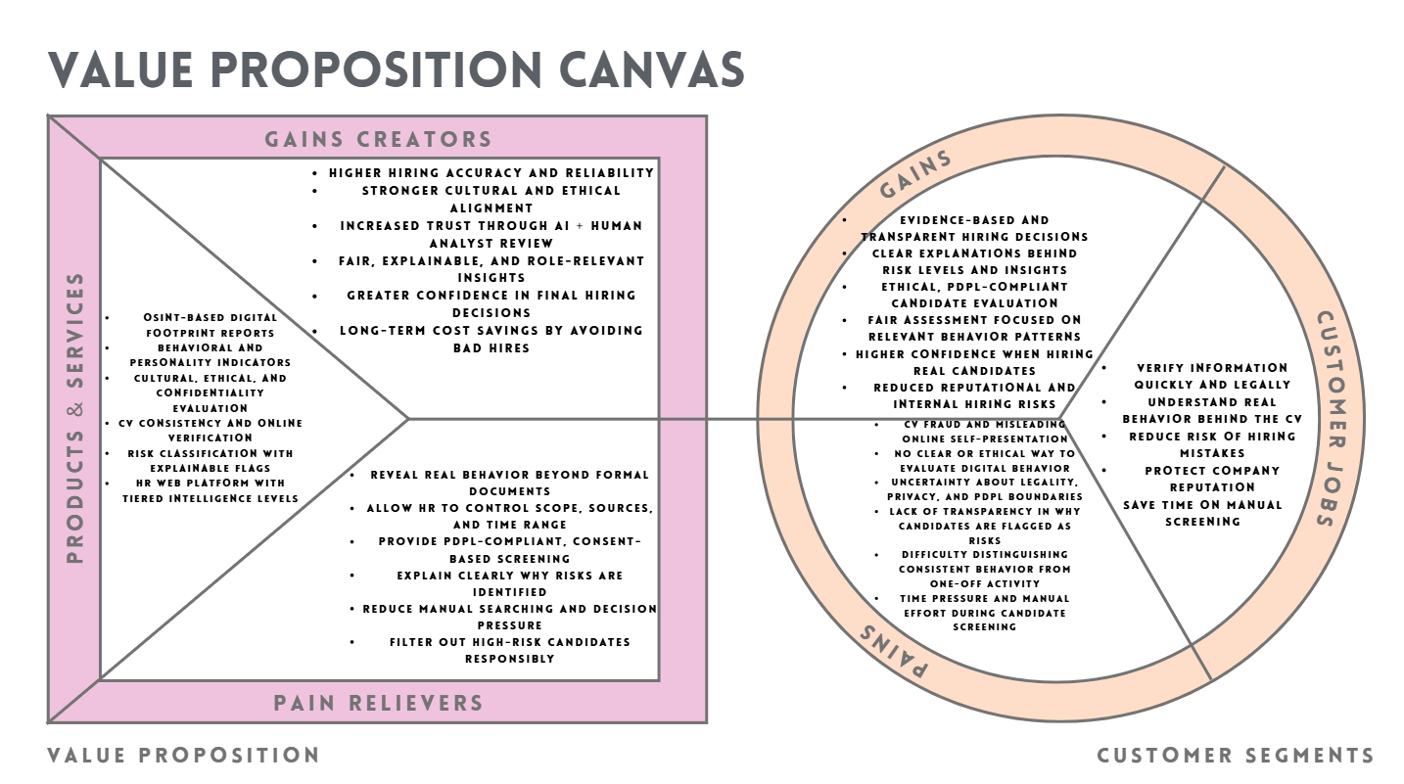

The points used in the Figure above, are found in bullet points below
CUSTOMER SEGMENTS (HR Managers)
Customer Jobs (What HR Needs to Do)
- Hire trustworthy, reliable candidates
- Verify information quickly and legally
- Understand real behavior behind the CV
- Ensure cultural and ethical fit
- Reduce risk of hiring mistakes
- Protect company reputation
- Save time on manual screening
Pains (What HR Struggles With)
- CV fraud and exaggerated or misleading candidate information
- No structured or ethical way to evaluate candidates’ digital behavior
- Lack of control over what online information should or should not be reviewed
- Uncertainty about legal boundaries and PDPL compliance when checking online presence
- Fear of invading candidate privacy or crossing ethical lines
- Difficulty understanding why a candidate is flagged as a potential risk
- Black-box screening tools that provide conclusions without explanation
- Inability to distinguish between consistent behavior patterns and short-term or situational online activity
- Difficulty identifying which online discussion topics are relevant to a specific role
- Time-consuming manual searches across multiple platforms
- Pressure to make fast hiring decisions with incomplete behavioral insight
- Risk of hiring someone who may compromise confidentiality, professionalism, or company reputation
Gains (What HR Wants)
- Evidence-based hiring decisions supported by transparent explanations
- Clear understanding of why a candidate is flagged as low, medium, or high risk
- Control over the scope of background evaluation based on role and company policy
- Ability to exclude irrelevant or ethically sensitive platforms with confidence
- Fair and time-bounded assessment of candidate behavior
- Insight into dominant discussion topics and values relevant to the role
- Confidence that insights reflect stable behavior patterns, not isolated incidents
- Trust in a screening process that combines AI efficiency with human analyst judgment
- Legal reassurance through PDPL-compliant consent and transparent data boundaries
- Reduced time spent on manual online searching
- Higher confidence when submitting real candidate names for screening
- Protection of organizational reputation and internal culture
- A locally designed tool that respects Jordanian legal, cultural, and ethical norms

VALUE PROPOSITION (Chosen Elites)
Products & Services
- OSINT-based digital footprint reports
- Behavioral & personality indicators
- Cultural and ethical fit evaluation
- CV consistency & online verification
- Risk-classification and red-flag summaries
- HR web platform for report requests
- Tiered intelligence levels (Basic → Deep)
Pain Relievers (How We Reduce HR Pain)
- Reveal real behavior, not just documents
- Automate digital screening across platforms
- Provide PDPL-compliant, ethical reports
- Highlight only relevant risks—no noise
- Reduce time spent searching online
- Provide objective insights for pressured decisions
- Filter out high-risk candidates before hiring
Gains Creators (How We Improve HR Results)
- Better hiring accuracy and reliability
- Stronger cultural and ethical fit
- Higher confidence in decision-making
- Safer workplace and better team alignment
- Improved protection of confidential information
- Long-term savings by avoiding bad hires
- A clearer picture of the “real person”

Present the initial version of your prototype, highlighting its main features and benefits.

Explain how your prototype responds to user needs and ensures ease of use for your intended audience.
First, having finished the prototype of the Chosen Elites in the first version and posted it online, I showed it to the HR manager to receive the feedback of a real representative of the target population. Although she liked the general idea, she pointed out that the interface was the one that could use more detail, better explanation, and closer reflection on how the HR professionals in reality read and interpret the background-intelligence reports.
On her response, I created a more elaborate and formal second version in Figma. The major aspects of improvement are:
  - Making the mechanism of the system more elaborative.
The original explanation of the OSINT workflow was not well defined, particularly to non-technical users of HR.
The new version includes:
A graphic analysis of the steps:
- Request - Data Collection - Behavioral & Content Analysis - Risk Assessment - Final Report.
- Elucidation of the kind of data that is analyzed on platforms.
- This simplified the service to the HR managers.

  - Redesigning the Landing Page to have a more understandable introductory content.
Given that the HR manager asked to be explained more, I added:
- An easy, non-technical explanation of what Chosen Elites does.
- An explanation of the platform in terms of its audience.
- An hourly breakdown of the service value (behavioral insights, a review of the digital footprint, the detection of risks).
- Comparison of background checks (traditional) and OSINT-based intelligence.
- This will provide complete transparency to the users in advance.

  - Improving the Dashboard to indicate actual HR processes.
New features on the new Dashboard are:
- Planned actions, achieved reports, and indicators.
- Risk levels (Low, Medium, High) are coded in colors.
- A realistic candidate card that displays platforms utilized, content posted, activity and rate of consistency.
- This is a direct reaction to the request of more approachable and practical interface by HR.
  - Enhancing the OSINT Report with outlined and classified areas.
The HR manager wanted more detail and obvious division in particular.
Thus I submitted a well formed report comprising:
- Identity Verification
- Behavioral Analysis
- Content Integrity
- Values & Culture Fit
- Privacy & PDPL Compliance
- Network Quality
- Key Findings summary has also been provided to provide a brief decision-ready view of HR.

  - Enhancing the user flow and navigation.
To avoid the misunderstanding and make the prototype more realistic, I made a more clear navigation structure:
- Landing -Login -Dashboard-Profile-Reports.
- This mirrors how HR systems are typically used in real environments.

- The first prototype is:
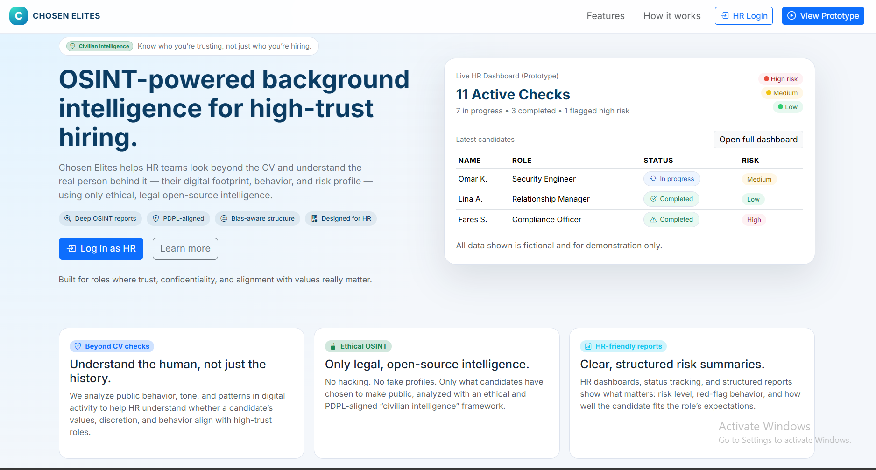
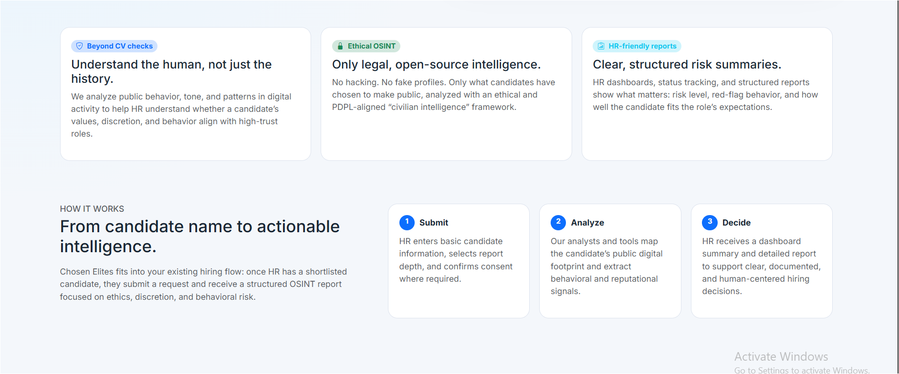
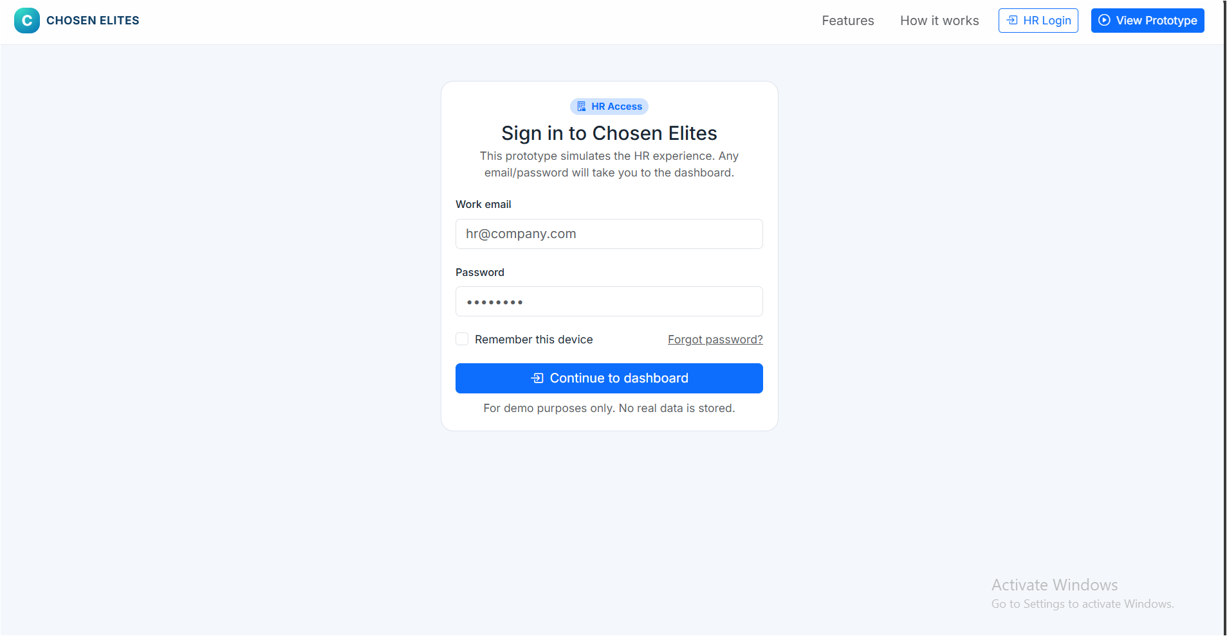
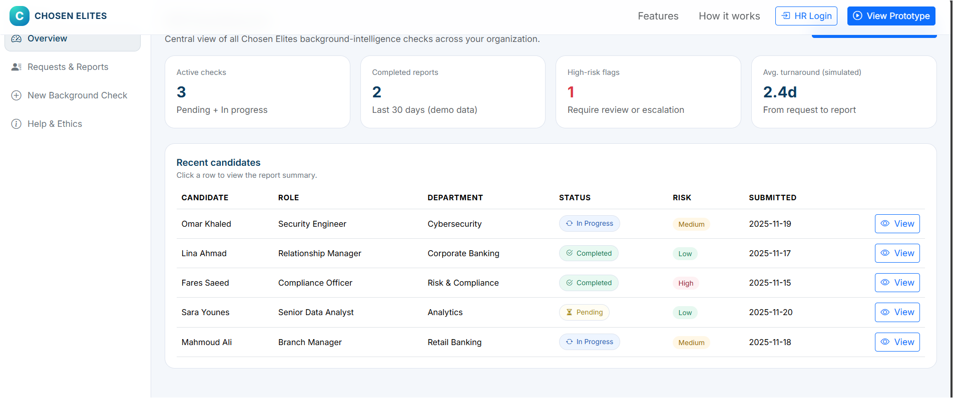
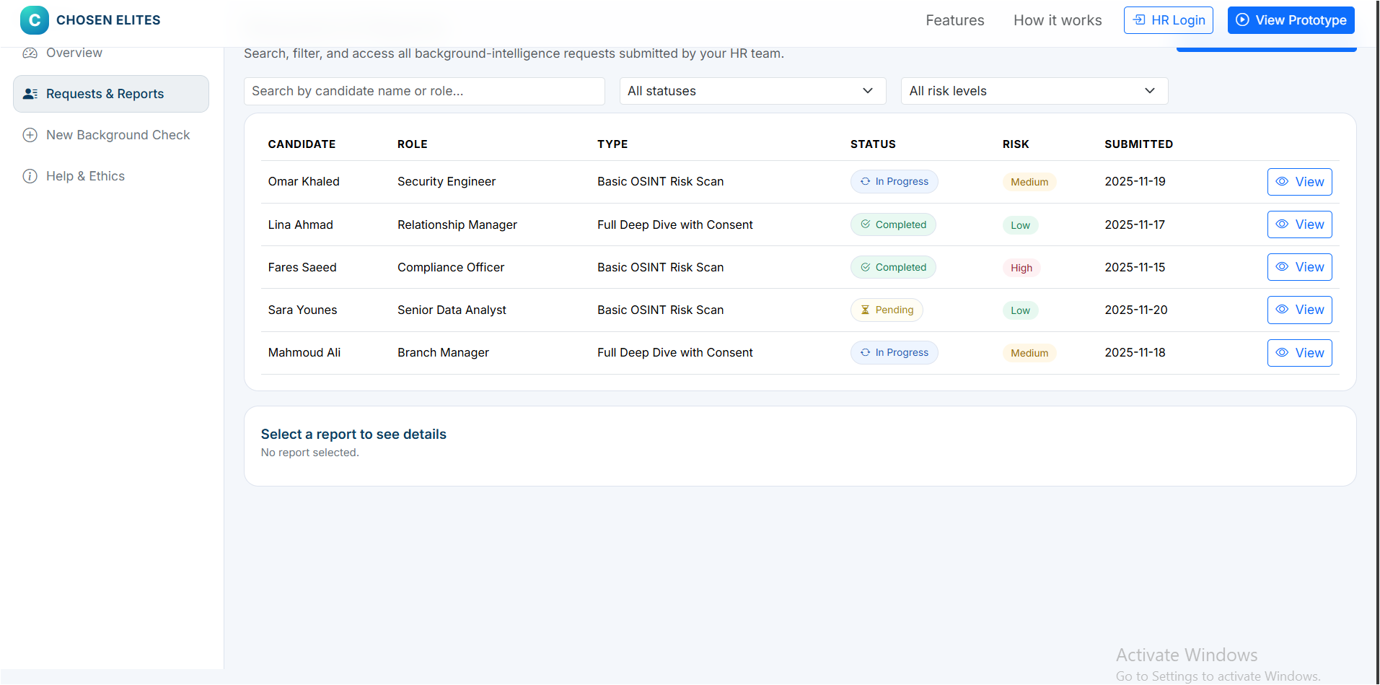
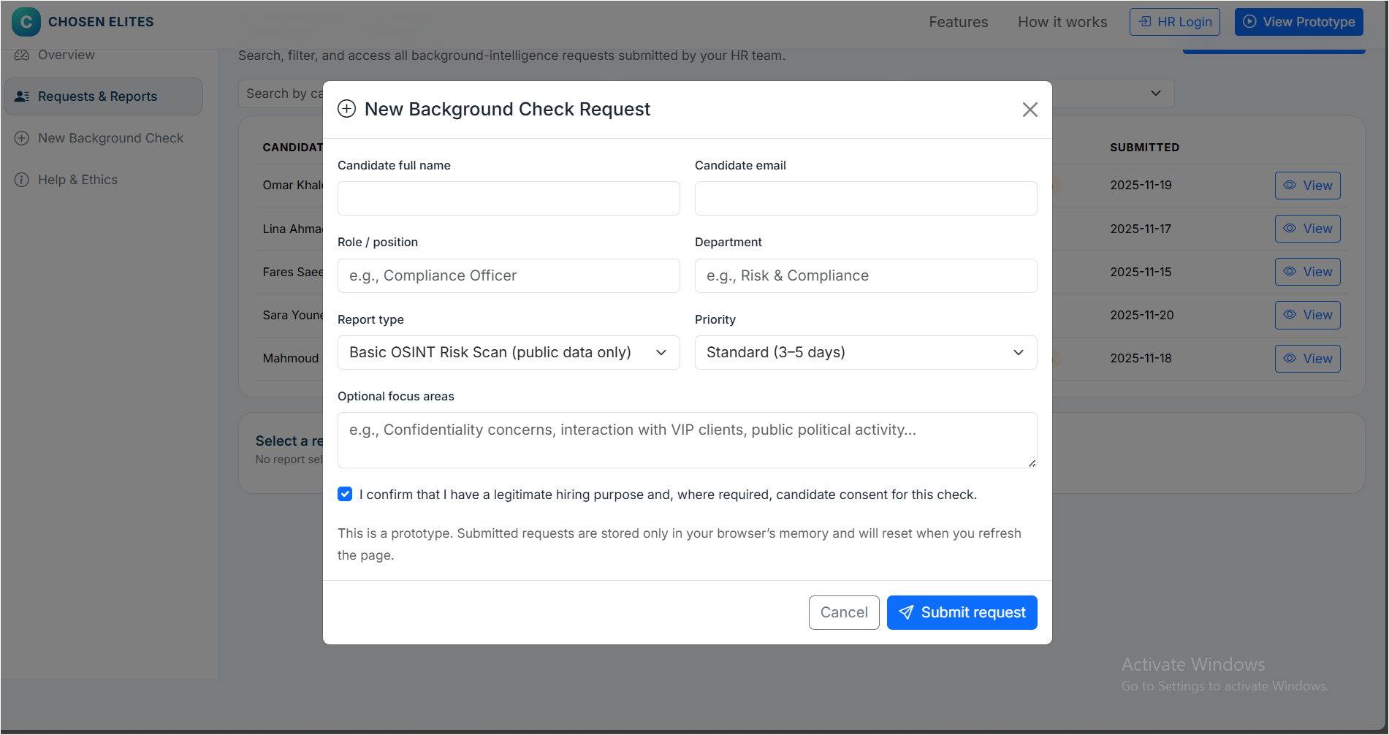

Background Intelligence based on OSINT Powered Chosen Elites Prototype The Prototype:
This prototype is not meant to be a demonstration of the technical excellence of the OSINT system in all its complexity, but is designed to replicate the actual working process that an HR decision-maker would go through:
- being able to know the service through the landing page.
- logging in as an HR user
- placing a request of a background-check.
- reading a systematic digital-behavior report.
The prototype aims at the transparency, simplicity, and high-trust, PDPL-oriented hiring experience, designed specifically to the HR professionals.

Main Features
- Landing Page:
The Service in a Simple and HR-Friendly Exploration.
The prototype starts with a landing page that is aimed at presenting the purpose of Chosen Elites in a manner that is not technical. The page includes:
- title:
OSINT-based background intelligence to hire high-trust employees.
- Short description:
It describes how the system extends the traditional checking of the CV, by analyzing the digital behavior, values and risk indicators.
- Top-level value cards:
Overviews of the key advantages including; be beyond CV checks, legal open-source intelligence, and structured risk summaries.
- Clear CTAs:
  - The top left has a log in as HR which takes one to the log in page.
  - The directive to learn more will take one to the explanation of how the service works.
- How it Works section:
Displays the three critical steps: Submit ,Analyze, a Report.
- It provides the user to know the service and be confident to enter the system.

- HR Login (Simulated Access)
The second section of the flow is the login page, which should look like the HR systems that are familiar.
- E-mail and password fields on work.
- Remember this device checkbox.
- Minimal and clean design that creates trust.
- The user is redirected to the dashboard with the help of the login button.
This is done to ensure that there is friction reduction and a clean entry point of HR staff.
HR Dashboard
- Background Checks: Overview of All Background Checks.
Upon the login, the HR user is redirected to the dashboard a main page that will show all the active and finished checks.
The dashboard contains:
- Key performance summaries, such as:
  - Total active checks
  - Completed reports
  - High-risk flags
  - Average turnaround time

- Candidates table, sorted by date, ascending, with:
- Candidate name
- Role and department
- Current status (Pending / In Progress / Completed)
- Risk level (Low / Medium / High)
- Submission date
- An Open report action to open the report.

- New Background Check button:
This button enables the HR to initiate a new request immediately.
The dashboard gives a summary view of what is really needed by HR decision-makers in workload, priorities and risk.
- Background Check Submission / New Analysis.
The page of New Background Check enables the HR to make a new request with the help of an organized and bare-bones form.
The form includes:
- Candidate full name
- Candidate email
- Role / position
- Department
- Report type ( Basic public-data scan or other types available)
- Priority (Normal or urgent options)
- Optional areas of focus (e.g., confidentiality issues, demeanor in the general, handling sensitive patients) PDPL, the presence of a legitimate-purpose confirmation checkbox on consent.
- Request button to complete the request.
- Determining the result of the analysis duration
- Type of social communication choose the types of social media.
- Cancel button to the dashboard.
The page will make sure that the HR could start the background check process in less than one minute of time, which helps save time and would not require several searches to be performed externally.
- Full OSINT Summary to HR Digital-Behavior Report.
Upon a candidate being selected, a detailed behavioral report and digital-footprint report will be presented to the HR user in clear sections.
- Report Header
- Candidate name
- Username
- Job title
- Location
- Email
- Number of platforms found
- Total posts detected
- Consistency rate
- Overall risk level
- Trust score

- Digital Footprint Analysis
Cross-platform summary displaying:
- Activity in each platform.
- Number of posts.
- Engagement rate.
- Presence level on LinkedIn, Twitter, GitHub, Facebook, Instagram, Medium, YouTube and on personal websites.
- Risk Assessment Overview
Consolidated risk score including sub-indicators including:
- Content integrity.
- Behavioral stability.
- Network quality.
- Privacy awareness.
- Confirmed professional background.
- Interoperability between platforms.
- Behavioral Analysis
Monitors behavioral indicators that HR teams are concerned with, including:
- Posting frequency.
- Peak activity time.
- Engagement behavior.
- Response time.
- Style of communication (professionalism or emotionality, technicalism, or pedagogy). Summarizing behavioral patterns.
- Content Analysis
Displays the posts of the candidate on topics and the themes:
- Top discussion topics.
- Sentiment (positive, neutral, negative).
- Frequently used keywords.
- Network Analysis
Provides insight into:
- professional networks strength.
- Community involvement.
- Situated within the industry.
- Authenticated or superior relationships.
- Activity Timeline
Historical overview of the past activity on all platforms:
- Monthly posting trend.
- High-engagement events.
- Important interactions or posts.
The online structured format assists HR in knowing the online behavior of the candidate without having to research on various sites manually.

How the Prototype Responds to User Needs and Ensures Ease of Use?
Our intended customer is HR professionals in a high-trust industry, including finance, cybersecurity, compliance, and data-sensitive industries. According to these requirements, the prototype was formulated with the following principles:

- I do not have time to get acquainted with a complicated OSINT tool.
- The interface is based on a basic dashboard instead of technical OSINT screens.
- The navigation is reduced to that of a handful of important sections: Dashboard, New Analysis, Reports, Analytics, and Compliance.
- The entire language is in a HR friendly language.

- I would like to have a short overview, not a long technical report.
- A small overview of checks and risk level is displayed on the dashboard.
- The reports are split into understandable sections with labels with meaning.
- The assessment of risk is divided visually through clear color coding and plain words.

- I need to make certain that this is an ethical and legal process.
- Only consent-based and public data is utilized in the system.
- The legal/consent checkbox is available in the submission form, which meets the requirements of PDPL.
- The platform explains in a straightforward manner what it does and does not (e.g., no hacking, no unauthorized access to data).

- I require to search numerous applicants and locate one in a short time.
- The new candidates table is fast scanning.
- The requests and reports are displayed in searchable and structured tables.

- I do not want to be lost in interface.
- Regular layout between screens.
- Well defined hierarchical design of cards.
- Few clicks between logging in and requesting/reporting.

- MVP and Design Thinking Alignment.
- The prototype is concerned with the minimum user flow: the perception of the service, a request, a structured report.
- The exclusion of unnecessary features (real databases, authentication systems, PDFs) was also intentional to make the prototype testable.
- The framework is dynamic such that it may be narrowed down following actual HR responses.

The summarizer for part 9:
This prototype will support an intuitive hiring process among the HR professionals through yielding to the background intelligence based on OSINT. The main characteristics are the existence of a landing page which is user-friendly and displays the purpose and benefits of the service, an HR log-in portal resembling the usual ones, and a detailed dashboard with the active and completed checks. Background checks can be initiated by a simple submission form and detailed digital behavior reports are provided to the HR users such as risk assessment and behavioral analysis. The interface is designed with efficiency and clarity in order to meet the requirements of fast overview, ethical use of data, and easy navigation. The design is in line with the principles of MVP, and it pays attention to just the fundamental features and nothing beyond that.
Prototype design:
- The link for prototyping: https://www.figma.com/buzz/q94PZWDtz08QxB52JB7uby/Untitled?node-id=1-468&t=nImZj7mFLowrrzA3-1
- Photo prototype design:
- Section Fist page (Main Features)

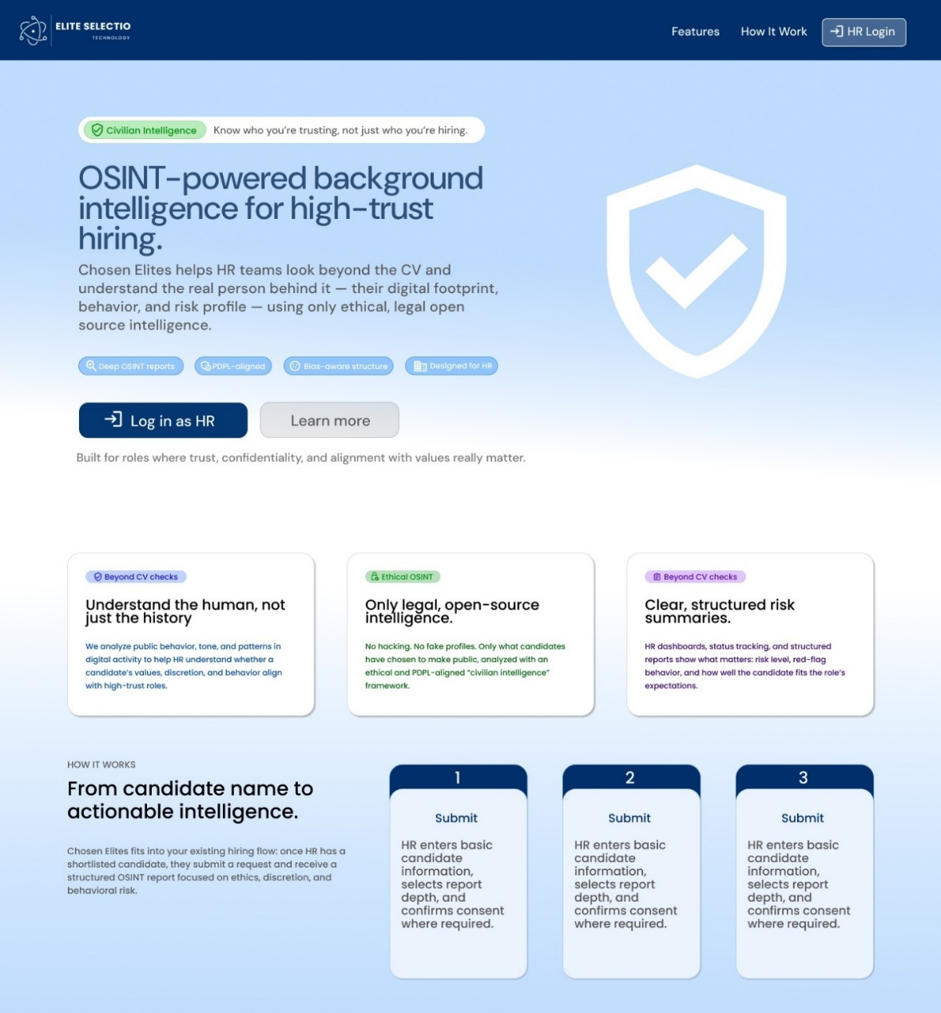

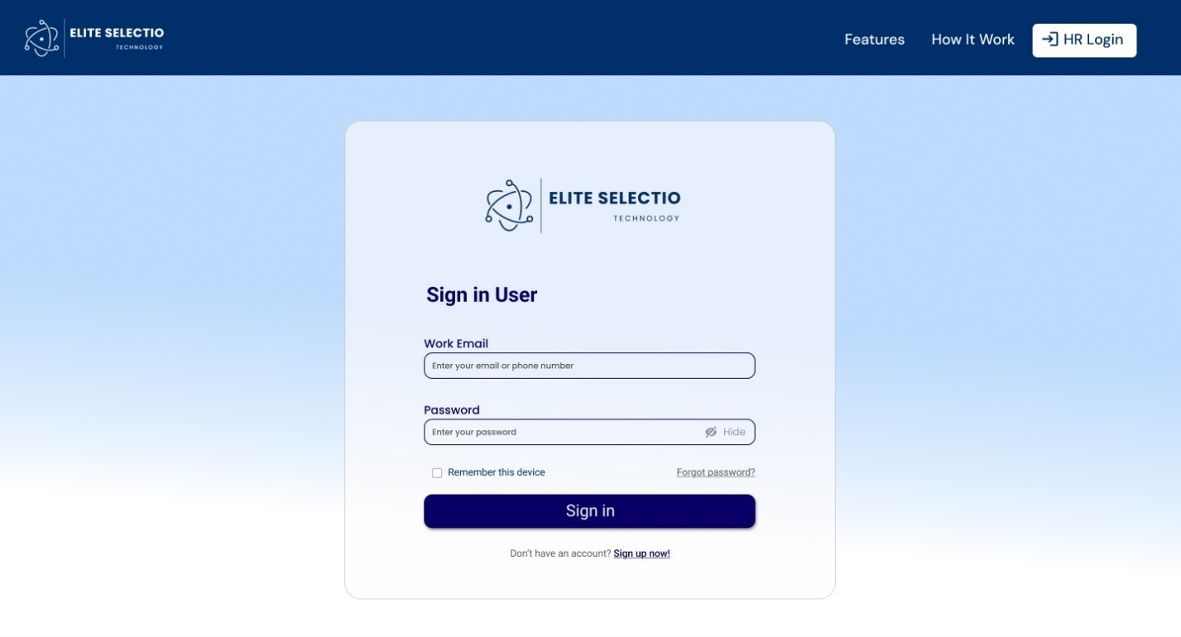
- Section two-page login (Login Page)
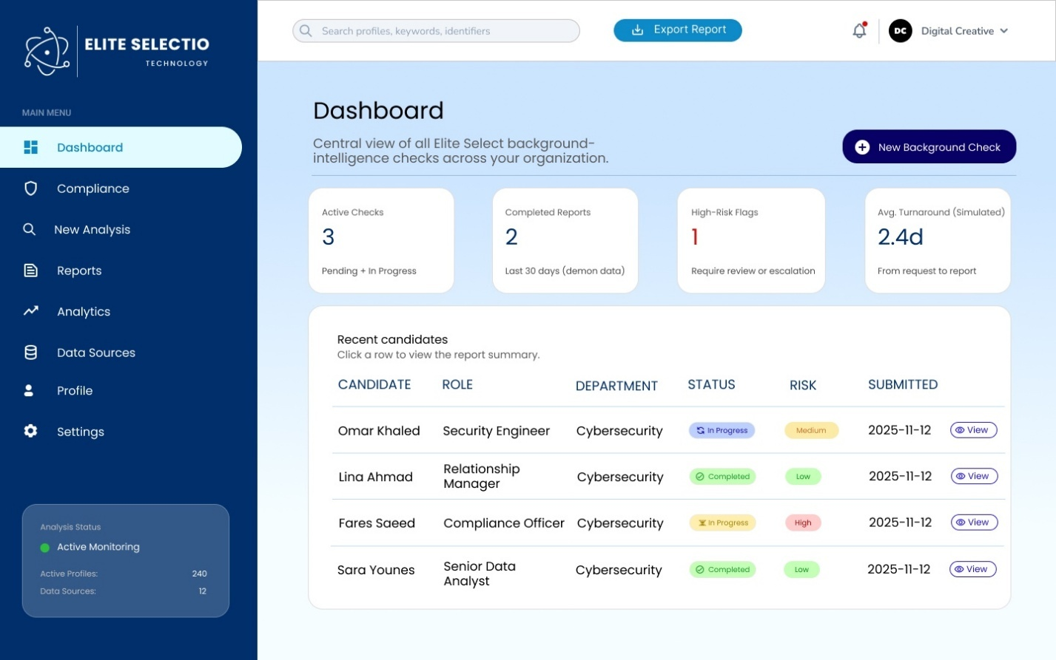
- Section three-page dashboard (Dashboard)

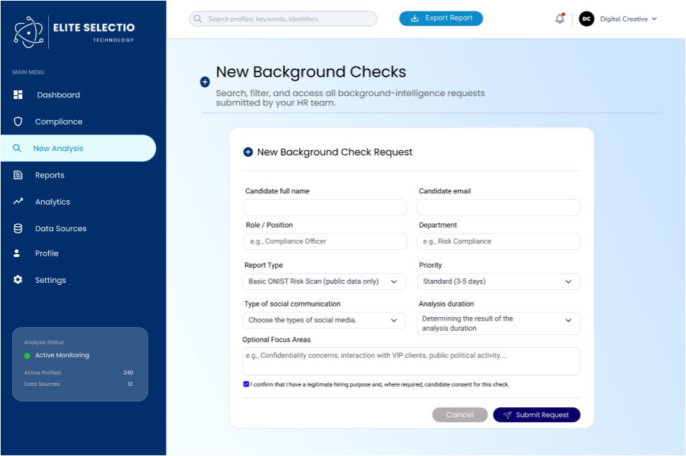
- Section four-page add new analysis (New Analysis)

- Section five-page view report and analysis (Compliance)
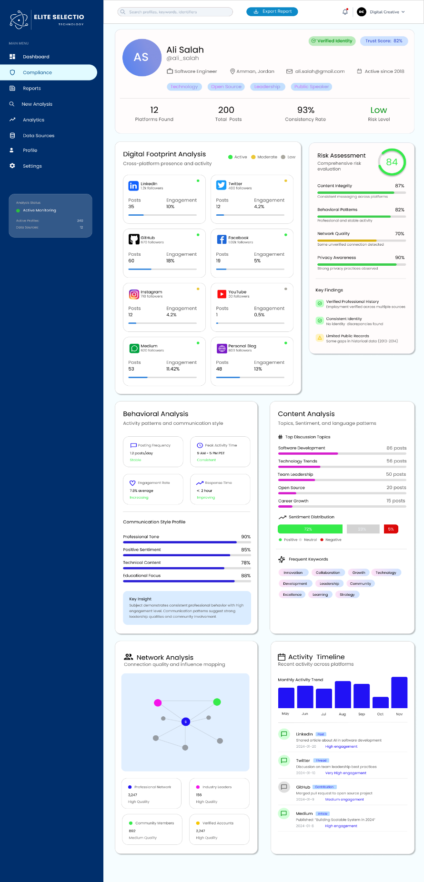

Design a testing plan for your business solution and prototype. Outline the testing steps, target users, feedback tools (e.g., surveys, interviews), and success metrics you will use to evaluate performance and gather insights for further improvement.
Category | Description / Findings
Prototype Description | A low- to mid-fidelity interactive mock-up of the Chosen Elites OSINT-Powered Background Intelligence Platform designed for HR users. The prototype simulates the end-to-end non-technical workflow, including landing page, login, HR dashboard, background-check request submission, OSINT report summary, analysis explanation layer (AI + human analyst), and Help & Ethics section. The prototype focuses on clarity, trust, legality, privacy perception, and decision support, not on technical engine performance.
Purpose of the Prototype Test | To evaluate usability, clarity, trust, legality perception, and decision-making confidence among HR professionals. The test specifically aims to assess whether users:  • Understand how OSINT data is analyzed (AI vs human analyst roles)  • Trust the generated report and insights • Believe the platform is legal and PDPL-compliant • Feel that candidate privacy is respected  • Can confidently use the platform in real hiring decisions
Key Features to Be Tested | - Ability to choose the scope of background evaluation  Whether HR professionals can decide to review a candidate’s professional background, personal background, or a combination of both, based on hiring needs and organizational policies.  - Ability to exclude specific platforms or sources  Whether HR professionals can exclude certain platforms (such as personal social media) from the background check when they consider them irrelevant, intrusive, or ethically inappropriate.  - Ability to limit the time range of the background check  Whether HR professionals can set a reasonable time period for how far back the evaluation should consider, ensuring relevance and fairness in assessing past behavior.  - Ability to interpret why a candidate is flagged as a risk  Whether HR professionals can understand and responsibly interpret when a candidate is flagged as a potential risk.  - Ability to understand dominant discussion topics  Whether HR professionals can clearly understand what topics the candidate most frequently discusses and whether these topics are relevant to the role being considered.  - Ability to distinguish stable behavior from short-term activity  Whether HR professionals can tell that the behavior shown reflects consistent patterns over time rather than temporary or situational activity.
Target Users | Participants:  5–7 non-technical participants representing real end users, including:  - HR Officers  - Recruiters  - Talent Acquisition Specialists  - HR Managers  Participant Characteristics:  - Aged between 24–45 years  Experienced in hiring and candidate verification processes
Test Methodology (Test Type, Tools) | The test will be conducted through interview-based evaluation in which HR professionals answer structured and open-ended questions related to the key features to be tested, focusing on perceptions, trust, ethics, and decision-making.
List of Specific Evaluation Questions | - How easy was it for you to decide whether to review a candidate’s professional background, personal background, or both?  - Did you feel you could comfortably exclude certain platforms or sources (such as personal social media) when you considered them irrelevant or inappropriate? Why or why not?  - How clear and reasonable did you find the ability to limit how far back in time the background check looks?  - When a candidate was flagged as a potential risk, did you clearly understand why? Did this information feel responsible and fair?  - How clear were the candidate’s dominant discussion topics, and did they help you assess relevance to the role?  - Did the behavioral information help you distinguish between consistent behavior patterns and short-term or situational activity?
Metrics for Evaluation | - Perceived control over background evaluation scope  The extent to which HR professionals feel able to decide what type of background information is reviewed.  - Ethical comfort with source and platform exclusion  The degree to which HR professionals feel comfortable and justified excluding certain platforms or sources.  - Perceived fairness of time-range limitation  Whether HR professionals consider the selected time period reasonable and relevant for evaluating candidate behavior.  - Clarity of risk explanation  Whether HR professionals clearly understand why a candidate is flagged as a potential risk.  - Relevance of identified discussion topics  The extent to which dominant topics are seen as meaningful and relevant to the role.  - Ability to distinguish consistent behavior patterns  Whether HR professionals can differentiate between stable behavior and short-term or situational activity.  - Overall trust in insights provided  The level of trust HR professionals place in the information when supporting hiring decisions.  - Support for professional judgment  Whether HR professionals feel the insights assist rather than replace their own decision-making.
Data Collection & Analysis | Data will be collected through participants’ responses to the evaluation questions during the interviews. Notes will be taken to capture key statements, reasoning, and reactions related to control, clarity, fairness, and trust. The collected data will be analyzed qualitatively by comparing responses across participants to identify common patterns, agreements, and concerns. The analysis will focus on how HR professionals perceive the usefulness of the features, their ability to interpret insights, and the extent to which the information supports confident and ethical hiring decisions.

Part two
Execute your testing plan and explain how the testing was carried out. Summarize the key feedback received
from users or stakeholders. Describe how you used this feedback to refine your solution and improve your
prototype.

Execute your testing plan and explain how the testing was carried out. Summarize the key feedback received from users or stakeholders.

Describe how you used this feedback to refine your solution and improve your prototype.
1. How the Testing Was Carried Out
The testing plan for the Chosen Elites OSINT-Powered Background Intelligence Platform was executed through qualitative, interview-based usability testing with real representatives of the target user group. The focus of this testing phase was non-technical evaluation, prioritizing human perception, ethical comfort, clarity, and decision-making support rather than system performance or algorithmic accuracy.
Testing sessions were conducted with three HR professionals, each of whom has direct experience in hiring, candidate verification, and HR decision-making. Participants were guided through the interactive prototype and asked to complete realistic tasks aligned with the testing plan, including:
- Exploring the landing page to understand the purpose of the platform
- Navigating the HR dashboard and identifying candidate risk levels
- Reviewing a sample OSINT report and interpreting risk indicators
- Reflecting on whether the information provided would support real hiring decisions
During each session, participants were encouraged to think aloud and explain their reasoning. Structured and open-ended questions were used to capture perceptions related to trust, ethics, fairness, relevance, and usability. Notes were taken throughout the sessions to document points of confusion, hesitation, and strong positive or negative reactions.
This approach ensured that the testing reflected real HR workflows and captured how non-technical users interpret and react to OSINT-based insights.

2. Summary of Key Feedback from Users
The feedback from all three HR professionals was highly consistent and revealed several important insights.
First, participants strongly agreed that the concept itself was valuable. All testers stated that understanding a candidate’s digital behavior and communication style would increase confidence in hiring decisions, particularly for sensitive or public-facing roles. They confirmed that informal online checks already occur in practice, but without structure, ethics, or documentation.
However, the testing also revealed critical areas for improvement, especially around clarity and explainability.
a. Need for Clear and Explainable Risk Flags (Ayman Hnaif and Maryam Arafat highlighted and Taher Al-Falah)
One of the most important insights was that numerical scores alone are not sufficient. HR professionals expressed discomfort with abstract or unexplained risk ratings. While the prototype presented a clear overall risk score and category indicators (e.g., Content Integrity, Behavioral Patterns, Network Quality, Privacy Awareness), participants emphasized that they need to clearly understand why a candidate is flagged.
In its current prototype form, risk indicators are visually presented through percentages and short labels (e.g., “Some unverified connection detected” or “Limited public records”), which participants found useful as a quick overview but not sufficient on their own. HR professionals stated that without deeper explanation, such indicators could feel ambiguous or difficult to justify internally.
They stressed that explainable reasoning is essential for:
- Defending hiring decisions to management
- Ensuring fairness toward candidates
- Maintaining ethical confidence in using the tool
This feedback reinforced the idea that the system must function as a decision-support tool, not an automated decision-maker.
b. Preference for Behavioral Patterns Over Isolated Incidents (Ayman Hnaif)
Another strong insight was the importance of context and consistency. Participants emphasized that HR decisions should not be based on one-off posts or emotional moments. They valued the prototype’s attempt to highlight behavioral stability (e.g., “Professional and stable activity”) but requested clearer differentiation between long-term patterns and short-term activity.
3. How Feedback Was Used to Refine the Prototype (Maryam Arafat highlighted)
The feedback collected during testing directly informed several refinements to the prototype and design direction.
a. Improving Risk Flag Explainability
Based on user feedback, the prototype was refined to emphasize clear explanations alongside visual indicators. Rather than relying solely on scores or percentages, the design direction now focuses on pairing each risk category with:
- Short, human-readable explanations
- Plain-language descriptions of what triggered the flag
- Ensuring indicators reflect observable patterns rather than abstract judgments
This approach ensures that HR users can quickly understand what was observed, why it matters, and how it should be interpreted, without requiring technical knowledge.
b. Reinforcing the Role of Human Judgment (Taher Al-Falah)
Language throughout the prototype was refined to clearly position insights as supportive, not definitive. This reflects HR professionals’ preference for tools that assist judgment rather than replace it, and aligns with ethical hiring practices.
4. Impact on the Overall Solution
Executing the testing plan validated that the core value proposition of Chosen Elites is strong, but also revealed that trust, clarity, and explainability are essential for real-world adoption. The feedback ensured that the prototype evolved from a technically impressive concept into a human-centered, defensible HR tool.
By responding directly to user concerns—especially around risk flag clarity—the refined prototype better supports ethical hiring, professional accountability, and confident decision-making. This testing phase ensured that the solution aligns not only with user needs, but also with real HR workflows and expectations.

Assess the effectiveness of your testing and feedback process. Discuss whether the feedback you received, was useful and reliable, and whether your success measures accurately indicated how well the prototype worked.

Reflect on what aspects of your testing process were successful and what you would change or improve in future iterations
Effectiveness of the Testing Approach
Overall, the testing and feedback process for the Chosen Elites OSINT-Powered Background Intelligence Platform was effective and appropriate for the prototype’s stage of development. The use of qualitative, interview-based usability testing allowed the team to gather rich, context-aware feedback from HR professionals who closely match the intended target users. Since the solution is designed to support judgment, ethics, and trust rather than purely technical performance, this human-centered testing approach was well aligned with the nature of the product.
The testing successfully evaluated whether non-technical HR users could understand the platform, interpret insights responsibly, and feel confident using the tool within real hiring workflows.
Usefulness and Reliability of the Feedback
The feedback was highly useful because it revealed exactly what needed to change for the prototype to be viable in real HR environments. HR professionals made it clear that without clearer explanations, transparent risk reasoning, and ethical reassurance, the system would not be trusted or adopted by companies. This feedback directly guided improvements such as clarifying risk flags, explaining why candidates are flagged, and emphasizing long-term behavioral patterns instead of isolated incidents. These refinements significantly improved the clarity, credibility, and business readiness of the prototype.
The feedback was reliable because the same concerns were raised by all participants, despite being interviewed separately. This consistency showed that the issues identified were core HR priorities rather than personal opinions. Since the participants assessed the prototype based on real hiring responsibilities, legal accountability, and organizational decision-making, their feedback was practical, credible, and representative of the target users.

Accuracy of Success Measures and Evaluation Metrics
The evaluation metrics used in testing accurately reflected how well the prototype worked for its intended purpose. Each metric aligned closely with the core objectives of the platform and provided meaningful insight into user experience:
- Perceived control over background evaluation scope was effectively assessed through users’ comfort navigating the platform and discussing how they would choose what information to review.
- Ethical comfort with source and platform exclusion was clearly evaluated through user reactions to data boundaries and discussions about professionalism and privacy.
- Perceived fairness of time-range limitation was reflected in user emphasis on avoiding outdated or one-off behavior.
- Clarity of risk explanation emerged as one of the strongest indicators of prototype effectiveness, revealing both strengths and areas for improvement.
- Relevance of identified discussion topics helped assess whether insights were meaningful rather than distracting.
- Ability to distinguish consistent behavior patterns directly supported the platform’s behavioral intelligence goal.
- Overall trust in insights provided was consistently discussed and proved central to adoption.
- Support for professional judgment confirmed whether the tool was seen as assistive rather than prescriptive.
Together, these metrics provided a clear and accurate picture of how well the prototype supports ethical and confident hiring decisions.

What Worked Well in the Testing Process
Several aspects of the testing process were particularly successful:
- Alignment with real HR workflows: Tasks reflected realistic actions HR professionals perform, increasing validity.
- Non-technical focus: Testing emphasized clarity and ethics rather than system mechanics, matching user needs.
- Think-aloud method: This revealed moments of confusion and hesitation that would not appear in surveys alone.
- Early-stage validation: The testing confirmed that the concept itself addresses a real problem before further development.
These strengths ensured that the prototype was evaluated not just as a design artifact, but as a practical HR decision-support tool.

Limitations and Areas for Improvement
Despite its effectiveness, the testing process had some limitations.
- Small sample size: Testing involved three HR professionals, which is appropriate for early usability testing but limits generalizability.
- Prototype constraints: As a mid-fidelity prototype, some features (such as deeper explanations or system feedback states) could only be discussed conceptually rather than fully experienced.
- Lack of longitudinal testing: Users did not interact with the system over time, which would be valuable for evaluating sustained trust and reliance.

Improvements for Future Iterations
In future iterations, the testing process could be improved by:
- Expanding the number of participants to include HR professionals from different industries and organization sizes.
- Adding scenario-based testing, where users make simulated hiring decisions using the tool.
- Introducing light quantitative measures (e.g., confidence ratings before and after using the prototype).
- Conducting iterative re-testing after each major design refinement.
- Testing accessibility features such as Arabic language support and onboarding guidance.

Overall Reflection
In conclusion, the testing and feedback process was effective, appropriate, and well-aligned with the solution’s goals. The feedback was reliable, actionable, and directly informed meaningful improvements to the prototype. The evaluation metrics accurately captured whether the platform supports ethical, transparent, and confident hiring decisions.
Most importantly, the testing confirmed that Chosen Elites succeeds not by replacing HR judgment, but by strengthening it—which is the core measure of success for this type of solution.

Define and quantify your Total Addressable Market (TAM), Serviceable Available Market (SAM), and Serviceable Obtainable Market (SOM).

Provide a clear overview of your product’s or service’s total market potential, showing its reach, scale, and growth opportunities.

Market Size Analysis (TAM, SAM, SOM)

Introduction: Core Service Definition and Market Scope
Chosen Elites is an open-source civilian intelligence (OSINT) service designed to support safer, more informed organizational decision-making by transforming publicly available digital information into structured, ethical, and consent-based intelligence reports. At its core, the service enables decision-makers to move beyond surface-level information by providing deeper insight into online behavior, communication patterns, professionalism signals, and potential digital risks that are not captured through traditional background checks or curriculum vitae (CVs).
More specifically, Chosen Elites focuses on delivering OSINT-based behavioral intelligence solutions to medium and large companies, where hiring decisions carry higher levels of organizational, reputational, and compliance-related risk. In these organizations, poor hiring decisions can lead to significant financial loss, cultural disruption, regulatory exposure, or damage to brand image. By leveraging legally accessible digital footprints and applying structured behavioral analysis within clear ethical boundaries, Chosen Elites helps organizations reduce uncertainty, improve judgment quality, and make confident, evidence-based decisions.
During its initial market-entry phase, Chosen Elites is positioned as a B2B decision-support service for Human Resources (HR) departments within medium to large enterprises. The platform supports hiring and pre-employment decision-making by complementing traditional background checks with contextual behavioral and communication insights derived from public digital activity. This focus reflects a strategic B2B positioning, where purchasing authority is centralized, risk mitigation is a priority, and the value proposition is closely tied to compliance, workforce quality, and long-term organizational performance.
While the service is currently positioned for organizational use, the underlying OSINT capabilities are not inherently limited to corporate customers. Open-source civilian intelligence can also serve individuals—such as founders, landlords, or professionals making high-trust decisions. However, for strategic focus, operational efficiency, and revenue sustainability, Chosen Elites will initially concentrate on medium-to-large enterprise customers, with any potential B2C expansion considered only after the platform achieves market validation and maturity.

- Define the Target Market

1. Product / Service Definition
The product being analyzed is Chosen Elites, an open-source civilian intelligence (OSINT) service that converts publicly available digital information into structured, ethical, and consent-based intelligence reports. The service supports organizational decision-making by providing insight into online behavior, communication style, professionalism indicators, and potential cultural or ethical risks. In its primary use case, Chosen Elites functions as a decision-support tool for HR departments, enhancing traditional background checks with behavioral and digital intelligence that improves hiring accuracy and reduces organizational risk.

2. Market Type
Current Market Focus (B2B):
Chosen Elites is initially offered to medium and large enterprises, with a specific focus on HR departments, recruitment teams, and organizational decision-makers responsible for hiring and workforce risk management.
Future Market Consideration (B2C):
Although the early-stage strategy is firmly B2B, the service may later expand to individual users who require structured, ethical intelligence for high-trust decisions. This future possibility is acknowledged at the TAM level but is not included in the initial SAM or SOM calculations.

3. Geographic Scope
Initial Market – Jordan:
The first target market is Jordan, where Chosen Elites can operate within a familiar legal, cultural, and regulatory environment and where medium and large companies increasingly face challenges related to digital misrepresentation, CV fraud, and culture-fit uncertainty.
Mid-Term Expansion – MENA Region:
Following validation in Jordan, the service is designed to expand regionally to Middle East and North Africa (MENA) markets with similar hiring practices, regulatory structures, and digital adoption patterns.
Long-Term Expansion – Global:
Due to its digital delivery model and OSINT-based methodology, Chosen Elites has strong potential for global scalability, subject to compliance with local data protection laws and regulatory requirements.

4. Target Industry and Business Function
Primary Industry Focus:
Medium and large-sized companies across regulated and reputation-sensitive sectors.
Primary Business Functions Served:
- Human Resources (HR)
- Talent acquisition and recruitment
- Hiring and operational decision-making roles

5. Target Customer Profile (Initial Focus)
Organization Size:
Medium and large enterprises (excluding small and very large corporations).
Decision-Makers:
HR managers, recruiters, and operations or compliance managers involved in hiring decisions.
Key Needs and Behaviors:
- High need to reduce hiring, reputational, and compliance risk
- Frequent recruitment for roles with access to sensitive information or public representation
- Strong reliance on digital channels for recruitment and candidate evaluation
- Preference for ethical, legally compliant, and defensible decision-support tools
- Limited availability of structured behavioral intelligence within existing hiring processes

6. Target End Users
The primary end users of Chosen Elites are HR professionals and hiring managers who:
- Make frequent and high-impact recruitment decisions
- Require deeper insight beyond CVs, interviews, and reference checks
- Must operate within legal and ethical boundaries (e.g., PDPL compliance)
- Are accountable for workforce quality, culture fit, and organizational reputation

Importance of Target Market Definition
Defining the target market at this stage is critical because it establishes the foundation for all subsequent market-sizing and strategic decisions. Clearly identifying the product, customer segment, organizational size, and geographic scope ensures that TAM, SAM, and SOM estimates are realistic and defensible. This step reduces strategic risk, supports accurate revenue forecasting, and ensures that growth, positioning, and expansion decisions are aligned with genuine market demand rather than theoretical opportunity.

- Total Addressable Market (TAM)
To accurately estimate the Total Addressable Market (TAM) for Chosen Elites, market research focused on identifying the global population of companies that match the defined target criteria, namely medium and large enterprises, while explicitly excluding small and very large corporations. This distinction is essential because Chosen Elites is designed for organizations with formal HR structures, frequent hiring activity, and elevated reputational and compliance risks—characteristics that are most consistently found in medium and large companies.

Global Company Size Distribution
There is no single global registry that reports the exact number of medium and large companies worldwide using a unified definition. However, international economic and enterprise statistics consistently show that the vast majority of companies globally are micro or small, while medium and large enterprises represent a relatively small but economically significant minority.
Company Size Definitions
- Micro Enterprises
1–4 employees
Typically owner-managed with informal structures and no dedicated HR function.
- Small Enterprises
5–19 employees
Limited organizational hierarchy and minimal formal HR processes.
- Medium Enterprises
20–99 employees
Formal organizational structures, dedicated HR or recruitment functions, and regular hiring activity.
- Large Enterprises
100+ employees
Complex organizational structures, formal governance, compliance requirements, and continuous recruitment needs.
According to OECD and Eurostat structural business statistics, enterprise size distribution across developed and emerging economies follows a highly consistent pattern:
- Micro enterprises account for approximately 90–95% of all firms
- Small enterprises account for approximately 4–6%
- Medium-sized enterprises typically represent 0.7–1.2%
- Large enterprises represent approximately 0.1–0.3%
When combined, medium and large companies account for approximately 1–2% of all formal enterprises worldwide. This pattern is further supported by national statistics from advanced economies such as Canada, the United States, and EU member states, all of which report similar proportions of medium and large firms relative to total business populations.

Estimating the Global Number of Medium and Large Companies
Global business population estimates commonly place the number of formal enterprises worldwide at approximately 350 million. Applying the internationally observed 1–2% share for medium and large firms yields a realistic and conservative estimate.
To avoid overestimation and maintain academic rigor, a midpoint value of 1.5% is used:
$$\text{Estimated Medium + Large Companies Worldwide}=350,000,000×1.5\% \\ ≈5,250,000\text{ companies}$$
This figure represents the best available approximation of the global population of medium and large enterprises that structurally align with the value proposition of Chosen Elites. The estimate deliberately excludes micro and small firms, which typically lack the organizational scale, HR maturity, and risk exposure required for advanced behavioral intelligence services, as well as very large enterprises, which often rely on long-established global vendors and complex procurement processes unsuitable for early-stage market entry.

Relevance to Chosen Elites’ TAM
These approximately 5–6 million medium and large companies worldwide form the foundation of the Total Addressable Market (TAM) for Chosen Elites. Given that Chosen Elites operates primarily through subscription-based access to behavioral intelligence reports, the TAM is calculated using a conservative annual revenue per organization rather than discounted per-report prices. Assuming one basic annual subscription per company, priced at USD 800, the Total Addressable Market is calculated as follows:
TAM = 5,250,000 × 800 = USD 4.2 billion
This estimate reflects the maximum theoretical revenue opportunity if all target organizations adopted the service at a minimal annual usage level and confirms strong long-term scalability potential.
TAM=Number of target companies×Annual revenue per company
$$\text{TAM}=5,250,000×800$$
TAM = 4.2B $
The USD 800 pricing used in the TAM calculation represents the conservative annual value of Chosen Elites’ entry-level subscription plan. This price corresponds to the Starter subscription, which provides organizations with bundled access to multiple behavioral intelligence reports over a defined period and reflects the minimum realistic annual spend by a medium or large enterprise using the service. While per-report prices may be discounted through higher-volume subscription plans, the TAM calculation intentionally uses annual subscription value to capture the full economic potential of the market rather than tactical pricing incentives.
This approach ensures that the TAM estimate is:
- grounded in credible international statistics,
- aligned with the defined target market, and
- conservative and defensible in an academic evaluation context.
References
- OECD. (n.d.). Enterprises by business size.
https://www.oecd.org/en/data/indicators/enterprises-by-business-size.html
- Eurostat. (n.d.). Structural business statistics overview.
https://ec.europa.eu/eurostat/statistics-explained/index.php/Structural_business_statistics_overview
- Innovation, Science and Economic Development Canada. (2024). Key Small Business Statistics.
https://ised-isde.canada.ca/site/sme-research-statistics/en/key-small-business-statistics
- U.S. Census Bureau. (n.d.). Statistics of U.S. Businesses (SUSB).
https://www.census.gov/programs-surveys/susb.html
- Available Market (SAM)
The Serviceable Available Market (SAM) represents the portion of the Total Addressable Market (TAM) that Chosen Elites can realistically serve during its initial market-entry phase, considering geographic focus, regulatory alignment, and operational feasibility.

1. SAM Boundary
For Chosen Elites, the SAM is defined as:
Formal, active medium and large companies operating in Jordan that have structured HR decision-making needs.
Small enterprises are excluded because they typically lack formal HR structures and sufficient hiring risk exposure, while very large enterprises are excluded due to complex procurement processes and reliance on established global vendors. This definition ensures alignment between the service’s value proposition and the operational realities of the target customer segment.

2. Data Source and Reliability
Jordan does not publish a single statistic explicitly labeled “total number of medium and large companies.” Therefore, the most reliable approach is to use official census-based establishment data and apply firm-size distribution percentages.
The Jordan Department of Statistics (DoS) General Census of Economic Establishments provides the most credible count of active operating economic establishments, excluding inactive or non-operational entities.

3. Active Operating Businesses in Jordan
According to the Jordan Department of Statistics, Jordan has approximately:
- 180,600 active operating economic establishments
This figure represents currently operating businesses and provides a solid foundation for market sizing.

4. Firm Size Distribution in Jordan
The same DoS census data categorizes businesses by size:
- Micro enterprises (1–4 employees): ~89.7%
- Small enterprises (5–19 employees): ~8.0%
- Medium enterprises (20–99 employees): ~1.7%
- Large enterprises (100+ employees): ~0.5%
Chosen Elites targets medium and large enterprises only, which together account for:
$$1.7\%+0.5\%=2.2\%$$
of all operating businesses in Jordan.

5. Derived Target Customer Count (Jordan)
Applying this proportion to the total number of active establishments:
$$\text{Medium + Large Companies}=180,600×2.2\% \\ ≈3,973\text{ companies}$$
To remain conservative and simplify calculations:
Estimated medium and large companies in Jordan ≈ 4,000 companies

6. Pricing Assumption
Based on the pricing strategy, the Serviceable Available Market (SAM) is calculated using the conservative annual subscription value per organization. The USD 800 figure represents the Starter subscription plan, which reflects the minimum realistic annual spend by a medium or large organization using the Chosen Elites service.

7. SAM Formula and Result
SAM (Jordan)=Number of target companies×Annual revenue per company
SAM = 4000 X 800$
SAM = 3.2M $

Final SAM Summary
The Serviceable Available Market (SAM) represents the realistic revenue opportunity for Chosen Elites within its initial launch market of Jordan. Using official data from the Jordan Department of Statistics, Jordan has approximately 180,600 active operating businesses, of which medium and large enterprises account for around 2.2%, resulting in an estimated 4,000 target companies.
Consistent with the subscription-based pricing model, the SAM is calculated using a conservative annual subscription value of USD 800 per organization. Accordingly, the Jordanian SAM is estimated at approximately USD 3.2 million. This figure reflects the portion of the market that Chosen Elites can realistically serve during early market entry, prior to regional or global expansion.

- Serviceable Obtainable Market (SOM)
The Serviceable Obtainable Market (SOM) represents the portion of the Serviceable Available Market (SAM) that Chosen Elites can realistically capture during its initial market entry phase. SOM reflects early market adoption rather than full penetration and is shaped by adoption behavior, perceived value, and the relevance of the solution to early adopters’ needs.
- SOM Boundary
For Chosen Elites, the SOM is defined as:
Medium and large companies in Jordan that fall within the Innovators and Early Adopters categories and are willing to adopt specialized, risk-reduction and behavioral intelligence solutions during the early stage of market entry.
These organizations typically:
- Have formal HR structures and governance requirements
- Face higher reputational, ethical, or compliance-related hiring risks
- Are open to piloting new decision-support technologies
- Actively seek differentiation in hiring quality and risk management
This definition aligns with Chosen Elites’ positioning as a behavioral intelligence decision-support service, rather than a mass-market recruitment or automation tool.
- Justification of Market Capture Rate (SOM %)
To determine the SOM percentage, the Diffusion of Innovations Theory (Rogers, 1962) as presented in the course materials is applied.
According to this model:
- Innovators represent approximately 2.5% of a market
- Early Adopters represent approximately 13.5% of a market
Together, Innovators and Early Adopters account for:
16% of the total addressable segment
Based on instructor guidance, this analysis assumes that Chosen Elites’ first-year obtainable market corresponds to the full Innovators + Early Adopters segment, rather than a fractional subset. This assumption is justified because:
- The service addresses a clear and unmet pain point (ethical, behavioral hiring risk)
- Early adopters are more willing to trial specialized, high-value B2B solutions
- The target segment (medium-to-large organizations) has the budget, authority, and motivation to adopt decision-support tools early
- The service is delivered digitally, enabling scalable early adoption without physical constraints
Therefore, the SOM capture rate is set at 16% of the SAM, in direct alignment with Diffusion of Innovations theory and instructor guidance.
- SOM Formula and Calculation
$$\text{SOM}=\text{SAM}×\text{Innovators + Early Adopters}$$
Where:
- SAM (Jordan) = USD 3,200,000
- Innovators + Early Adopters = 16%
$$\text{SOM}=3,200,000×16\% \\ \text{SOM}=\text{USD 512,000}$$

Final SOM Summary
The Serviceable Obtainable Market (SOM) represents the realistic early-adoption revenue opportunity for Chosen Elites within the Jordanian market. By targeting Innovators and Early Adopters among medium-to-large organizations and applying a 16% adoption rate grounded in Diffusion of Innovations theory, the first-phase obtainable market is estimated at approximately USD 512,000.
This figure reflects a focused but meaningful entry strategy in which Chosen Elites prioritizes early adoption by risk-aware organizations, pilot usage, and repeat decision-support engagements, while building credibility and operational momentum prior to regional or global expansion.
Conclusion and Reflection on Task 3 Results (TAM, SAM, SOM)

This market-sizing analysis demonstrates that Chosen Elites has strong long-term scalability potential, a clearly defined and feasible launch market, and a realistic early-adoption revenue opportunity, all fully aligned with the analytical frameworks presented in the course.
At the global level, the Total Addressable Market (TAM) was defined as medium and large enterprises worldwide, excluding small firms and very large corporations. Using internationally consistent firm-size distributions derived from OECD and Eurostat statistics and a conservative estimate of the global enterprise population, the TAM was approximated at approximately 5.25 million target companies. Applying a conservative annual subscription value of USD 800 per organization, representing the minimum realistic annual spend for access to Chosen Elites’ behavioral intelligence service, results in a Total Addressable Market of approximately USD 4.2 billion. This confirms the platform’s strong long-term growth potential and global scalability.
At the national level, the Serviceable Available Market (SAM) narrowed the opportunity to Jordan, focusing on medium and large companies with structured HR functions and elevated hiring-risk exposure. Using official data from the Jordan Department of Statistics, approximately 4,000 companies fall within this segment. Applying the same conservative annual subscription value of USD 800 per organization, the Jordanian SAM is estimated at approximately USD 3.2 million, confirming the feasibility of the initial launch market.
Finally, the Serviceable Obtainable Market (SOM) reflects early-stage adoption rather than full market penetration. By applying the Diffusion of Innovations model and targeting Innovators and Early Adopters (16% of SAM), the SOM is estimated at approximately USD 512,000. This figure represents a realistic and instructor-aligned estimate of the revenue Chosen Elites can obtain during its initial market entry phase while building credibility, operational capacity, and reference clients.
Overall, the market-sizing results confirm that:
- TAM demonstrates strong long-term global scalability and revenue potential
- SAM validates the feasibility and attractiveness of the Jordanian launch market
- SOM reflects realistic early traction grounded in adoption theory and conservative assumptions
Together, these findings support the financial viability and strategic soundness of Chosen Elites’ phased market entry approach, balancing ambition with realism and ensuring alignment between pricing strategy, adoption behavior, and market opportunity.

Conduct an analysis of both direct and indirect competitors in your target market:

Develop a benchmarking table comparing competitors across key dimensions such as price, quality, target segment, features, distribution channels, and value proposition
Factor | Chosen Elites (Your Brand) | Jordan Search Consultants (JSC) | DataFlow Group | Fama.io | Ferretly
Type of Competitor | Direct – Behavioral OSINT HR service | Indirect – Local HR consultancy | Indirect – Global background check | Emerging – Closest functional | Emerging – Closest functional
Price | USD 800$ per sub | 20–30% of annual salary | USD 82–250 per check | USD 30–50 per report | ~USD 15 per report
Quality / Depth of Insight | High – Behavioral, cultural & ethical insight + human review | Medium – Interviews & references only | Medium – Credential & fraud verification | Medium–High – AI-based misconduct detection | Medium – Fast but shallow
Customization | High – Scope defined per role, consent-based, HR-controlled | Medium – Depends on consultant | Low–Medium – Standardized checks | Low – Automated categories | Low – Automated scanning
Behavioral Intelligence | Yes (core focus) | No | Very limited | Partial (text-based AI) | Partial (content scanning)
Cultural & Local Context | High – Arabic language & Jordanian norms | High (human judgment) | Low | Low | Low
Ethical / Legal Alignment (PDPL) | Explicit PDPL compliance, consent-based | Implicit (traditional HR) | Compliance-focused (not PDPL-specific) | Western compliance focus | Western compliance focus
Human-in-the-Loop Review | Yes (key differentiator) | Yes | Limited | Very limited | No
Target Segment | HR managers & recruiters in Jordan (SMEs & regulated sectors) | Senior / executive hiring | Healthcare & regulated sectors (GCC) | US & EU enterprises | Startups & SMEs (Western markets)
Key Features | • PDPL-compliant OSINT• Behavioral & communication analysis• Ethical risk indicators• HR-ready reports | • Executive search• Interviews• References | • Primary Source Verification• Credential checks | • AI text screening• Misconduct flags | • Image & text scanning• Automated risk flags
Distribution Channel | Direct B2B digital platform (HR dashboard) | Direct consulting | B2B enterprise contracts | SaaS (API & dashboard) | SaaS
Core Value Proposition | Ethical, culturally informed behavioral intelligence supporting safer hiring decisions | Human expertise in candidate selection | Compliance-driven credential verification | AI-driven detection of online misconduct | Low-cost, fast social screening

Visual Competitor Benchmarking Table (Score-Based)
Factor | Chosen Elites | Jordan Search Consultants (JSC) | DataFlow Group | Fama.io | Ferretly
Price Accessibility | ★★★☆☆ | ★★☆☆☆ | ★★★☆☆ | ★★★★☆ | ★★★★★
Depth of Behavioral Insight | ★★★★★ | ★★★☆☆ | ★★☆☆☆ | ★★★★☆ | ★★★☆☆
Customization Flexibility | ★★★★★ | ★★★☆☆ | ★★☆☆☆ | ★★☆☆☆ | ★★☆☆☆
Cultural & Local Context Fit | ★★★★★ | ★★★★☆ | ★★☆☆☆ | ★★☆☆☆ | ★★☆☆☆
Ethical & Legal Alignment (PDPL) | ★★★★★ | ★★★☆☆ | ★★★★☆ | ★★★☆☆ | ★★★☆☆
Human-in-the-Loop Review | ★★★★☆ | ★★★★☆ | ★★☆☆☆ | ★★☆☆☆ | ★☆☆☆☆
HR Decision-Readiness | ★★★★★ | ★★★☆☆ | ★★★☆☆ | ★★★☆☆ | ★★☆☆☆
Automation Speed | ★★★☆☆ | ★★☆☆☆ | ★★★★☆ | ★★★★★ | ★★★★★
Overall Strategic Fit for Jordanian HR | ★★★★★ | ★★★☆☆ | ★★★☆☆ | ★★★☆☆ | ★★☆☆☆

Star Rating Legend
★★★★★ (5 stars) – Core strength / best-in-class
★★★★☆ (4 stars) – Strong capability
★★★☆☆ (3 stars) – Adequate / partial capability
★★☆☆☆ (2 stars) – Limited capability
★☆☆☆☆ (1 star) – Very limited or not supported
Ratings are based on comparative analysis of pricing structure, functional depth, cultural relevance, ethical compliance, and suitability for medium-to-large organizations operating in Jordan.
Key Insights from the Benchmarking Analysis
The score-based benchmarking analysis highlights several important strategic insights regarding Chosen Elites’ position within the competitive landscape.

  - Value-Oriented Pricing for Medium-to-Large Enterprises
The benchmarking scores indicate that Chosen Elites is positioned as a value-oriented service for medium-to-large organizations, rather than as a low-cost or mass-market solution. While some automated tools offer lower per-report prices, they score significantly lower on behavioral depth, cultural interpretation, and ethical alignment. Conversely, enterprise-grade global providers often charge higher prices while focusing primarily on credential verification and compliance. Chosen Elites occupies a middle-ground position, offering advanced behavioral intelligence, human validation, and legal defensibility at a price point appropriate for organizations with formal HR structures and higher hiring-risk exposure.

  - Superior Depth of Insight and Explainability
Chosen Elites consistently scores Very High in depth of behavioral insight, HR decision-readiness, and customization flexibility. Unlike traditional HR consultancies that rely primarily on interviews and references, or global tools that emphasize document verification or automated flagging, Chosen Elites delivers structured behavioral, cultural, and ethical insights supported by human-in-the-loop review. This approach significantly improves explainability and defensibility, which are critical for medium-to-large organizations that must justify hiring decisions internally and operate under regulatory and reputational scrutiny.

  - Strong Alignment with the Intended Target Segment
The benchmarking clearly shows that most competing solutions are optimized either for Western markets, very large multinational enterprises, or compliance-only use cases. As a result, these solutions score lower in cultural relevance and contextual fit for organizations operating in Jordan. Chosen Elites, by contrast, is purpose-built for medium-to-large companies in Jordan, with consistently high scores in cultural context fit, PDPL alignment, and HR-oriented reporting. This alignment reflects the needs of organizations that conduct regular hiring, manage reputational risk, and require structured yet flexible decision-support tools.

  - Clear Differentiation Through Integrated Capabilities
The analysis reveals a clear feature integration gap in the market. No competing solution combines explicit PDPL compliance, behavioral OSINT analysis, Arabic and Jordanian cultural interpretation, human-in-the-loop validation, and HR-ready decision-support reporting within a single coherent service. Chosen Elites’ high scores across these dimensions demonstrate that its competitive advantage lies not in any single feature, but in the integration of multiple capabilities that medium-to-large organizations require to make safe, ethical, and well-documented hiring decisions.

  - Distinct Value Proposition Focused on Risk-Aware Hiring
Overall, the benchmarking confirms a clear value proposition gap between Chosen Elites and existing alternatives. While many competitors focus on verifying documents, accelerating recruitment, or automating risk detection, Chosen Elites addresses a different and unmet question for medium-to-large organizations:
“Is this candidate’s observable digital behavior compatible with our organization’s ethical, cultural, and professional standards?”
By positioning behavioral intelligence as a decision-support layer rather than an automated judgment tool, Chosen Elites establishes itself as a trusted partner for ethical, defensible, and confident hiring within medium-to-large enterprises.
References
- Alliance Recruitment Agency. (n.d.). Alliance Recruitment Agency – Jordan. Retrieved from https://www.alliancerecruitmentagency.com
- Akhtaboot. (n.d.). Akhtaboot – Jobs and Career Opportunities in the Middle East. Retrieved from https://www.akhtaboot.com
- CRI Group. (n.d.). EmploySmart – Employment Screening Services. Retrieved from
https://crigroup.com/services/employsmart
- DataFlow Group. (n.d.). Primary Source Verification and Background Screening Services. Retrieved from https://www.dataflowgroup.com
- Fama Technologies. (n.d.). Fama: Online Screening for Workplace Misconduct. Retrieved from https://fama.io
- Ferretly. (n.d.). Ferretly – Social Media Screening for Risk Management. Retrieved from
https://www.ferretly.com
- First Advantage. (n.d.). Global Background Screening Solutions. Retrieved from
https://fadv.com
- Greves Group. (n.d.). Greves Group – Investigations and Risk Management. Retrieved from https://www.grevesgroup.com
- ICS World. (n.d.). ICS World – Corporate Investigations and Intelligence. Retrieved from https://www.icsworld.com
- Jordan Search Consultants. (n.d.). Jordan Search Consultants – Executive Search and Talent Advisory. Retrieved from https://www.jsc.com.jo
- Social Intelligence. (n.d.). Social Intelligence – Social Media Background Screening. Retrieved from https://www.socialintel.com
- Verifitech. (n.d.). Verifitech – Employment Verification Services. Retrieved from https://www.verifitech.com

Identify your unique selling points (USPs) and explain how they create added value for customers.
Unique Selling Points (USPs) of Chosen Elites and Customer Value Creation
Based on the competitor benchmarking analysis, Chosen Elites demonstrates several distinct and defensible Unique Selling Points (USPs) that clearly differentiate it from both local and international alternatives. These USPs directly address unmet needs of medium-to-large organizations in Jordan and create measurable added value for HR teams operating in risk-aware, compliance-sensitive environments.

  - Behavioral Intelligence Beyond Traditional Background Checks
What makes it unique
While most competitors focus on verifying documents such as education, employment history, or criminal records, Chosen Elites focuses on observable digital behavior, communication style, and professionalism through structured OSINT-based behavioral analysis.
How it creates value for customers
- Enables HR managers to identify behavioral and ethical risks (e.g., aggression, unprofessional conduct, reputational red flags) before hiring.
- Reduces the likelihood of cultural mismatch and reputational damage that cannot be detected through CVs, interviews, or reference checks alone.
- Supports more holistic and defensible hiring decisions, particularly for customer-facing, leadership, or high-trust roles common in medium-to-large organizations.
Why competitors cannot match this
- Local HR firms rely primarily on interviews and references.
- Global background-check providers prioritize credential verification and compliance.
- Automated tools flag content without contextual or behavioral interpretation.
  - PDPL-Compliant, Consent-Based OSINT Workflow
What makes it unique
Chosen Elites is designed with a compliance-first approach, aligning fully with Jordan’s Personal Data Protection Law (PDPL) through explicit consent, purpose limitation, transparency, and controlled scope of analysis.
How it creates value for customers
- Protects HR departments from legal, regulatory, and reputational risk.
- Replaces informal and legally risky “manual social media checking” with a documented, auditable, and defensible process.
- Builds trust with candidates and internal stakeholders by ensuring fairness and ethical treatment.
Why competitors cannot match this
- Informal HR practices are undocumented and legally risky.
- Many global tools are designed for Western regulatory frameworks and do not explicitly align with PDPL requirements.
  - Human-in-the-Loop (HITL) Verification with Cultural Context
What makes it unique
Chosen Elites combines AI-supported analysis with trained human OSINT analysts who validate findings and interpret cultural and linguistic nuance before insights are delivered to HR teams.
How it creates value for customers
- Reduces false positives caused by sarcasm, slang, activism, or culturally specific expression.
- Provides explainable insights, not opaque algorithmic scores.
- Increases HR confidence in using reports for real, high-impact hiring decisions that require justification.
Why competitors cannot match this
- Fully automated tools prioritize speed over accuracy and context.
- Western-trained AI models struggle with Arabic language use and Jordanian cultural norms.
  - Localized Arabic and Jordanian Cultural Intelligence
What makes it unique
Chosen Elites is specifically tailored to Arabic language use and Jordanian cultural context, including dialects, communication norms, and professional standards relevant to the local labor market.
How it creates value for customers
- Prevents misinterpretation of culturally normal behavior as risk.
- Produces insights that are relevant, accurate, and fair for organizations operating in Jordan.
- Supports equitable evaluation of candidates who communicate primarily in Arabic.
Why competitors cannot match this
- Global OSINT tools are optimized for English-speaking markets.
- No existing provider in Jordan offers structured behavioral OSINT with localized cultural interpretation.
  - HR-Oriented, Decision-Ready Reporting
What makes it unique
Reports are designed specifically for HR workflows, using clear categories, contextual explanations, and summaries rather than technical intelligence outputs.
How it creates value for customers
- Saves HR time by eliminating unstructured manual searches across platforms.
- Enables quick understanding of insights without technical expertise.
- Supports internal justification of hiring decisions to management, legal teams, or auditors.
Why competitors cannot match this
- Investigation firms produce complex intelligence reports not suited for HR use.
- Automated tools provide scores without reasoning.
- HR platforms lack behavioral intelligence entirely.
  - Value-Based Pricing Aligned with Medium-to-Large Organizations
What makes it unique
Chosen Elites offers value-based pricing (USD 800$ per sub) that reflects analytical depth, human validation, and ethical responsibility, while remaining appropriate for medium-to-large organizations with formal HR structures.
How it creates value for customers
- Provides access to advanced behavioral intelligence without the cost and rigidity of enterprise-only global providers.
- Encourages responsible, repeat use for high-risk or high-impact hiring decisions rather than one-off checks.
- Delivers strong cost–benefit by reducing the long-term costs of poor hiring decisions, reputational damage, and compliance exposure.
Why competitors cannot match this
- Global providers are priced for very large multinational enterprises.
- Local firms often charge high percentages of annual salaries without providing behavioral intelligence.
(Summary) How These USPs Create Competitive Advantage
Together, these USPs position Chosen Elites as:
The first HR-oriented, PDPL-compliant, culturally informed behavioral intelligence service designed for medium-to-large organizations in Jordan.
By combining ethical OSINT, human validation, cultural understanding, and HR-ready reporting at a value-aligned price point, Chosen Elites creates greater decision confidence, reduced hiring risk, and long-term organizational value that no existing competitor currently offers.

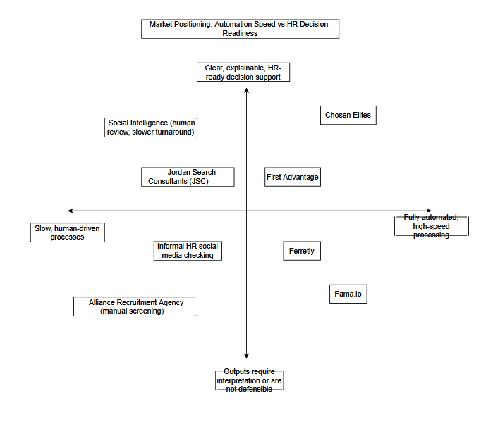
Create a positioning chart (e.g., price vs. quality or innovation vs. convenience) to visually show where your product or service stands in comparison to competitors.

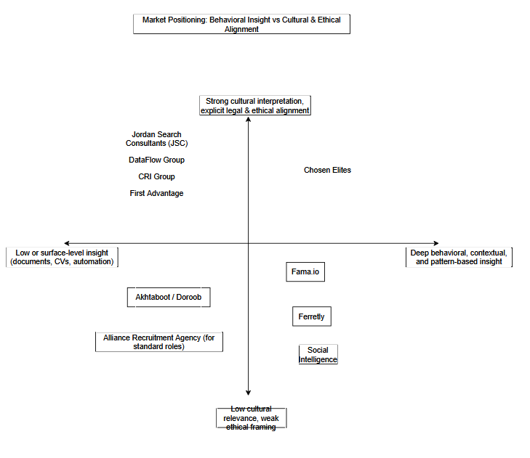

Explanation of the Positioning Maps

The two positioning maps were developed to visually represent Chosen Elites’ strategic position in relation to key competitors, based on the competitive benchmarking and user research findings presented earlier. The selected axes reflect the most critical decision factors for HR teams in medium-to-large organizations operating in Jordan: behavioral insight quality, cultural and ethical alignment, automation speed, and HR decision-readiness.
  - Depth of Behavioral Insight vs. Cultural & Ethical Alignment

The first positioning map compares competitors along two dimensions: Depth of Behavioral Insight (X-axis) and Cultural & Ethical Alignment (Y-axis). These dimensions were selected because HR professionals identified insight quality and ethical confidence as primary factors influencing adoption of background intelligence tools.

Competitors positioned in the lower-left quadrant (low insight, low alignment) primarily offer operational or surface-level hiring support, such as job-matching platforms or manual screening services, with limited behavioral analysis and minimal ethical framing. The lower-right quadrant (high insight, low alignment) includes technologically advanced OSINT and AI-based tools that analyze online behavior but lack Arabic-language interpretation, local cultural understanding, or explicit alignment with Jordan’s Personal Data Protection Law (PDPL).

The upper-left quadrant (low insight, high alignment) represents traditional HR consultancies and compliance-focused background-check providers. These services offer legitimacy, structured processes, and regulatory alignment, but rely mainly on interviews, references, or credential verification rather than analysis of real digital behavior.

Chosen Elites is positioned in the upper-right quadrant (high insight, high alignment), reflecting its unique ability to combine deep behavioral OSINT analysis with explicit PDPL compliance, human-in-the-loop validation, and localized cultural interpretation. This position highlights a clear gap in the market and demonstrates that Chosen Elites addresses an unmet need for ethically grounded, context-aware behavioral intelligence in HR decision-making.

  - Automation Speed vs. HR Decision-Readiness

The second positioning map evaluates competitors based on Automation Speed (X-axis) and HR Decision-Readiness (Y-axis). This map illustrates how different solutions balance efficiency with explainability and defensibility in hiring decisions.

Competitors in the lower-left quadrant (low speed, low decision-readiness) rely on manual or fragmented processes that are both slow and inconsistent. The lower-right quadrant (high speed, low decision-readiness) includes highly automated tools that deliver rapid results but often lack transparency, contextual explanation, or defensibility, increasing the risk of false positives and ethical concerns.

The upper-left quadrant (low speed, high decision-readiness) contains human-driven services that provide defensible outputs but require longer processing times, making them less scalable for organizations with frequent hiring needs.

Chosen Elites is positioned in the upper-right quadrant (balanced speed, high decision-readiness), reflecting its deliberate design choice to combine automation with human review. Rather than competing solely on speed, Chosen Elites prioritizes explainable, HR-ready insights that support confident and defensible hiring decisions. This balance ensures that efficiency does not come at the expense of fairness, transparency, or ethical responsibility.

Strategic Implications

Together, the two positioning maps demonstrate that Chosen Elites occupies a distinct and defensible strategic position within the competitive landscape. By prioritizing behavioral depth, ethical alignment, and decision confidence, Chosen Elites differentiates itself from both traditional HR services and fully automated screening tools. These positioning choices directly support the platform’s value proposition and reinforce its suitability for medium-to-large organizations seeking safer, more informed, and ethically sound hiring decisions.

Based on this analysis, explain how your product or service is positioned in the market.

Based on the comprehensive competitor benchmarking, score-based comparison, USP analysis, and perceptual positioning maps, Chosen Elites is positioned as a high-value, behavior-focused decision-support service for medium-to-large organizations in Jordan, occupying a distinct space between traditional HR services and fully automated global screening tools.

Unlike local recruitment agencies and HR consultancies, which primarily rely on interviews, references, and human judgment without structured behavioral intelligence, Chosen Elites positions itself as a behavioral intelligence layer that complements existing hiring processes. It does not compete on candidate sourcing or placement, but rather on risk-aware evaluation, helping organizations assess whether a candidate’s observable digital behavior aligns with professional, ethical, and cultural expectations.

At the same time, Chosen Elites is clearly differentiated from global background-check providers and emerging AI-based screening tools. While these solutions emphasize credential verification, automation speed, or AI-driven flagging, they often lack explainability, cultural relevance, and alignment with Jordan’s legal and regulatory environment. Chosen Elites deliberately avoids positioning itself as a low-cost or mass-market solution; instead, it adopts a value-based positioning, offering deep behavioral insight, human-in-the-loop validation, and PDPL-compliant workflows at a price point suitable for organizations with formal HR structures and higher hiring-risk exposure.

The positioning maps reinforce this strategic stance by placing Chosen Elites in the high behavioral insight / high ethical and cultural alignment quadrant, as well as the high HR decision-readiness / balanced automation quadrant. This reflects a conscious design choice: prioritizing explainability, defensibility, and trust over raw automation speed. As a result, Chosen Elites is positioned not as an automated decision-maker, but as a trusted decision-support partner for HR teams operating under accountability, reputational risk, and compliance constraints.

Overall, Chosen Elites is positioned as the first HR-oriented, PDPL-compliant, culturally localized behavioral intelligence service in Jordan, designed specifically for medium-to-large organizations that require confident, ethical, and well-documented hiring decisions. By bridging the gap between superficial CV-based screening and expensive, culturally misaligned global tools, Chosen Elites establishes a clear and defensible market position centered on safer hiring, reduced organizational risk, and improved decision quality.

Describe your marketing strategy using the four Ps:

Marketing Mix Element | Strategy Description | Purpose / Impact on Target Market
Product | Chosen Elites provides OSINT-based behavioral intelligence reports designed for HR and recruitment teams. Each report is human-reviewed, ethically compliant, and structured to support informed hiring decisions rather than automated judgment. | Helps organizations reduce hiring risk, gain behavioral insights beyond CVs and interviews, and make defensible, ethical hiring decisions.
Price | Pricing follows a cost-plus strategy. A single report is priced at USD 120. Subscription bundles are offered as: 10 reports for USD 800 (USD 80/report), 20 reports for USD 1,400 (USD 70/report), and 50 reports for USD 3,250 (USD 65/report). | Ensures financial sustainability while offering volume discounts that encourage repeat usage and long-term client relationships.
Place (Distribution) | Services are delivered digitally through a secure online workflow. Clients submit requests, receive reports, and communicate through protected digital channels. | Provides convenience, scalability, and confidentiality while ensuring data protection and ease of access for HR teams.
Promotion | Promotion relies on professional B2B channels such as LinkedIn outreach, direct engagement with HR departments, pilot programs, demonstrations, and educational content on ethical hiring and OSINT use. | Builds awareness and trust among decision-makers, positions the brand as a credible specialist, and supports long-term client engagement.

Justifications by Marketing Mix Element
- Product justification
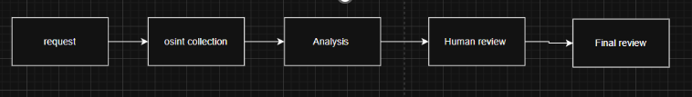
Chosen Elites is designed as a specialized decision-support service for HR and recruitment teams rather than a traditional screening or automated scoring tool. The product’s core value lies in transforming unstructured public online information into clear, structured, and ethically reviewed behavioral intelligence reports.
Unlike informal online background checks, Chosen Elites applies defined analytical criteria, human validation, and ethical boundaries. This ensures that insights are contextual, defensible, and relevant to professional decision-making. By complementing CVs and interviews, the service reduces blind spots in hiring while minimizing bias and legal risk. This differentiation positions Chosen Elites as a high-trust, professional HR intelligence solution rather than a generic data product.
2. Price – Justification (Cost-Plus Pricing Strategy) 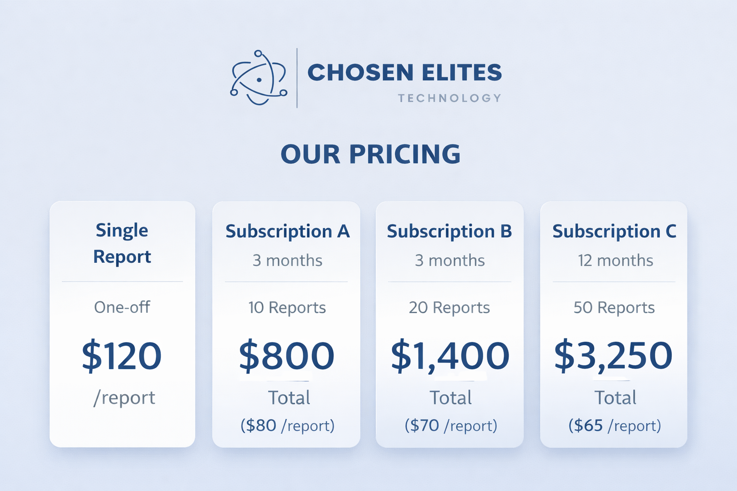
Chosen Elites applies a cost-plus pricing strategy, which is appropriate for a service where production costs are primarily driven by human analytical labor and ethical oversight.
Each report requires analyst time for case preparation, OSINT data collection, validation, ethical review, and structured report writing. The estimated variable cost per report is USD 50, based on conservative time-based costing. Pricing is then set by adding a margin that contributes toward fixed costs such as platform maintenance, OSINT tools, compliance, and business operations.
The tiered pricing structure serves multiple strategic objectives:
- The USD 120 single-report option lowers adoption barriers for new or smaller organizations.
- Subscription bundles reduce the average cost per report (USD 80, USD 70, and USD 65) by spreading fixed costs across predictable demand.
- Volume-based pricing encourages long-term engagement while preserving profitability.
This approach ensures transparency, aligns price with effort and value, and supports sustainable growth without underpricing a labor-intensive, trust-based service.
Pricing clarification paragraph (required):
The USD 120 single-report option is intentionally positioned as an entry-level service with a standardized scope, designed for small organizations or first-time users to test the platform. Subscription plans represent the primary revenue source and rely on predictable demand, standardized workflows, and operational efficiency, which reduces the average cost per report. Advanced analysis, deeper validation, and advisory services are offered separately and are not included in basic subscription packages. This tiered structure ensures pricing remains aligned with analytical effort, cost structure, and service quality.
Plan | Duration | Reports | Total Price (USD) | Price / Report | Gross Margin
Single report | One-off | 1 | 120 | 120 | 58%
Subscription A | 3 months | 10 | 800 | 80 | 37.5%
Subscription B | 3 months | 20 | 1,400 | 70 | 28.6%
Subscription C | 12 months | 50 | 3,250 | 65 | 23%

3. Place (Distribution) – Justification
Chosen Elites uses a fully digital distribution model, which is the most suitable approach for a knowledge-based, confidentiality-sensitive service. Clients submit requests, receive reports, and communicate through secure online channels without the need for physical locations or intermediaries.
This model ensures:
- Fast turnaround times
- Geographic flexibility
- Lower operational overhead
- Secure handling of sensitive information
Digital delivery also allows the service to scale efficiently while maintaining consistent quality and compliance standards. For HR teams, this ensures ease of access and seamless integration into existing recruitment workflows.

4. Promotion – Justification
The promotional strategy of Chosen Elites is intentionally professional, targeted, and credibility-focused, reflecting the sensitive nature of hiring and behavioral analysis services. Rather than mass advertising, promotion focuses on relationship-building and education.
Key promotional efforts include:
- LinkedIn outreach targeting HR managers, recruiters, and decision-makers
- Direct B2B communication and demonstrations
- Pilot programs to reduce adoption risk
- Educational content on ethical OSINT use and responsible hiring
This approach positions Chosen Elites as a trusted specialist rather than a sales-driven service provider. By emphasizing transparency, ethics, and professional value, promotion supports long-term client relationships and repeat usage rather than one-time transactions.
Overall Strategic Fit
Together, the Four Ps reinforce a coherent marketing strategy. The product delivers ethical professional value, pricing reflects real costs and effort, distribution ensures accessibility and security, and promotion builds trust within a conservative B2B market. This alignment strengthens Chosen Elites’ positioning as a credible and sustainable HR intelligence service.

Identify your expected business costs and revenues using realistic assumptions. Classify your costs as startup vs. operational and fixed vs. variable to clarify your financial structure.
Expected Business Costs
Chosen Elites is an online business digital service which generates a digital report of behavioral analytics via OSINT to assist in HR decision-making. Thus, the expenses of the company will be based on the construction and the functioning of the platform, the analytics, legal and ethical compliance, and attracting clients. The table below will show the anticipated expenditure as viewed by the company.
  - Platform and Technical Costs.
- Domain Purchase and Renewal: The purchase and renewal of a domain name on an annual basis costs a given sum of money to keep a professional name and get easy access to the service.

- Hosting/Cloud Hosting: The continued amount to maintain the operation of the site and platform to accept the clients, the control panel and reports with the server resources needed to store and operate the services.

- Platform or Prototype Development: The cost of developing or establishing the bare minimum system to receive requests, handle cases and provide reports. Development costs will also be incurred even when the development is in-house.

- Maintenance and Troubleshooting of the Platform: Continuous expenses to ensure stability of the platform, troubleshooting, and enhancement of the user experience according to the feedback.

- Secure Data and Report Storage: It is the cost of storing reports and case files in a well-organized and secure way with the capability of attaining them whenever they are needed.

- Security and Authorization Control Tools: Price of administration and environment that discourages any form of illegal access to reports, e.g. log in details, user rights, and safe sharing of results.

- OSINT Tool Subscriptions: Any commercial equipment used to gather and check publicly available information faster and more effectively.

- Sponsoring Analytics Services.
Expenses of analytics tools or services to summarize content, find patterns or organize results prior to human examination.

- Reporting and Document Generation Tools: Professional report tools cost (to create professional reports in the same format (consistent, reliable) (PDF templates, export, or an in-platform reporting interface).

- Environment and Prototyping Tools: Expenses on the operation of a pilot version of the platform and tools associated with the development and testing of prototypes when optimizing the process.

2) Human and Operational Costs
- Request Receiving and Case Preparation: Efforts and time on accepting requests by the clients, verifying the scope of analysis, availability of inputs as well as setting up the case on the system.

- Execution Time of the OSINT Analysis: The dedication in gathering and examining the digital public information concerning the case in context of the report.

- Human Review and Work Check Time: Time will be spent in terms of reviewing results, minimizing errors, and guaranteeing that conclusions are justifiable and founded on clear indicators.

- Quality and Coherence of Reports: Hard work to make sure every report has the same format, has clear descriptions and does not have ambiguous or unwarranted indications.

- Writing and formatting of reports in an HR friendly format: Time to transform results to a comprehensible format that should be understood by the HR with comments and provide a final, ready-to-use report.

- Customer Support and Communication: Efforts to answer questions posed by clients, describe the findings, and deal with any clarifications or follow-ups.

- Internal Co-ordination and Workflow Management Employees: time and resources to assign tasks and control implementation and deadline compliance.

- Training and standardization Need to set regular internal rules on what will be covered or not and interpretations of signals and the way to develop explanations to get repeatable results.

3) Legal Costs and Compliance
- Making Consent Procedures and Forms: Expense of formulating transparent consent forms and a system of collecting permission prior to carrying out the analysis.

- Revision of Privacy and Data Protection Compliance: Fee of a simple legal audit to make sure the working procedure is not against privacy requirements.

- Policy Writing and Updates: Writing and revising of Privacy Policy, Terms of Use, and Data Retention Policy as the product is developed.

- Assuring Ethical Boundaries and Scope of Analysis: Attempt to clarify what will be left out (private accounts, sensitive information) and see to it that the service offered is in the form of a decision support tool, rather than a computerized judgment.

- Safely Retaining and deleting Data: Expense of putting in place measures to store data just in time and then carefully destroy them.
  - Marketing and Relationship Building (B2B) Costs.
- Visual Identity Materials: Creating cohesive identity components (templates, designs, documents) that create customer trust.

- Creation of Professional Contents: Developing materials that justify the worth of the service, its ethical limits, and its application to help the HR make decisions.

- Outreach and Lead Building Campaigns: Expense of communicating with human resource departments, proposals, meetings/demos, and lead list.

- Presentation Materials and Sales: Developing presentations, summaries and sample reports to demonstrate the value proposition and steps.

- Activation and Usage Information Materials: Writing basic descriptions to make the customer know how the service works, eliminate confusion, and adopt it.

- Digital Direct Advertising: Professional advertisement to HR decision-makers in limited quantities.

  - General Operational Support Costs.
- Tools of Work Organization and Management: The work documentation and tasks organization and internal follow-up subscriptions and tools.

- Communication Tools: Professional interaction with clients through official e-mail, meetings, and customer support.

- Minor Administrative Operating Expenses: Invoicing systems, case management and in-house bookkeeping.
Expected Business Revenues
Chosen Elites generates revenue primarily through the delivery of OSINT-based behavioral intelligence reports to organizational clients as a B2B decision-support service. Revenue is realized through a hybrid structure that combines subscription bundles (multi-report packages) and individual report purchases, with pricing reflecting the expected analysis effort and report complexity. This supports a value-based strategy that prioritizes quality, ethical oversight, and trust-building over high-volume, low-cost delivery.

- Primary source of Revenue: Behavioral Intelligence Reports.
- Behavioral intelligence report sales to companies (company revenue)
Every report completed is a paid service to a company that wants to gain further understanding to help in a hire or a decision based on trust.

- Reports can be purchased either individually or through bundled subscription packages, enabling recurring revenue from repeat organizational use.

- Tiered Logic (Report-Based Pricing Structure).
The pricing structure of Chosen Elites is organized around usage-based packages rather than abstract report categories. This tiered approach reflects different organizational hiring needs, frequency of use, and demand predictability.Normal behavioral intelligence reports (company revenue)
- Single Report Package
Designed for trial use or limited hiring needs, allowing organizations to request individual OSINT-based behavioral intelligence reports on a pay-per-report basis.
- Subscription Bundles
Subscription packages are offered for organizations with recurring hiring cycles and ongoing decision-support needs. These bundles include predefined report volumes (10 reports per month, 20 reports per month, and 50 reports per year), providing cost efficiency, predictable budgeting, and continuity of analysis.

Higher-tier packages reflect broader analytical scope, additional cross-platform validation, and increased human review effort. This structure aligns revenue generation with actual service usage while supporting recurring, non-contractual revenue from organizational clients.
- Revenue Model
Chosen Elites operates under a client-based, service-oriented revenue model. Revenue is generated through the delivery of OSINT-based behavioral intelligence services to organizational clients, rather than through the sale of individual digital products or software licenses.

- Subscription-first service model
The primary revenue mechanism is based on subscription packages purchased by organizational clients. Each subscription grants access to a predefined number of behavioral intelligence reports over a given period, allowing predictable budgeting and recurring revenue.

- Pay-per-client logic
Clients pay for analytical service access rather than for standalone reports. Reports represent units of service delivery within the client relationship, not independent products.

- Supplementary pay-per-report usage
Individual report purchases are offered as a secondary option for trial usage or exceptional cases. These purchases primarily serve as an entry point for new clients or as add-ons for existing clients, rather than the core revenue stream.

- Revenue Logic and Assumptions.
- Value per analytical package is the primary revenue driver
Revenue generation is driven by the value of the analytical service delivered to organizational clients. While reports represent the unit of analytical output, pricing reflects the depth of analysis, ethical oversight, and decision-support value provided within each client package..

- Conservative demand assumptions
Revenue projections assume a limited number of organizational clients in the first year, each purchasing a small number of report packages. This aligns with conservative adoption behavior observed in B2B HR markets, where trust-building and procurement cycles require time.

- Alignment with market sizing assumptions (SAM and SOM)
Operating revenue is derived from a conservative adoption share of the Serviceable Obtainable Market (SOM). Additional revenue is generated through repeat purchases, package upgrades, and expanded usage by existing clients over time. These additional revenues do not alter the SOM calculation, but reflect increased client lifetime value within the obtained market share.

- Revenue Sustainability
- Repetition by organizational clients (company revenue)
Organizational clients may purchase analytical packages multiple times across different recruitment cycles and job positions. This creates recurring revenue driven by repeat organizational usage rather than one-time transactions.

- Scalability through standardization and tier differentiation (company revenue)
As internal analytical workflows become more standardized, Chosen Elites can increase throughput while maintaining analytical quality and ethical oversight. Tiered service levels allow revenue to scale in proportion to analytical depth and client needs.

Costs Categorization: Start up vs. Operational.
The cost of the business identified above is categorized in this section according to the timing of the occurrence in the business lifecycle. The startup costs cover the expense incurred before or at the commencement of the service whereas the operational costs are recurrent expenses that will be needed to operate the business on daily basis.
- Startup Costs
(One-time or pre-launch costs)
- Startup costs are the costs that are involved in the process of setting up of Chosen Elites during the initial stage before the entire operation of the service.

- Platform or Prototype Development.
Expenses to establish or have the minimum viable platform needed to take requests, process cases, and provide reports.

- Initial Domain Registration .
The price of acquiring the domain name at the establishment phase of creating a professional online presence.

- Preliminary Platform Environment and Prototyping Tools.
Costs associated with the creation of a testing or pilot environment and the tools applied in testing and refining the platform prior to launch.

- Preliminary Security and Authorization Configuration.
Expenses connected with the developing access control systems, authentication and role-based permissions on the launch level.

- Preliminary Legal and Policy Establishment.
Expenses involved in preparing necessary legal documents like privacy policies, terms of use and data retention policies, prior to the commencement of the operations.

- Preliminary Visual Materials and Branding.
Costs to develop basic branding components and templates of reports to be used at the beginning of the business.

- Operational Costs
(Ongoing costs)
- Recurrent expenses are called operational costs and are needed to maintain the platform, provide reports, and facilitate the continued work of the business.

- Hosting and Cloud Services
Continued expenses of hosting the platform, maintenance of servers, and availability of the system.

- Domain Renewal
The recurrent expenditure of registering the domain name to keep having continuous access to the service.

- Supporting and Maintaining a Platform.
Continued costs of updating the systems, fixing bugs and performance issues.

- Data and Report storage Security.
Expenses on the storage of case data and report formations in a safe place and in orderly access.

- OSINT Tool Subscriptions
Periodic subscription fees on software to be utilised in gathering and authenticating the publicly accessible data.

- Analysis and Supporting Analysis Services.
Recurrent expenses in analytical instruments or services that are applied to organize data and determine patterns.

- Reporting and Document Generation Tools.
Expenses that are incurred in the creation, exportation and formatting of professional reports.

- Human Review and Effort of Analysis.
The expenses involved in the current human intervention that was needed to analyze the data, make validations and assure quality.

- Request Management and Case Preparation.
Costs of planning of incoming requests, preparation of cases, and workflow.

- Customer Care and Customer Communication.
Expenses were associated with contact with the client, description of the results and subsequent communication.

- Continuing Legal and Compliance Activities.
Regular legal audits and complies with keep up to standard data protection and privacy requirement.

- Marketing and Relation Building Activities.
Continuous activities associated with professional outreach, content development, and establishment of a B2B relationship.

- General Operational Support Tools.
Productivity and communication and administrative support tools subscriptions.
Summary statement is, startup expenses form the base of the platform and make it possible to enter the market, whereas operational expenses ensure the further services delivery, the compliance, and the interaction with customers.

Costs Classifications: Fixed and Variable.
Under this section, the already identified business costs are categorized under how they behave relative to the level of business activity. The fixed costs will not change much irrespective of the number of reports generated, whereas the variable costs will vary with the amount of requests and amount of work to be done in the analytical process.
- Fixed Costs
Fixed costs are expenses that remain constant regardless of the number of organizational clients served, subscription packages sold, or behavioral intelligence reports delivered. These costs are required to keep Chosen Elites operational, secure, and compliant, and are incurred even in periods of low service activity or limited client demand.
In the context of Chosen Elites’ client-based, subscription-first service model, fixed costs support the availability and reliability of the platform rather than individual report production. As a result, they do not vary directly with the volume of analytical output.
Examples of fixed costs include:
• Domain Registration and Renewal
Costs associated with maintaining the company’s professional online presence, independent of service volume.
• Base Hosting and Cloud Infrastructure
Core hosting expenses required to keep the platform accessible and functional at all times.
• Core Platform Maintenance
Ongoing technical maintenance to ensure platform stability, security updates, and performance reliability.
• Security and Authorization Infrastructure
Fixed costs related to access control, authentication mechanisms, and role-based permissions.
• Base-Level Secure Data and Report Storage
Minimum storage capacity required to keep the platform operational, regardless of the number of reports generated.
• Legal, Compliance, and Policy Maintenance
Costs associated with maintaining privacy compliance, ethical guidelines, and legal documentation.
• General Operational Support Tools
Productivity, communication, and administrative tools necessary for day-to-day operations.
These fixed costs establish the foundational infrastructure that enables Chosen Elites to deliver its services and scale client activity without proportionally increasing overhead expenses.
- Variable Costs
Variable costs are expenses that change in proportion to the level of business activity.
For Chosen Elites, activity is reflected in the number of organizational clients served, packages sold, client requests received, and the volume and complexity of reports delivered. As service demand increases, variable costs rise due to higher analytical workload and increased operational effort.
Examples of variable (or usage-driven) costs include:

• Analyst labor, review, and quality assurance effort
Time-based costs that increase as more client cases are processed, analyzed, validated, and finalized into HR-ready reports.

• Request management and case preparation
Operational effort that grows with the number of incoming organizational requests and the complexity of each case.

• Report writing, formatting, and documentation
Additional effort required for each delivered report, including standardized formatting and preparation of final deliverables.

• Customer support and communication
Support workload increases as client inquiries, clarifications, and follow-up discussions increase.

• OSINT tools and subscriptions (semi-variable)
A base subscription component is treated as fixed (annual access), while additional usage, add-ons, or higher-intensity investigation needs may introduce variable components as service volume grows.
OSINT tool subscriptions are treated as fixed costs in Year 1, as usage does not exceed the contracted capacity.

• Supporting analytics and analysis services (usage-based where applicable)
Costs that may increase with higher data processing frequency and larger investigation workloads, depending on the chosen tool model.

• Incremental secure storage and processing
While a base storage level is fixed, additional report volume and retained case files may require extra storage capacity over time.

• Marketing and outreach activities (controllable variable)
Marketing spending can increase depending on growth targets and acquisition campaigns. It is variable because it is adjustable and may scale with business expansion rather than report volume alone.

Summary:
Fixed costs provide the stable infrastructure required to keep the platform operational and compliant, while variable costs increase as analytical workload and organizational client activity grows. This classification clarifies cost behavior and supports realistic break-even planning for a service-based startup.
Cost Classification Table

Cost | Start-up or Operational Cost | Fixed / Variable | Explanation / Justification
Domain Registration | Start-up | Fixed | One-time cost required to establish a professional digital presence prior to service launch.
Domain Renewal | Operational | Fixed | Annual recurring cost required to maintain continuous access to the platform regardless of business volume.
Platform / Prototype Development | Start-up | Fixed | One-time cost to build the minimum viable platform needed to receive requests, manage cases, and generate reports.
Platform Maintenance & Troubleshooting | Operational | Fixed | Ongoing technical maintenance to ensure platform stability and performance, independent of the number of reports.
Hosting / Cloud Hosting (Base) | Operational | Fixed | Core hosting infrastructure required to keep the platform operational at all times within planned first-year capacity.
Secure Data & Report Storage (Base Level) | Operational | Fixed | Baseline secure storage needed to retain reports and case data, regardless of report volume within expected limits.
Security & Authorization Control Tools | Start-up + Operational | Fixed | Initial configuration and ongoing maintenance of authentication, access control, and role-based permissions, not dependent on usage volume.
OSINT Tool Subscriptions | Operational | Fixed (Year 1) | Subscriptions are contracted at a fixed annual level in Year 1 and do not increase with report volume within planned operational capacity.
Analytics & Supporting Analysis Services | Operational | variable | Analytical tools are budgeted as virable subscriptions during the first year.
Reporting & Document Generation Tools | Operational | Fixed | Report generation tools are subscription-based and required regardless of the number of reports produced.
Environment & Prototyping Tools | Start-up | Fixed | Tools used during initial development, testing, and process optimization prior to full operational launch.
Request Receiving & Case Preparation | Operational | Variable | Effort increases proportionally with the number of client requests and cases handled.
Execution of OSINT Analysis | Operational | Variable | Analyst time varies directly with the number and complexity of reports produced.
Human Review & Quality Control | Operational | Variable | Human validation effort increases as more reports are generated, ensuring ethical and analytical quality.
Report Writing & Formatting | Operational | Variable | Each report requires additional time and effort to produce HR-ready outputs.
Customer Support & Communication | Operational | Variable | Client support workload grows with report volume and client interaction frequency.
Legal & Compliance Setup (Policies, Consent Forms) | Start-up | Fixed | One-time legal preparation required before operations begin.
Ongoing Legal & Compliance Updates | Operational | Fixed | Periodic compliance reviews and policy updates required regardless of service volume.
Visual Identity & Branding Materials | Start-up | Fixed | Initial branding and report template creation required to establish professional credibility.
Marketing & Outreach Activities | Operational | Variable | Spending varies depending on growth targets, outreach intensity, and client acquisition strategy.
Work Organization & Management Tools | Operational | Fixed | Subscription-based productivity and workflow tools used regardless of report volume.
Administrative & Invoicing Tools | Operational | Fixed | Core administrative systems required to manage finances and cases independent of activity level.

Develop a detailed and realistic startup budget that includes estimated costs for key business areas such as production, marketing, operations, staffing, and other relevant expenses.
Income Structure and Revenue Model – Chosen Elites
This section presents a clear and realistic explanation of how Chosen Elites generates income during its first year of operation. The income structure is designed to reflect the characteristics of an early-stage, B2B, service-based startup operating in the HR and recruitment sector in Jordan. All assumptions are conservative, internally consistent with the approved budget, and aligned with the project’s pricing strategy, cost structure, and Serviceable Obtainable Market (SOM).
Chosen Elites generates income primarily through the delivery of OSINT-based behavioral intelligence reports to organizational clients. Additional funding sources are included to ensure financial stability during the market entry and validation phase.
Overview of Income Sources (Year 1)
Income Source | Amount (USD)
Operating Revenue (Service Sales) | 16,000
Founder / Team Contribution | 4,000
Investor Funding | 10,000
Total Income | 30,000
This total income exceeds the planned first-year total cost of USD 26,100, allowing the business to operate sustainably and achieve a modest first-year surplus.

1. Operating Revenue – USD 16,000

Description
Operating revenue represents income generated directly from selling OSINT-based behavioral intelligence reports and report subscription packages to organizational clients. This is the core revenue stream of Chosen Elites and reflects actual service delivery rather than speculative income.

Basis of Estimation
The operating revenue is derived from a conservative assumption of capturing 3% of the Serviceable Obtainable Market (SOM).
- Assumed SOM (from market sizing analysis): USD 512,000
- Conservative capture rate: 3%
Operating Revenue = 512,000 × 3% = USD 16,000
This assumption is realistic for a first-year B2B HR service, where adoption is gradual due to trust, ethical review, and procurement cycles.

Operating Revenue Breakdown (Exactly USD 16,000)
Revenue Source | Units Sold (Year 1) | Price (USD) | Revenue (USD)
Single Reports | 10 reports | 120 | 1,200
Subscription A (10 reports / 3 months) | 10 subscriptions | 800 | 8,000
Subscription B (20 reports / 3 months) | 2 subscriptions | 1,400 | 2,800
Subscription C (50 reports / 12 months) | 1 subscription | 4,000 | 4,000
Total Operating Revenue | — | — | 16,000

Total Reports Delivered (Operating Revenue)
Revenue Source | Units | Reports per Unit | Total Reports
Single Reports | 10 | 1 | 10
Subscription A | 10 | 10 | 100
Subscription B | 2 | 20 | 40
Subscription C | 1 | 50 | 50
Total Reports Delivered | — | — | 200 reports
This confirms that the operating revenue is supported by a realistic production volume of 200 reports, which aligns exactly with the variable cost assumptions and staffing capacity.

Why This Operating Revenue Is Realistic
- B2B HR services typically scale gradually
- Organizations prefer trial usage and small subscriptions before committing
- Ethical and compliance considerations slow adoption but increase retention
- The mix of single reports and subscriptions reflects real HR purchasing behavior

2. Founder / Team Contribution – USD 4000

Description
The founder and core team contribution represents internal seed funding used to support early-stage operations. This amount demonstrates commitment to the project while remaining financially realistic and sustainable for the founding team.

Purpose
The contribution helps cover:
- Early operational gaps before revenues stabilize
- Part of OSINT tool subscriptions
- Initial workflow and compliance setup

Why It Is Appropriate
- Reflects realistic personal investment capacity
- Reduces reliance on external funding
- Strengthens financial credibility of the project
- Supports continuity during early months when revenue is received gradually
This contribution is not operating revenue and is clearly separated to avoid inflating business performance.
3. Investor Funding – USD 10,000

Description
Investor funding is included to support the business during its first year of market entry and validation. This funding recognizes that early-stage service businesses do not receive all revenues upfront and require cash-flow support to cover fixed costs.

Justification
- Total first-year costs: USD 26,100
- Founder contribution: USD 4,000
- Remaining operational exposure is covered partially by operating revenue and partially by investor funding
The USD 10,000 investment is:
- Modest and realistic for a pre-seed stage
- Aligned with actual cost requirements
- Sufficient to absorb early fixed costs such as tools, compliance, and infrastructure

Strategic Role of Investor Funding
- Stabilizes cash flow during early growth
- Prevents underpricing pressure
- Allows focus on service quality and ethics
- Avoids over-reliance on aggressive sales assumptions
Income vs. Cost Summary
Item | Amount (USD)
Total Income | 30,000
Total Costs | 26,100
Year 1 Surplus | 3,900
This confirms that Chosen Elites is financially sustainable and profitable in Year 1, even under conservative assumptions.
Conclusion
The income structure of Chosen Elites is intentionally conservative, transparent, and aligned with real B2B HR purchasing behavior. Operating revenue is grounded in market sizing and supported by a realistic mix of report sales and subscriptions. Founder contribution and investor funding ensure financial stability during early operations without inflating revenue assumptions.
Together, these income sources create a balanced and credible financial model that supports ethical service delivery, controlled growth, and long-term sustainability.

Overview of Operating Expenses
Chosen Elites operates as a lean, digital service provider with no physical office and no full-time employees during its first year. Accordingly, operating expenses primarily reflect:
- Human analytical effort
- Specialized digital tools
- Basic technical infrastructure
- Client engagement activities
- Legal and ethical compliance requirements
This structure aligns with early-stage startup operating models commonly adopted by digital service companies in Jordan.
Salaries / Wages (Founding Team – Part-Time) – 0$
Rent (Remote / Home Office) – USD 0
No rental costs are incurred during the first year, as operations are conducted entirely through remote work. This approach minimizes fixed costs while maintaining operational efficiency and is widely adopted by digital startups during early market entry.
Postage – USD 100
This item covers limited physical mailing requirements, such as occasional document delivery or official correspondence. The low allocation reflects the project’s reliance on digital communication channels.
Travel Expense (Client Meetings) – USD 1,000
This cost covers local transportation expenses related to:
- In-person meetings with HR departments
- Pilot program discussions
- Trust-building engagements with organizational clients
In the Jordanian B2B context, face-to-face meetings remain important, particularly for sensitive services related to hiring and risk evaluation. The allocated amount reflects limited domestic travel only.

Marketing Expense (B2B Outreach & Ads) – USD 1,200
Marketing expenses support targeted B2B outreach activities, including:
- LinkedIn-based professional advertising
- Preparation of presentation and demonstration materials
- Limited participation in HR-related events
The marketing strategy prioritizes credibility and relationship-based engagement over mass advertising.
Depreciation Value – USD 200
This item represents the depreciation of basic equipment such as laptops and storage devices used in operations. It reflects a conservative accounting treatment rather than a cash expense.
Taxes & Licenses – USD 300
This expense covers basic registration, licensing, and administrative fees required to operate legally within Jordan. The amount reflects limited first-year compliance requirements.
Research & Development (Process Improvement) – USD 600
This cost supports internal process refinement, including:
- Improving analytical workflows
- Standardizing report structures
- Enhancing clarity and consistency of behavioral indicators
- Refining PDPL-compliant consent and review processes
Accounting & Legal – USD 500
This item covers basic accounting and legal support, including financial record organization, contract review, and compliance-related consultation. The amount reflects limited, as-needed professional services.
Office Supplies – USD 150
This cost includes basic administrative supplies such as printing, documentation materials, and minor office-related items, appropriate for a remote operating model.

Web Hosting & Domains – USD 300
This expense covers website hosting, domain registration, SSL certificates, and secure access infrastructure required to deliver reports and maintain the digital presence of the company.
Utilities – USD 0
No utilities are recorded, as the company does not maintain a physical office during the first year.
Employee Health Insurance – USD 500
A limited health insurance allocation is included to cover basic insurance needs for the core team members involved in the project during the first year. Although there are no full-time employees, this amount reflects a minimal and conservative provision for contributors actively working on the project and supports responsible and sustainable operations.
Maintenance and Repairs – USD 200
This item represents a small contingency for equipment maintenance, technical repairs, or replacement of minor operational tools.
Interest Expense – USD 0
No interest expenses are incurred, as the company does not rely on loans or debt financing during the first year.
Payroll Expenses – Included Above
All payroll-related costs are included within the salaries and wages category to avoid double counting.
Insurance – USD 150
This expense provides basic professional liability coverage appropriate for a decision-support service that delivers analytical reports to organizational clients.
Dues and Other Subscriptions (OSINT Tools) – USD 8,000
This item represents annual subscriptions to professional OSINT and analytical tools required to deliver accurate, verifiable, and ethically compliant behavioral intelligence reports.
Rather than relying on a single platform, the project utilizes a bundle of specialized tools, including:
- OSINT investigation and advanced search tools
- Identity verification and cross-checking platforms
- Digital footprint monitoring solutions
- Secure evidence storage and archiving systems
- Professional communication and reporting tools

Variable Cost per Report – Detailed Calculation (Method A)
To support accurate break-even, pricing, and profitability analysis, the variable cost per report was calculated using a time-based costing method. Only costs that increase directly with each additional report delivered are included as variable costs. All other operational expenses are treated as fixed within the planned first-year capacity.

Analyst Labor per Report
Activity | Hours per report
Case intake & preparation | 0.5
OSINT data collection | 2.0
Validation & ethical review | 1.0
Report writing & formatting | 1.0
Total analyst hours | 4.5 hours
Assumed conservative hourly rate ( analyst, part-time): USD 10/hour
Analyst labor cost per report
= 4.5 × 10
= USD 45

Customer Support & Follow-ups per Report
Activity | Hours per report
Client clarifications & communication | 0.5
Customer support cost per report
= 0.5 × 10
= USD 5

Total Variable Cost per Report
Variable cost per report
= Analyst labor (45) + Customer support (5)
= USD 50 per report
This variable cost is used for pricing, contribution margin, and break-even calculations.

Tool Bundle Structure
The OSINT tools cost was estimated based on a core operational bundle (Professional level – not Enterprise), as outlined below:
1. OSINT Investigation & Advanced Search Tools
Advanced search and data-linking tools across multiple platforms (social media, web sources, and public records).
Purpose: Collecting initial evidence and linking digital accounts and behavioral patterns.
Estimated Annual Cost: USD 2,500
2. Verification & Identity Cross-Checking Tools
Tools used to verify identities, validate information, and cross-check digital accounts.
Purpose: Reducing false positives and improving the overall accuracy and reliability of reports.
Estimated Annual Cost: USD 1,500
3. Monitoring & Digital Footprint Analysis Tools
Tools that monitor digital presence and behavioral patterns over time.
Purpose: Analyzing behavioral trends and longitudinal digital footprint evolution rather than static snapshots.
Estimated Annual Cost: USD 1,200
4. Secure Storage & Evidence Archiving
Encrypted storage solutions for reports and digital evidence.
Purpose: Legal compliance, structured documentation, and the ability to retrieve evidence when required.
Estimated Annual Cost: USD 1,000
5. Professional Email & Secure Communication Tools
Encrypted professional email services, secure file-sharing tools, and client communication platforms.
Purpose: Ensuring secure and professional communication and report delivery.
Estimated Annual Cost: USD 800
6. Reporting, Documentation & Case Management Tools
Tools used for report formatting, standardized templates, and case management.
Purpose: Converting analytical findings into clear, structured, and HR-ready reports.
Estimated Annual Cost: USD 1,000

Total OSINT Tools Cost
USD 2,500 + 1,500 + 1,200 + 1,000 + 800 + 1,000 = USD 8,000 per year
This bundled approach reflects standard professional OSINT practice and ensures analytical quality, accuracy, and compliance.
Other Operating Expenses (Contingency) –
USD 1,000
This category represents a contingency buffer for minor, unforeseen operational costs that may arise during market entry, such as additional tools, platform fees, or compliance-related adjustments.
Summary of Operating Expenses
The total operating expenses of USD 23,700 reflect a lean, digitally driven, and human-centered operating model. The expense structure prioritizes analytical quality, ethical compliance, and operational sustainability while avoiding unnecessary fixed costs. This approach is appropriate for an early-stage startup entering the Jordanian B2B market.
Start-Up Expenses – Explanation
Start-up expenses represent the one-time, non-recurring costs required to prepare and launch the Chosen Elites service. These expenses are incurred before or at the initial launch stage and are necessary to establish the technical, legal, and professional foundation of the business.
All start-up costs were estimated conservatively and realistically, reflecting the nature of Chosen Elites as a digital, remote-first B2B service operating in Jordan.
1. Furniture – USD 0
Justification
No budget was allocated for furniture, as the project operates under a remote-first model with no physical office during the initial stage. Existing home-office setups are used instead.
This approach aligns with common early-stage startup practices in Jordan, where physical office costs are deferred until market validation is achieved.
2. Equipment – USD 400
Intended Use
This cost covers essential technical equipment such as:
- Basic work accessories
- Additional screens or storage tools
- Minimal hardware improvements required for OSINT analysis and report preparation
Estimation Basis
The amount reflects minimal, essential equipment purchases rather than heavy upfront investment.
3. Software – USD 700
Intended Use
This category includes:
- Basic productivity software
- Report writing and documentation tools
- Workflow organization tools
- Initial licenses for non-specialized software
Rationale
These tools are required to establish the initial operational environment and are distinct from ongoing OSINT tool subscriptions.
4. Branding & Report Templates – USD 500
Intended Use
This cost supports:
- Basic brand identity development
- Professional HR-focused report templates
- Consistent visual presentation of reports
Rationale
As Chosen Elites delivers decision-support reports used in sensitive hiring contexts, professional report presentation is a functional necessity rather than a cosmetic choice.
5. Legal & Policy Setup (PDPL, Consent Forms) – USD 500
Intended Use
This expense covers:
- Privacy policy preparation
- Consent form development
- Data retention and deletion policies
- Alignment with Jordan’s Personal Data Protection Law (PDPL)
Rationale
Legal compliance is a core component of the project’s value proposition, particularly due to the sensitive nature of OSINT-based services.
6. Other Start-Up Expenses – USD 300
Intended Use
This category accounts for:
- Minor unforeseen setup costs
- Administrative fees
- Supporting tools required during the launch phase
Rationale
Including a contingency buffer is a standard financial planning practice for early-stage startups.
Sub-Total Start-Up Expenses – USD 2,400
This total represents a minimal yet sufficient investment required to launch the project responsibly, without overburdening the initial budget while maintaining operational and legal readiness.

FINANCIAL BUDGET
Company Name: | Chosen Elites | Company Location: | Jordan
Income: | $ 30000 | Budgeted Date: | 2026/1/6
Expenses: | $26,100 | Balance: | $ 3900
Income List | Budget | Actual | Difference
Operating Revenue  (Based on 3% Market Share of SOM) | 16,000 | - | 16,000
Founder / Team Contribution  (Seed Funding) | 4000 | - | 4000
Investors | 10,000 | - | 10,000
Rental Income | 0 | - | 0.00
Interest Income | 0 | - | 0.00
Other | 0 | - | 0.00
Total Income | $30000 | $0.00 | $30000
Expense List | Budget | Actual | Difference
OPERATING EXPENSES
Salaries / Wages (  Analysts – per report)  Variable cost per report = $50, Expected reports in Year 1 = 200, Total variable production cost (Year 1) = $50 × 200 = $10,000 | 10,000 | - | $0.00
Rent (Remote / Home office) | 0 | - | $0.00
Postage | 100 | - | $0.00
Travel Expense (Client meetings) | 1000 | - | $0.00
Marketing Expense  (B2B outreach & ads) | 1,200 | - | $0.00
Depreciation Value | 200 | - | $0.00
Taxes & Licenses | 300 | - | $0.00
Research & Development  (Process improvement) | 600 | - | $0.00
Accounting & Legal | 500 | - | $0.00
Office Supplies | 150 | - | $0.00
Web Hosting & Domains | 300 | - | $0.00
Utilities | 0 | - | $0.00
Employee Health Insurance | 500 | - | $0.00
Maintenance and Repairs | 200 | - | $0.00
Interest Expense | 0 | - | $0.00
Payroll Expenses | Included above | - | $0.00
Insurance | 150 | - | $0.00
Dues and Other Subscriptions  (OSINT tools) | 8,000 | - | $0.00
Other | 500 | - | $0.00
`Sub-Total Expense | $23,700 | $0.00 | $23,700
Start-Up EXPENSES
Furniture | 0 | - | $0.00
Equipment | 400 | - | $0.00
Software | 700 | - | $0.00
Branding & Report Templates | 500 | - | $0.00
Legal & Policy Setup  (PDPL, consent forms) | 500 | -
Other Expenses | 300 | - | $0.00
Sub-Total Expense | $2,400 | $0.00 | $0.00
Total Expense | $ 26,100 | $ | $ 26,100

Clearly explain how your business will generate income. Describe your revenue streams and model to show how your startup will sustain profitability.

Revenue Streams and Revenue Model
How the Business Generates Income
Chosen Elites generates income through a B2B, service-based revenue model focused on delivering OSINT-based behavioral intelligence reports to organizations. The service supports ethical and informed hiring decisions by providing structured, human-reviewed insights derived from publicly available information.
Revenue is generated only when analytical services are delivered to client organizations. The business does not rely on advertising, data resale, or licensing. Instead, income is directly tied to professional analytical effort, ethical review, and report delivery. This ensures that revenue growth remains aligned with service quality, compliance requirements, and operational capacity.
Revenue Stream | Description | Target Customer Segment | Pricing Model | Frequency
Single Report Sales | One-off OSINT-based behavioral intelligence reports delivered for specific hiring or risk-evaluation cases | Small and medium organizations, first-time clients | Pay-per-report (USD 120 per report) | Occasional
Subscription A (10 Reports) | Bundled reports for organizations with short-term or moderate hiring needs | Medium organizations / HR teams | Subscription (USD 800 for 10 reports / 3 months) | Recurring
Subscription B (20 Reports) | Larger bundle for organizations with recurring recruitment cycles | Medium to large organizations | Subscription (USD 1,400 for 20 reports / 3 months) | Recurring
Subscription C (50 Reports) | Annual high-volume package for organizations with sustained hiring activity | Large organizations / enterprises | Subscription (USD 3,250 for 50 reports / 12 months) | Recurring
Justification of Revenue Streams

1. Single Report Sales
Single-report sales are included to reduce adoption barriers for new or smaller organizations. This option allows HR teams to test the service or address urgent hiring needs without committing to a subscription. The higher per-report price reflects the full analytical effort and ethical review required for each report. While not the primary revenue driver, this stream supports client acquisition and trust-building.

2. Subscription-Based Revenue (Primary Revenue Source)
Subscription packages represent the core operating revenue of Chosen Elites. Organizations typically make multiple hiring decisions throughout the year, making bundled reports more practical and cost-efficient. Subscriptions provide predictable demand, improve workflow planning, and allow the business to optimize analytical capacity while maintaining quality and compliance.
The tiered structure (10, 20, and 50 reports) reflects different organizational sizes and hiring intensities, ensuring flexibility without fragmenting the service offering.

3.Cost-Plus Pricing Logic
Pricing is designed using a cost-plus strategy, where each report price accounts for:
- Human analyst time
- Ethical and quality review
- OSINT tool usage
- Operational overhead
Higher-volume subscriptions benefit from lower average prices per report due to standardized workflows and reduced administrative overhead, while still maintaining positive margins.

Revenue Model Description
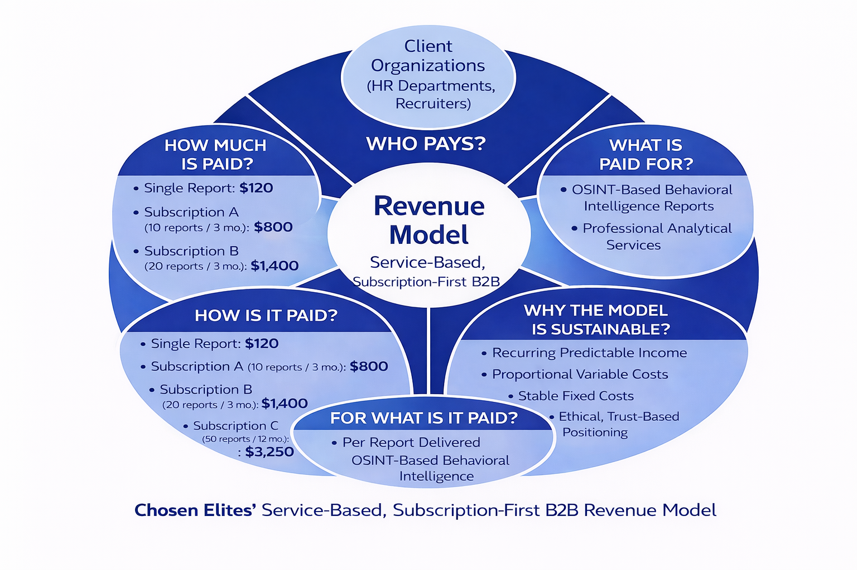
Chosen Elites operates under a service-based, subscription-first B2B revenue model designed to generate sustainable income from ethical, human-reviewed OSINT services that support organizational hiring decisions. The model balances flexibility for clients with predictable revenue for the business, while maintaining alignment between pricing, analytical effort, and cost structure.
Who Pays?
The paying customers are client organizations, specifically HR departments, recruiters, and hiring decision-makers within medium and large companies.
Payments are made at the organizational level because the service directly supports corporate hiring processes, risk mitigation, and compliance responsibilities.
Individuals are not charged directly, ensuring the service remains positioned as a professional decision-support tool rather than a consumer product.

What Is Paid For?
Clients pay for OSINT-based behavioral intelligence reports and related professional analytical services.
Each paid unit represents a completed analytical service that includes:
- Systematic OSINT data collection
- Behavioral pattern assessment
- Ethical scope control
- Human validation and quality review
- HR-ready reporting and interpretation
The payment reflects professional expertise, time investment, and ethical oversight, not automated outputs.

How Is It Paid?
Revenue is generated through a hybrid payment structure, combining:
- Pay-per-report purchases for occasional or trial usage
- Prepaid subscription bundles (10, 20, or 50 reports) for organizations with recurring hiring needs
Subscriptions are prepaid and time-bound, providing upfront cash flow while allowing organizations to plan usage across hiring cycles.

For What Is It Paid?
Payment is made per completed report or prepaid report bundle, not for platform access alone.
This ensures revenue is directly tied to delivered analytical value, reinforcing transparency and fairness in pricing.
Advanced or extended analytical services are offered separately and are not bundled into basic subscription packages, preserving clarity between standard and premium services.

How Much Is Paid?
Pricing follows a cost-plus pricing strategy, based on the actual cost of delivering a report plus a justified markup that supports sustainability.
- Single report: USD 120
- Subscription A (10 reports / 3 months): USD 800
- Subscription B (20 reports / 3 months): USD 1,400
- Subscription C (50 reports / 12 months): USD 3,250
The average price per report decreases with volume, reflecting operational efficiencies while maintaining positive contribution margins.

How the Model Scales
Revenue scales with report volume and subscription adoption, while most fixed costs—such as OSINT tools, hosting, compliance, and platform maintenance—remain stable within planned capacity.
This structure allows additional reports delivered under subscriptions to contribute more efficiently toward covering fixed costs and improving profitability.

Why the Revenue Model Is Sustainable
The sustainability of the model is supported by:
- Recurring subscription usage, which creates predictable income
- Variable costs that scale proportionally with output
- Stable fixed costs, absorbed as volume increases
- Ethical, human-reviewed positioning, which supports trust and long-term client retention
- Controlled growth, avoiding reliance on high-volume, low-cost automation
Profitability is achieved through repeat organizational usage, disciplined pricing, and operational efficiency, rather than aggressive market capture or unrealistic volume assumptions.

Summary
Chosen Elites generates income through a clearly defined set of revenue streams centered on OSINT-based behavioral intelligence reports delivered to organizations. Subscription packages form the primary operating revenue, supported by single-report sales for flexibility and market entry. The revenue model is service-driven, scalable, and aligned with ethical, human-centered analysis, ensuring both financial sustainability and long-term credibility.

Perform a break-even analysis using both a graphical and a numerical calculation. Identify and present the point at which total revenues equal total costs, indicating when your business is expected to become profitable.
Break-Even Analysis (Numerical and Graphical)
The break-even analysis was conducted to determine the point at which Chosen Elites’ total revenue equals its total costs, indicating when the business transitions from loss-making operations to financial sustainability. The analysis uses the finalized first-year cost base, the updated pricing structure (single report + subscription bundles), and a realistic cost classification where production-related effort is treated as variable per report.

1) Cost and Pricing Assumptions (Year 1)
Fixed Costs (FC):
Total fixed operating costs were taken from the first-year budget as USD 16,100, excluding variable analyst labor and one-time start-up costs.
Variable Cost per Report (VC):
Variable cost is the cost that increases directly with the number of reports produced. Based on the business operating model, the variable cost per report is estimated at USD 50 per report, representing analyst time and customer support effort required to deliver each OSINT behavioral intelligence report.
Pricing Structure:
Chosen Elites sells reports through:
- Single report (one-off): USD 120 per report
- Subscription A (10 reports): USD 800 → USD 80 per report
- Subscription B (20 reports): USD 1,400 → USD 70 per report
- Subscription C (50 reports): USD 3,250 → USD 65 per report

2) Sales Mix and Weighted Average Price per Report
Because the company offers multiple pricing plans, a sales mix is required to calculate a realistic average selling price per report. A conservative and realistic early-stage B2B mix was assumed:
- 20% of reports sold as Single reports
- 30% of reports sold through Subscription A
- 30% of reports sold through Subscription B
- 20% of reports sold through Subscription C
Using this mix, the weighted average selling price per report is:
$$P_{avg}=(0.2×120)+(0.3×80)+(0.3×70)+(0.2×65)=82$$
So, the average revenue generated per report is USD 82 per report.

3) Contribution Margin per Report
$$CM=P_{avg}-VC=82-50=32$$
Thus, the contribution margin is USD 32 per report, meaning each report contributes $32 toward covering fixed costs after variable production costs are paid.

4) Break-Even Point (Reports)
The break-even point in reports is calculated using:
$$BEP_{reports}=\frac{FC}{CM}=\frac{16,100}{32}≈503.1$$
Rounded up, the break-even point is:
(BEP ≈ 504 reports)
This means Chosen Elites must deliver approximately 504 reports for total revenue from reports to fully cover total fixed costs, after accounting for variable production costs.

5) Break-Even Revenue (Sales Dollars)
Break-even revenue is:
$$BEP_{sales}=504×82=41,328$$
So break-even occurs at approximately:
(USD 41,328 in sales)
  - Graphical Break-Even Interpretation

The break-even chart visualizes:
- Fixed Cost as a horizontal line at USD 16,100
- Total Cost increasing with volume (Fixed Cost + 50 × Reports)
- Revenue increasing with volume (82 × Reports)
The intersection of the Revenue line and Total Cost line occurs at approximately 504 reports, confirming the numerical break-even result.

Break-Even Summary
In summary, using a realistic sales mix across the company’s pricing plans, Chosen Elites achieves a weighted average selling price of USD 82 per report and a contribution margin of USD 32 per report after variable costs. Based on correctly classified annual fixed costs of USD 16,100, the business reaches break-even at approximately 504 reports, corresponding to around USD 41,328 in revenue.
Given the current operational plan to deliver 200 reports in Year 1, the business intentionally operates below break-even during the first year, with the shortfall covered through founder contributions and external investment. Break-even is expected to be achieved in Year 2, driven by reduced variable costs and increased production efficiency.

Year 2 Cost Optimization and Margin Expansion Through AI-Assisted Analysis
Strategic Rationale
During Year 1, Chosen Elites intentionally operates with a fully human-centered analytical model to:
- Build trust with organizational clients
- Validate analytical quality and ethical boundaries
- Accumulate a structured dataset of human-produced, ethically reviewed OSINT reports
This first-year dataset forms a high-quality training foundation for internal AI-assisted analysis tools. Because the reports are:
- standardized,
- human-reviewed,
- ethically scoped,
they provide an ideal supervised learning base.
As a result, in Year 2, Chosen Elites transitions to a hybrid AI + human-in-the-loop model, where AI supports repetitive analytical tasks while humans retain final judgment and ethical oversight.
Year 1 vs Year 2 Variable Cost Structure
Year 1 Variable Cost per Report (Baseline – Human-Centered)
Analyst Labor
- Total analyst time per report: 4.5 hours
- Hourly rate (conservative, part-time): USD 10/hour
$$\text{Analyst labor cost}=4.5×10=USD 45$$
Customer Support
- Support & clarifications: 0.5 hours
- Hourly rate: USD 10/hour
$$\text{Support cost}=0.5×10=USD 5$$
Total Variable Cost (Year 1):
$$VC_{Y1}=45+5=\boxed{USD 50 per report}$$

Year 2 Variable Cost per Report (AI-Assisted Model)
Assumption (Explicit and Justified)
By integrating AI trained on Year-1 human reports, 70% of analyst labor time is automated, while:
- final review,
- ethical validation,
- contextual judgment
remain human-controlled.
This ensures quality, explainability, and trust are preserved
Reduction in Analyst Hours
Component | Year 1 | Year 2
Analyst hours per report | 4.5 hrs | 1.35 hrs
Reduction | — | 70%
$$4.5×(1-0.70)=1.35\text{ hours}$$

Year 2 Analyst Cost per Report
$${\text{Analyst cost}}_{Y2}=1.35×10=USD 13.5$$
Customer support remains unchanged (human trust requirement):
$$\text{Support cost}=USD 5$$
Total Variable Cost per Report (Year 2)
$$VC_{Y2}=13.5+5=\boxed{USD 18.5 per report}$$
This represents a 63% reduction in total variable cost per report:
$$\frac{50-18.5}{50}=63\%$$
Profit Margin Impact (Before vs After AI Integration)
Using the same pricing structure (no price inflation):
Plan | Price / Report | Margin (Year 1) | Margin (Year 2)
Single report | 120 | 120 − 50 = 70 | 120 − 18.5 = 101.5
Subscription A | 80 | 30 | 61.5
Subscription B | 70 | 20 | 51.5
Subscription C | 65 | 15 | 46.5

Margin Percentage Improvement
Plan | Margin % (Y1) | Margin % (Y2)
Single report | 58% | 84.6%
Subscription A | 37.5% | 76.9%
Subscription B | 28.6% | 73.6%
Subscription C | 23% | 71.5%

Strategic Implications for Year 2
- Reports become strongly profitable
  - Even the lowest-priced subscription generates >70% gross margin
- Break-even volume drops dramatically
  - Contribution margin increases sharply
  - Fixed costs are covered at far lower output levels
- Trust-driven AI adoption
  - AI is trained on your own ethical data
  - Clients experience continuity, not disruption
- Scalability without quality loss
  - Higher report volume
  - Stable human oversight
  - Stronger financial resilience

Integration with Break-Even Logic
While Year 1 intentionally operates below break-even to establish credibility and market trust, Year 2 benefits directly from this strategy by:
- reducing variable cost per report by over 60%,
- transforming subscriptions into high-margin revenue streams, and
- enabling profitability driven by both scale and efficiency rather than price inflation.
This staged approach reflects realistic startup behavior and supports long-term financial sustainability.

Prepare a projected income statement showing your expected revenues, costs, and profits over a defined period (e.g., 12 months). This should provide a clear picture of your startup’s financial performance and growth potential.

Month | No. of Reports | Total Revenue | Direct COGS | Gross Profit | Operating Expenses | Operating Profit | Interest + Tax | Net Profit
Jan | 10 | 800 | 500 | 300 | 1,341 | -1,041 | 0 | -1,041
Feb | 12 | 960 | 600 | 360 | 1,341 | -981 | 0 | -981
Mar | 14 | 1,120 | 700 | 420 | 1,341 | -921 | 0 | -921
Apr | 16 | 1,280 | 800 | 480 | 1,341 | -861 | 0 | -861
May | 18 | 1,440 | 900 | 540 | 1,342 | -802 | 0 | -802
Jun | 20 | 1,600 | 1,000 | 600 | 1,342 | -742 | 0 | -742
Jul | 22 | 1,760 | 1,100 | 660 | 1,342 | -682 | 0 | -682
Aug | 20 | 1,600 | 1,000 | 600 | 1,342 | -742 | 0 | -742
Sep | 18 | 1,440 | 900 | 540 | 1,342 | -802 | 0 | -802
Oct | 17 | 1,360 | 850 | 510 | 1,342 | -832 | 0 | -832
Nov | 16 | 1,280 | 800 | 480 | 1,342 | -862 | 0 | -862
Dec | 17 | 1,360 | 850 | 510 | 1,342 | -832 | 0 | -832
TOTAL | 200 | 16,000 | 10,000 | 6,000 | 16,100 | -10,100 | 0 | -10,100

The projected 12-month income statement reflects a conservative first-year rollout strategy for Chosen Elites, with revenues derived exclusively from customer-generated operating and value-added services. Revenue increases gradually over the year as market awareness grows and trust is established among B2B clients. Early months show lower revenues as the company focuses on pilot engagements, client onboarding, and service validation, while later months reflect increased demand driven by repeat usage, subscription adoption, and additional service requests by organizational clients.
The income statement is developed by aligning the startup’s revenue model, cost structure, and market assumptions established in Parts 5–8 of the analysis. Monthly revenue projections reflect realistic B2B adoption behavior, where procurement cycles and trust-building require time. Initial revenues are therefore modest, corresponding to pilot and early-adopter engagements, while later months demonstrate stronger and more stable income as credibility and client relationships mature.
Average Price per Report Calculation
Because Chosen Elites offers multiple pricing plans with different report volumes, the average price per report cannot be calculated using a simple arithmetic mean. Instead, a weighted average price is required, based on the expected sales mix across pricing plans.
The average price per report is calculated using the following formula:
Average Price per Report = Total Revenue from Reports ÷ Total Number of Reports Sold
This calculation requires a clear assumption regarding the distribution of report sales across pricing plans.
For Year 1, a realistic and conservative B2B sales mix is assumed, reflecting early adoption behavior among HR teams while allowing for trial usage:
- Single reports: 20% of total reports
- Subscription A (10 reports): 30% of total reports
- Subscription B (20 reports): 30% of total reports
- Subscription C (50 reports): 20% of total reports
Using this sales mix and the established pricing structure, the weighted average price per report is calculated as follows:
$$P_{avg}=(0.20×120)+(0.30×80)+(0.30×70)+(0.20×65) \\ P_{avg}=24+24+21+13=\text{USD 82 per report}$$
Accordingly, USD 82 per report represents the correct weighted average selling price under the stated assumptions. This value is used in break-even analysis, contribution margin calculations, and market sizing estimates to ensure internal consistency and realistic financial planning, but for more even numbers and to avoid fractions the average price is set to be 80$ .
Column Definitions and Calculations
Revenue
Revenue represents income earned from delivering OSINT-based behavioral intelligence reports and related services to clients.
$$\text{Revenue}=\text{Number of reports delivered}×\text{Average price per report}$$
Direct Costs (COGS)
Cost of Goods Sold (COGS) represents variable costs directly linked to report production, primarily analyst labor and client support effort.
$$\text{COGS}=\text{Number of reports delivered}×\text{Variable cost per report}$$
Gross Profit
Gross profit measures the contribution generated after covering variable production costs.
$$\text{Gross Profit}=\text{Revenue}-\text{COGS}$$
Operating Expenses
Operating expenses consist of fixed costs required to operate the business, including platform infrastructure, OSINT tool subscriptions, marketing baseline activities, legal and compliance costs, and administrative support. These expenses remain relatively stable across the year.
$$\text{Operating Expenses}=\text{Monthly share of annual fixed operating costs}$$
Operating Profit
Operating profit indicates profitability from core business operations before tax.
$$\text{Operating Profit}=\text{Gross Profit}-\text{Operating Expenses}$$
Interest Expense
Interest expense is zero, as the business does not rely on debt financing during the first year.
Tax
Tax is applied only in months where operating profit is positive, in line with Jordanian corporate tax regulations.
$$\text{Tax}=\text{Operating Profit}×20\%(\text{if Operating Profit}>0)$$
Net Profit
Net profit represents the final profit or loss after tax.
$$\text{Net Profit}=\text{Operating Profit}-\text{Tax}$$
Example Month (Illustrative)
Assume a month in which 30 reports are delivered at an average price of USD 82 per report, with a variable cost of USD 50 per report, and monthly fixed operating expenses of USD 1,342:
- Revenue = 30 × 82 = USD 2,460
- COGS = 30 × 50 = USD 1,500
- Gross Profit = 2,460 − 1,500 = USD 960
- Operating Profit = 960 − 1,342 = −USD 382
- Tax = 0 (operating loss)
- Net Profit = −USD 382
This example illustrates how early-stage months may incur operating losses due to fixed costs, while increasing report volume in later months improves gross and operating profitability.
Overall Interpretation
Operating expenses remain relatively stable throughout the 12-month period, reflecting Chosen Elites’ lean, remote-first operating model. As revenues grow while fixed costs remain controlled, operating losses gradually narrow, leading to break-even and modest profitability toward the end of the year. Overall, the updated income statement demonstrates a financially disciplined startup trajectory in which early losses are expected and strategically accepted, while controlled costs and increasing customer demand support long-term financial feasibility and sustainability.

Average Price per Report Calculation
Because Chosen Elites offers multiple pricing plans with different report volumes, the average price per report cannot be calculated using a simple arithmetic mean. Instead, a weighted average price is required, based on the expected sales mix across pricing plans.
The average price per report is calculated using the following formula:
Average Price per Report = Total Revenue from Reports ÷ Total Number of Reports Sold
This calculation requires a clear assumption regarding the distribution of report sales across pricing plans.
For Year 1, a realistic and conservative B2B sales mix is assumed, reflecting early adoption behavior among HR teams while allowing for trial usage:
- Single reports: 20% of total reports
- Subscription A (10 reports): 30% of total reports
- Subscription B (20 reports): 30% of total reports
- Subscription C (50 reports): 20% of total reports
Using this sales mix and the established pricing structure, the weighted average price per report is calculated as follows:
$$P_{avg}=(0.20×120)+(0.30×80)+(0.30×70)+(0.20×65) \\ P_{avg}=24+24+21+13=\text{USD 82 per report}$$
Accordingly, USD 82 per report represents the correct weighted average selling price under the stated assumptions. This value is used in break-even analysis, contribution margin calculations, and market sizing estimates to ensure internal consistency and realistic financial planning.

Evaluate the overall financial viability of your business using the projected financial data. Calculate key financial ratios such as profit margin and return on investment (ROI) to assess the sustainability and longterm growth potential of your business model.

Introduction
The overall financial viability of Chosen Elites is evaluated using the projected financial data derived from the income statement, startup budget, break-even analysis, and cost structure. Financial viability, in this context, is assessed not only by short-term profitability, but by the ability of the business model to sustain operations, manage financial risk, absorb early losses, reach break-even, and generate attractive returns over time.
To provide a comprehensive evaluation, key financial ratios—specifically profit margin and return on investment (ROI)—are calculated and interpreted across two distinct stages of the business lifecycle:
- Year 1: Market entry and validation phase
- Year 2: Scaling and efficiency phase
This staged analysis reflects the financial realities of early-stage, B2B, service-based startups operating in trust-sensitive and compliance-driven markets, where early investment typically precedes profitability.

1. Profitability Analysis and Profit Margins

Year 1 Profit Performance
Based on the projected 12-month income statement:
- Total Operating Revenue (Year 1): USD 16,000
- Total Variable Costs (COGS): USD 10,000
- Gross Profit: USD 6,000
- Total Fixed Operating Expenses: USD 16,100
- Operating Profit (Loss): –USD 10,100
This outcome reflects a conservative first-year rollout, characterized by limited market capture and intentional operation below break-even in order to prioritize credibility, compliance, and service quality.

Gross Profit Margin
Gross profit margin measures how efficiently the business converts revenue into gross profit after covering direct service delivery costs.
$$\text{Gross Profit Margin}=\frac{\text{Gross Profit}}{\text{Revenue}}×100=\frac{6,000}{16,000}×100=37.5\%$$
Interpretation:
A 37.5% gross profit margin demonstrates strong unit-level economics. Each report sold generates a positive contribution margin of approximately USD 32, confirming that the pricing strategy sufficiently covers variable costs and contributes toward fixed expenses.
This is a critical indicator of financial viability: although Chosen Elites reports an overall loss in Year 1, the core service itself is profitable, and increased sales volume directly improves financial performance through operating leverage.

Net Profit Margin (Year 1)
Net profit margin reflects overall profitability after all operating expenses.
$$\text{Net Profit Margin}=\frac{-10,100}{16,000}×100=-63.1\%$$
Interpretation:
The negative net profit margin is expected and acceptable for an early-stage startup. It is driven by upfront fixed costs related to professional OSINT tools, platform infrastructure, legal and ethical compliance, and trust-building activities, rather than inefficiencies in service delivery.
Importantly, these losses are:
- Planned and budgeted
- Fully financed through founder and investor capital
- Capped and temporary in nature
As such, the negative net margin does not undermine long-term financial viability.

2. Return on Investment (ROI) Analysis

Investment Base
Total invested capital in Year 1 consists of:
- Founder / Team Contribution: USD 4,000
- Investor Funding: USD 10,000
Total Investment = USD 14,000
Operating revenue is excluded from the investment base, as it represents earned income rather than capital at risk.

Year 1 ROI
$${\text{ROI}}_{Y1}=\frac{-10,100}{14,000}×100≈-72.1\%$$
Interpretation:
The –72% ROI in Year 1 reflects a strategic investment and validation phase, not financial weakness. This outcome is driven by:
- Conservative first-year market capture (3% of SOM)
- Intentional operation below break-even (200 reports vs. ~504 break-even reports)
- Heavy upfront investment in quality, ethics, compliance, and infrastructure
In early-stage B2B professional services, a negative ROI in the first year is common and often necessary to establish credibility, secure early adopters, and build long-term customer relationships.
Crucially, this negative ROI is predictable, pre-financed, and limited, which reduces financial risk and protects business continuity.

Expected ROI in Year 2
In Year 2, Chosen Elites transitions into a scaling and efficiency phase. Through the integration of AI-assisted analysis—while maintaining human-in-the-loop ethical oversight—the variable cost per report is projected to decrease by over 60%, from USD 50 to approximately USD 18.5, without increasing prices.
Under conservative post–break-even assumptions, the business is expected to generate approximately USD 20,000 in net profit, resulting in:
$${\text{ROI}}_{Y2}≈\frac{20,000}{14,000}×100≈140\%$$
Interpretation:
This sharp improvement in ROI demonstrates strong operating leverage and confirms that early losses are not structural. Instead, they enable a transition to high-margin, scalable operations, validating the long-term attractiveness of the business model for both founders and investors.

3. Benchmarking ROI Against Competitors
Because most competitors do not publicly disclose ROI, revenue growth rates are used as a proxy for return performance and investor attractiveness.

Competitor | ROI / Performance Proxy | Insight
Fama | ~69% YoY revenue growth | Indicates strong post-validation scaling
Ferretly | ~200–300% growth (early years) | Rapid growth after early losses
Chosen Elites – Year 1 | –72% ROI | Comparable early-stage investment phase
Chosen Elites – Year 2 (Projected) | ~140% ROI | Competitive with high-growth peers

This comparison shows that Chosen Elites follows a proven startup trajectory: early negative returns followed by rapid ROI improvement once efficiency and scale are achieved, even within a smaller and more conservative market.

4. Financial Sustainability and Long-Term Growth Potential

Financial Risk Control and Cash-Flow Sustainability
The business demonstrates strong financial sustainability despite early losses. Founder and investor funding fully covers Year 1 operating losses, ensuring no liquidity risk and allowing management to focus on validation, quality, and customer acquisition rather than short-term survival.
Additionally, the absence of high fixed commitments such as office rent or full-time salaries during the early phase significantly reduces financial pressure and limits downside risk.

Cost Structure and Scalability
Chosen Elites benefits from:
- Stable fixed costs (platform, tools, compliance)
- Declining variable costs through AI-assisted efficiency
- Recurring subscription-based revenue
This structure allows revenue growth to outpace cost growth, supporting margin expansion over time.

Break-Even and Growth Readiness
- Break-even volume: ~504 reports
- Year 1 output: 200 reports
- Year 2 strategy: Increased volume + lower variable costs
As sales volume increases, fixed costs are spread across more units, meaning that each additional report contributes disproportionately to profit, accelerating the path to sustainable profitability without reliance on price increases.

Conclusion
The financial evaluation confirms that Chosen Elites is financially viable, sustainable, and well-positioned for long-term growth. While the business records a planned loss and negative ROI in its first year, key financial ratios—particularly gross profit margin, contribution margin, and ROI trajectory—demonstrate strong underlying economics and disciplined financial planning.
The projected transition to a 140% ROI in Year 2, driven by cost efficiency, recurring revenue, and scalable delivery, confirms that early losses represent a strategic investment rather than a structural weakness. When benchmarked against competitors, Chosen Elites follows a realistic and defensible growth path consistent with successful B2B intelligence and SaaS-adjacent service models.
Overall, the projected financial data strongly supports the sustainability and long-term growth potential of the Chosen Elites business model.

Part three

q1, q2 Present a complete Business Model Canvas. Provide a clear explanation of each component in your BusinessModel Canvas. Describe how these elements are interconnected and how they collectively support thecoherence, feasibility, and strategic direction of your business. Critically assess each component of your Business Model Canvas. Highlight strengths and identify areas forimprovement. Suggest specific enhancements to improve the feasibility, desirability, and viability of yourbusiness model.
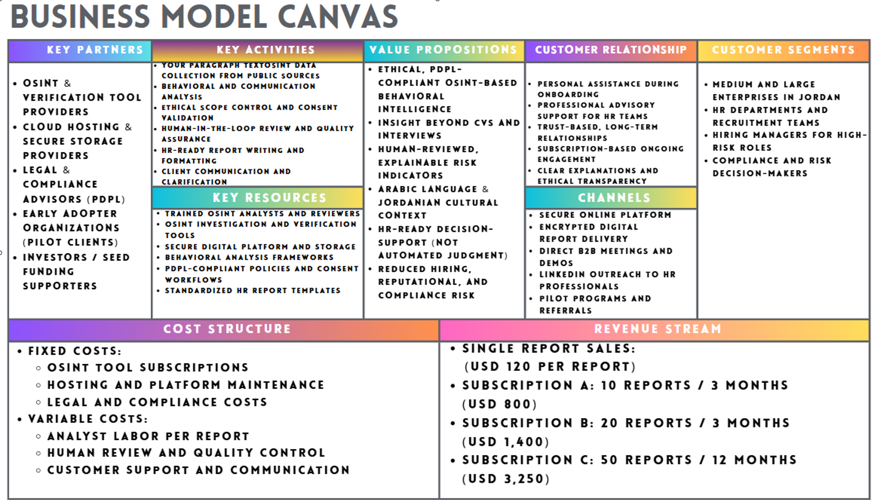

Business Model Canvas – Critical Explanation and Evaluation (Chosen Elites)
This section presents and critically evaluates the Business Model Canvas (BMC) of Chosen Elites, explaining how each component contributes to the business’s desirability, feasibility, and viability. The analysis clarifies what each component means (as described in the course slides), identifies strengths and weaknesses, and proposes practical improvements that strengthen the business model. In addition, it explains how the nine elements are interconnected and how, together, they support the coherence, feasibility, and strategic direction of the business.

1. Customer Segments
Chosen Elites is designed as a B2B decision-support service for hiring. The primary customer segments are medium and large organizations in Jordan that have formal hiring processes, repeated recruitment needs, and reputational or compliance exposure. These organizations typically include HR departments, recruitment teams, and hiring managers, especially those responsible for sensitive roles. Secondary customer segments include compliance officers and risk decision-makers who influence final hiring approvals.
Benefits / Advantages
Targeting medium and large organizations is strategically strong because these customers face clear consequences from poor hiring decisions, including reputational damage, compliance risk, internal culture issues, and potential legal exposure. These organizations usually already perform some form of background screening (often informal), so they clearly recognize the problem of unreliable or biased online checks. Additionally, they have structured HR workflows, which makes adoption easier because Chosen Elites can fit into existing recruitment steps (e.g., final-stage candidate screening). They also have stronger ability and willingness to pay for services that reduce risk and improve decision quality.
Drawbacks / Disadvantages
Focusing mainly on medium and large enterprises means that smaller companies and startups are less targeted, even though they may also experience hiring risk. However, smaller organizations often have limited budgets, informal decision-making, and fewer standardized HR procedures, which can reduce willingness to pay and slow customer conversion. Furthermore, enterprise clients usually have long procurement cycles and multiple stakeholders, which can delay onboarding, slow revenue recognition, and increase the time required for relationship building.
Future Plan
In the future, after the business gains strong traction and operational stability, Chosen Elites can introduce a simplified package for smaller SMEs. This package would provide standardized, lower-depth reports at a lower price point, while maintaining the full high-touch service for larger organizations.
How Will the Future Plan Affect the Business Model Canvas?
Introducing a simplified SME package would impact multiple BMC blocks. It would expand Customer Segments, which increases market size and improves viability through higher potential volume. However, it would require adjustments to the Value Proposition, creating tiered service levels instead of one premium service. It would also affect Key Activities and Key Resources because serving more clients at lower price points requires process standardization and stronger automation to remain feasible. In addition, it would influence Customer Relationships, since SMEs generally need more standardized support compared to the high-touch advisory style suitable for enterprise clients. For these reasons, the SME expansion should be implemented gradually, once the enterprise-focused model is stable.

2. Value Proposition
Chosen Elites offers ethical, PDPL-compliant OSINT-based behavioral intelligence that supports HR teams in making safer, more confident, and defensible hiring decisions. The service provides insight beyond CVs and interviews by analyzing publicly observable digital behavior, communication style, professionalism signals, and potential reputational risks—within clear ethical boundaries and consent-based processes. The business position is not “automated judgment,” but rather decision support that strengthens professional evaluation.
Benefits / Advantages
The value proposition is strong because it solves a real hiring challenge: traditional screening tools often miss behavioral and reputational signals, while informal social media checks can be biased, inconsistent, and legally risky. By using an ethical framework and PDPL alignment, Chosen Elites makes its service safer for organizations. Human review ensures explainability and context, which increases trust and reduces the risk of unfair or misleading conclusions. In addition, Arabic-language analysis and Jordanian cultural interpretation increase local relevance, allowing the service to produce insights that global tools often cannot.
Drawbacks / Disadvantages
Because the service relies on human-reviewed analysis, it requires more operational effort than fully automated screening tools. This can increase delivery time and limit scalability in early growth stages. There is also a potential trust barrier: some organizations may misunderstand OSINT and incorrectly assume it is intrusive or unethical, which makes early education and transparency essential. Another limitation is that OSINT depends on publicly available data, so report depth may vary between candidates, requiring careful client expectation management.
Future Plan
Chosen Elites can gradually implement AI-assisted analysis to automate repetitive tasks (such as initial filtering, categorization, and pattern detection) while keeping human oversight for ethical validation, interpretation, and final decision-support reporting.
How Will the Future Plan Affect the Business Model Canvas (Value Proposition)?
This future plan strengthens feasibility by reducing manual workload in Key Activities, improving speed and capacity without losing quality. It also strengthens Key Resources, because AI becomes a supportive resource that reduces reliance on scarce analyst time. Importantly, it must be implemented in a controlled way to protect the core value proposition: explainable and ethically bounded insights. If automation is introduced too aggressively, it may weaken trust and harm desirability. Therefore, the best approach is gradual automation that enhances efficiency while preserving human accountability.

3. Key Activities
Key activities represent the most important work Chosen Elites must perform to deliver its service successfully. These activities include case intake and scope definition, consent verification, OSINT data collection from public sources, behavioral analysis, cross-checking and validation, human review and quality assurance, report writing and formatting for HR use, secure delivery, and follow-up communication with clients.
Benefits / Advantages
The defined activities directly support the value proposition. Ethical scope control ensures compliance and protects clients from risky or intrusive screening. Human review and quality assurance increase accuracy and defensibility. Structured report writing ensures that outputs are usable by HR teams and fit professional hiring workflows. In addition, client communication and clarification reduce misunderstanding and increase trust, supporting long-term customer relationships.
Drawbacks / Disadvantages
Some key activities, especially manual analysis and review, are time intensive and require skilled personnel. Without standard processes, report quality may vary between analysts, which could harm customer trust. Additionally, if demand grows quickly, the workload could increase faster than the team’s capacity, reducing feasibility and causing delays.
Future Plan
The business should build standardized operating procedures, templates, and checklists, and gradually automate routine steps. This includes creating structured report templates, consistent risk categories, and clear analyst guidelines to ensure consistent outcomes.
How Will the Future Plan Impact the Business Model Canvas (Key Activities)?
Standardization improves feasibility by making activities repeatable and reducing variability. It also strengthens Customer Relationships, since consistent delivery increases trust. Furthermore, it improves Cost Structure in the long term because efficiency reduces time per report. However, it requires investment in training and documentation, which temporarily increases cost. Overall, standardization is a key improvement that strengthens feasibility and viability.

4. Key Resources
Key resources include the assets required to deliver the value proposition. For Chosen Elites, key resources include trained OSINT analysts and reviewers, OSINT and verification tools, secure cloud hosting and storage, PDPL-compliant policies and consent workflows, behavioral analysis frameworks, standardized HR reporting templates, and brand credibility in ethical hiring support.
Benefits / Advantages
The strongest resource advantage is the combination of human expertise and professional tools. Human analysts provide context, interpret nuance, and ensure cultural relevance, while tools improve efficiency and verification accuracy. Ethical frameworks and consent workflows are also key differentiators because they make the service defensible and compliant. Secure infrastructure supports trust, since hiring-related intelligence is sensitive.
Drawbacks / Disadvantages
The business depends on skilled analysts, which increases cost and creates operational risk if key team members leave. Tool subscriptions and secure infrastructure also create ongoing fixed costs. Additionally, building credibility requires time: without brand trust, customers may hesitate to adopt a service that touches hiring decisions.
Future Plan
Chosen Elites should invest in training, documentation, and internal knowledge sharing to reduce dependence on individuals. It can also build a structured internal knowledge base of best practices, ethical guidelines, and reporting standards.
How Will the Future Plan Impact the Business Model Canvas (Key Resources)?
This plan strengthens feasibility by making delivery less dependent on specific people and easier to scale. It also strengthens desirability because consistent quality improves customer trust. It may slightly increase costs in the short term (training and documentation), but it reduces long-term risk, improves continuity, and supports viability by preventing quality breakdown during scaling.

5. Key Partners
Key partnerships include external parties that help the business operate effectively, as described in the slides. For Chosen Elites, key partners include OSINT and verification tool providers, secure cloud and storage providers, legal and compliance advisors for PDPL alignment, pilot clients for validation and feedback, and investors who support early-stage growth.
Benefits / Advantages
Partners reduce the need to build everything internally. OSINT tool providers increase speed and verification reliability. Cloud partners enable secure delivery and compliance-friendly storage. Legal advisors strengthen credibility and reduce regulatory risk. Pilot clients help the business refine its service and confirm market fit before scaling. Investors support feasibility by funding early-stage expenses before break-even.
Drawbacks / Disadvantages
Reliance on external providers introduces dependency risks: partners may increase prices, change policies, or limit service features. Tool providers may also impose restrictions that impact workflow. Overdependence on a single vendor increases operational risk and reduces bargaining power.
Future Plan
The business should diversify tool providers, develop contingency plans, and explore selective in-house capabilities for critical steps (such as internal templates, internal validation logic, and platform ownership).
How Will the Future Plan Affect the Business Model Canvas (Key Partners)?
Diversification reduces dependency risk, strengthening feasibility and viability. However, managing multiple providers increases Key Activities complexity in the short term (vendor management). It may also increase costs initially, but it provides long-term stability and negotiating power. This improvement should be introduced gradually after the core workflow is stable.

6. Channels
Channels describe how Chosen Elites reaches customers and delivers its value. The company uses direct B2B outreach, LinkedIn networking, meetings and demonstrations, pilot programs, and secure digital delivery of reports through a platform and encrypted communication.
Benefits / Advantages
These channels match the Jordanian B2B environment, where trust and personal communication strongly influence buying decisions. Direct meetings and demos allow the company to explain ethical boundaries, report structure, and compliance benefits clearly. Pilots reduce adoption risk and increase customer confidence. Secure delivery channels reinforce trust and align with the sensitivity of hiring intelligence.
Drawbacks / Disadvantages
Direct sales channels require time, effort, and cost, which can increase customer acquisition cost early on. If the sales process is too dependent on personal outreach, scaling may be slow. In addition, without strong marketing assets (case studies, proof of value), customers may hesitate to adopt.
Future Plan
The business should gradually strengthen inbound marketing, referral systems, published case studies, and educational content on ethical OSINT to reduce dependence on direct outreach.
How Will the Future Plan Affect the Business Model Canvas (Channels)?
Inbound channels improve desirability by increasing trust before contact, since prospects learn about the service and understand its ethics early. This plan also impacts Key Activities by adding marketing content creation and case study development. It supports viability by reducing customer acquisition costs over time. The plan is best implemented after early successes provide evidence to market.

7. Customer Relationships
Customer relationships describe how Chosen Elites interacts with clients and maintains engagement. Relationships are professional and trust-based, supported by onboarding, interpretation guidance, ongoing communication, and subscription-based repeat usage. Because HR decisions are sensitive, the relationship approach is closer to advisory support than simple self-service.
Benefits / Advantages
High-touch relationships improve trust, reduce misunderstanding, and support retention. HR teams need confidence in ethical boundaries and report interpretation, so advisory support increases satisfaction and reduces churn. This strengthens desirability and improves customer lifetime value.
Drawbacks / Disadvantages
High-touch relationships require skilled time, which can constrain scaling. If every client needs intensive support, growth may increase costs and reduce operational feasibility.
Future Plan
Introduce tiered relationship models: high-touch advisory support for large enterprise clients and standardized support for smaller clients or lower-tier plans.
How Will the Future Plan Affect the Business Model Canvas (Customer Relationships)?
Tiered relationships improve feasibility by reducing pressure on Key Resources and allowing the business to serve more clients without proportional increases in staffing. It also supports viability by protecting margins while maintaining strong service quality where it matters most.

8. Revenue Streams
Revenue streams explain how the business earns money, and in Chosen Elites this is primarily through subscription bundles and single-report purchases. Subscriptions create predictable income and encourage repeat usage, while one-time reports function as a trial entry option for cautious customers.
Benefits / Advantages
Subscription revenue supports viability by stabilizing cash flow and improving predictability. Bundles encourage repeat usage and long-term relationships, which reduces churn risk. Single-report purchases lower the barrier to entry and help convert new customers into subscribers.
Drawbacks / Disadvantages
Revenue growth depends strongly on retention and customer confidence. Because the product is trust-based, losing credibility could harm renewals. Additionally, if pricing is not matched with perceived value, customers may revert to informal screening methods.
Future Plan
Introduce premium services such as advanced behavioral insights, executive-level screening packages, or compliance-focused reporting add-ons. The business could also offer periodic ethical training workshops for HR teams as an additional paid service.
How Will the Future Plan Affect the Business Model Canvas (Revenue Streams)?
Premium revenue options increase viability by raising revenue per client without relying only on more customers. They also strengthen desirability by increasing perceived value for clients who need deeper analysis. However, they impact Key Activities by requiring more analytical depth and additional expertise, so implementation should follow operational maturity.

9. Cost Structure
Cost structure represents the major costs of operating the business. For Chosen Elites, fixed costs include OSINT tool subscriptions, hosting and security, legal and compliance costs, and platform maintenance. Variable costs include analyst labor per report, human review effort, and customer support time.
Benefits / Advantages
The cost structure is relatively lean because the model is digital-first and can operate without a physical office. Variable costs scale with report volume, which allows controlled growth. Fixed costs are manageable and predictable, supporting feasibility in early stages.
Drawbacks / Disadvantages
As volume grows, variable costs (analyst time and review effort) can rise significantly unless efficiency improves. Tool and cloud costs may also increase with usage. If efficiency improvements are delayed, profitability may be pressured.
Future Plan
Optimize infrastructure usage, negotiate longer-term supplier contracts, and reduce time per report through standardization and partial automation.
How Will the Future Plan Affect the Business Model Canvas (Cost Structure)?
This plan strengthens viability by protecting margins as the business scales. It also supports feasibility by ensuring infrastructure remains stable and secure without excessive cost increases. Negotiating contracts improves cost predictability, which supports financial planning.

Evaluation of Feasibility, Desirability, and Viability (Explicit Alignment)
To align directly with the course framework:
Feasibility (Can the business deliver the value proposition?)
Chosen Elites is feasible because it has a realistic operating model based on clear Key Activities, strong Key Resources, and supportive Key Partners. The service can be delivered using trained analysts and existing OSINT tools without requiring heavy internal technology development at launch. Secure cloud infrastructure enables reliable delivery. The main feasibility challenge is operational scaling, because manual analysis can limit capacity. This is addressed through future improvements such as process standardization, documentation, and gradual AI-assisted automation, which strengthen execution capability as demand grows.
Desirability (Do customers want the value proposition?)
Chosen Elites is desirable because it meets a real HR need: reducing hiring risk and improving decision confidence without unethical or illegal screening. Customers benefit from explainable, human-reviewed insights and culturally relevant interpretation. The desirability challenge is customer education and trust—some clients may misunderstand OSINT or fear ethical concerns. This is addressed through relationship-building, transparent reporting methods, pilots, and future inbound marketing and case studies, which strengthen credibility and customer acceptance.
Viability (Can the business be financially sustainable?)
Chosen Elites is viable because its revenue model emphasizes subscriptions, creating predictable recurring income aligned with recurring hiring needs. The cost structure is manageable at launch because fixed costs are controlled and variable costs scale with service delivery. The main viability risk is margin pressure if analyst time remains high while pricing stays fixed. The business addresses this through efficiency improvements, vendor negotiation, tiered services, and premium offerings that raise revenue per client. Over time, partial automation increases capacity without proportional cost growth, strengthening profitability and sustainability.

Overall Evaluation
Overall, the Business Model Canvas of Chosen Elites shows strong alignment between market needs, ethical value creation, and long-term sustainability. The business is positioned as a high-trust HR decision-support service rather than a purely automated product, which differentiates it from generic screening tools. The key strengths are ethical compliance, explainability, and cultural relevance. The main weakness is scalability due to human effort requirements, but this is directly addressed through phased automation and standardized processes. With gradual improvements, the business model becomes more scalable while preserving trust and quality.

Coherence, Feasibility, and Strategic Direction (Interconnection Summary)
This business model is highly coherent because all elements support one focused objective: helping organizations make safer and more defensible hiring decisions through ethical behavioral intelligence. Customer Segments define the risk-sensitive HR problem, and the Value Proposition directly responds with compliance-friendly, explainable insights. Key Activities (ethical OSINT workflow, human review, reporting) deliver the promised value, while Key Resources (analysts, tools, frameworks) and Key Partners (tool providers, cloud, legal support) make delivery feasible.
The model is feasible because it relies on proven external infrastructure (tools and cloud services), lean operations, and a structured workflow. It does not require large upfront development before launch, which reduces risk. Over time, feasibility increases further through standardization, training, and AI-assisted efficiency improvements.
Strategically, Chosen Elites is well positioned for the Jordanian B2B market by emphasizing trust, transparency, and cultural alignment—key factors in local business decision-making. The subscription-first approach supports stable growth, while future tiering and premium services enable expansion into new segments without losing focus. In the long term, the model supports sustainable growth by improving efficiency while maintaining ethical credibility, allowing the business to scale responsibly and expand across additional sectors or markets.

Q3 Present your final prototype, highlighting its core functionalities. Explain how it evolved from earlierversions and demonstrate how it effectively addresses the initial challenge and meets the needs of your targetusers.
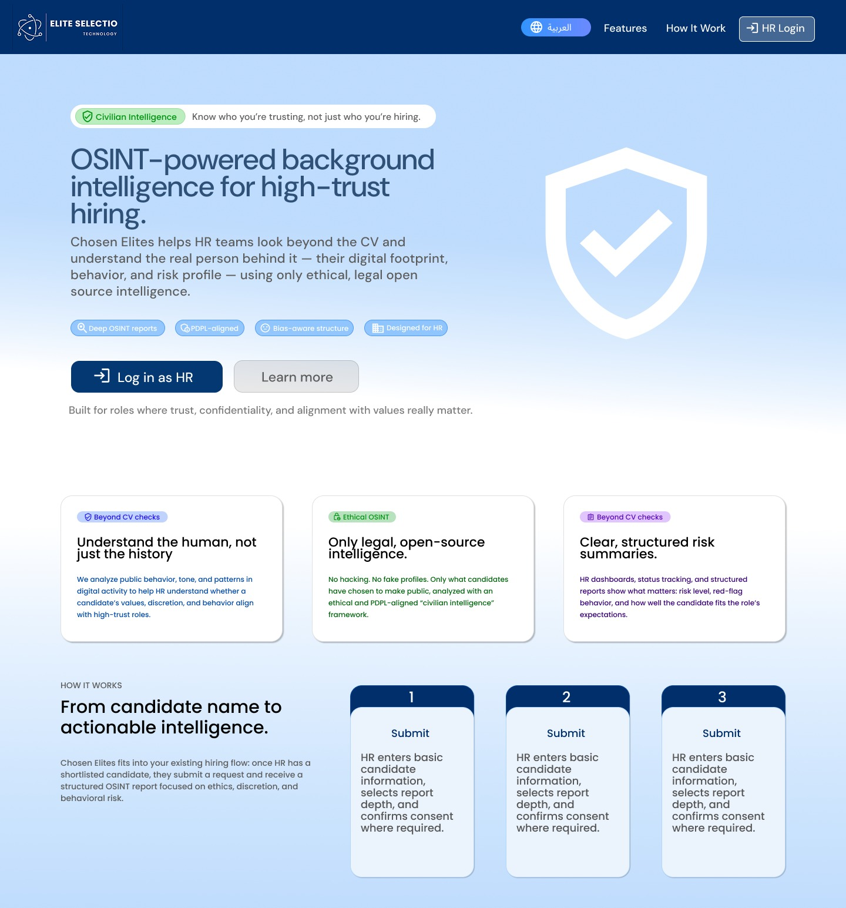
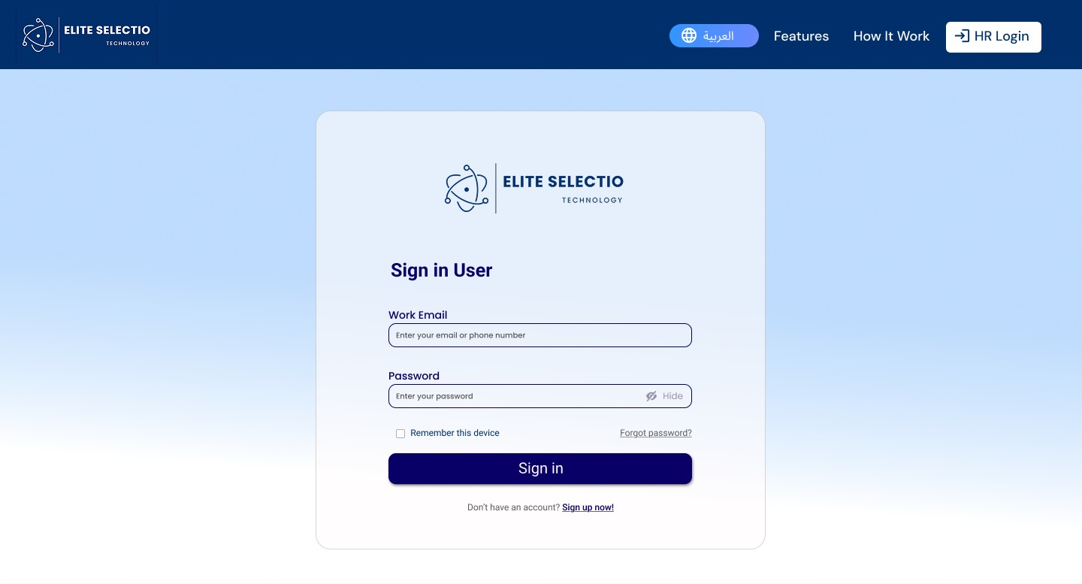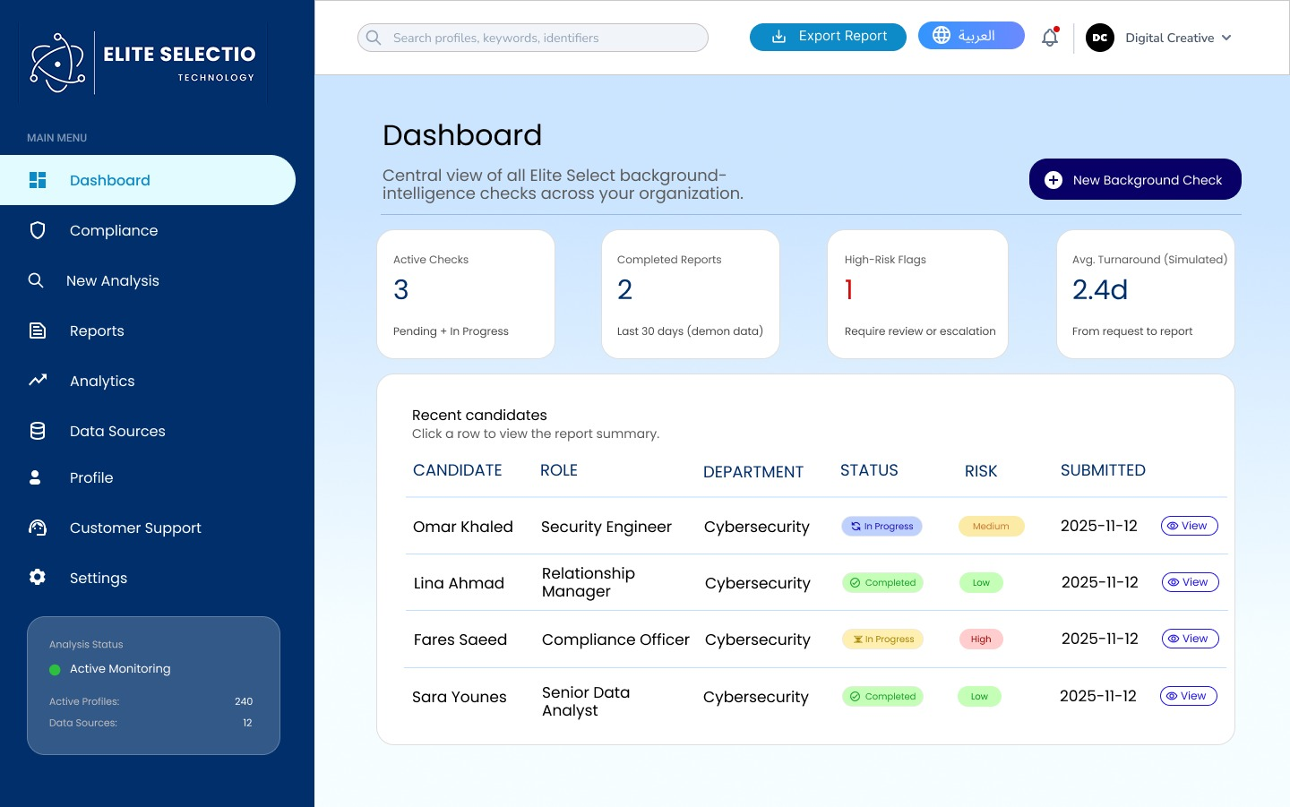
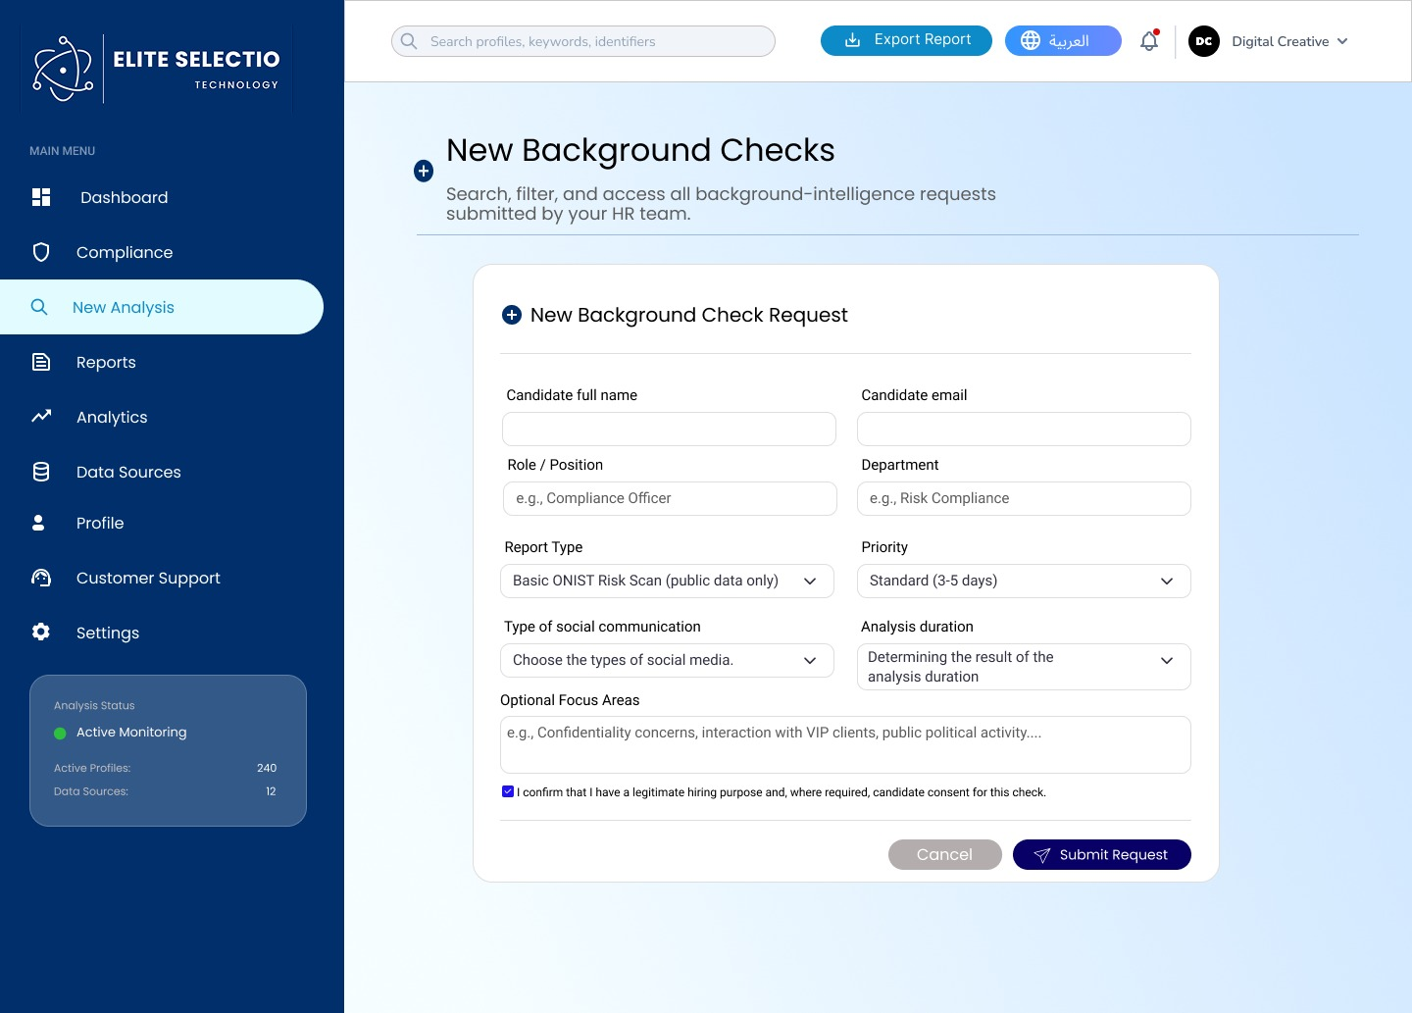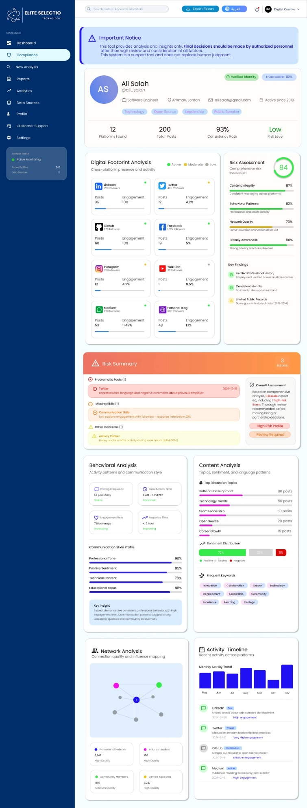

https://www.figma.com/design/wADwlaX3fPeZXO6hikOUw2/Untitled?node-id=0-1&t=UbnVUHZ98ltMmgVa-1

Final Refined Prototype (High-Fidelity)
The final prototype of Chosen Elites is a high-fidelity, HR-centered decision-support platform that delivers OSINT-based behavioral intelligence in a structured, ethical, and PDPL-aware workflow. It replicates the real steps an HR decision-maker would follow in practice: discovering the service, logging in, submitting a background-check request, and reviewing a decision-ready report.
1) Landing Page (Public Website)
The landing page is the public-facing entry point that communicates the system’s purpose: supporting high-trust hiring through ethical OSINT and structured behavioral insights. It emphasizes transparency and civilian intelligence principles to build trust.
Core functions include:
- Clear value proposition and audience explanation (HR-friendly, non-technical language)
- “How it Works” workflow explanation
- Call-to-action that guides the user to login and the next steps
2) Login Page (Secure Access)
The login page provides secure access for authorized HR users only, reinforcing confidentiality and controlled access to sensitive candidate insights. Its clean design mirrors familiar enterprise HR systems, reducing friction for non-technical users.
3) HR Dashboard (Operations & Oversight)
The dashboard acts as the central workspace for HR teams. It supports monitoring and prioritization through:
- Summary indicators (active checks, completed reports, high-risk flags, turnaround time)
- Candidate table with status tracking and direct report access
- Clear risk-level tagging (Low/Medium/High) to support workload prioritization and oversight
4) New Background Check Submission (Structured Request + Control + Consent)
This page enables HR professionals to submit a structured request quickly and ethically. It includes:
- Candidate information and job context (role, department)
- Report type selection
- Extended configuration options such as analysis duration and communication type to tailor scope based on role sensitivity
- Mandatory consent/legitimate purpose confirmation checkbox (PDPL-aligned practice)
5) Candidate Profile & Full OSINT Report (Decision-Ready Output)
This page is the system’s core output and the most important functionality. It provides a structured OSINT report including:
- Digital footprint overview (cross-platform)
- Behavioral and content analysis
- Network analysis and verification indicators
- Quantified risk score with sub-categories
- Visual cues to support fast scanning and deeper drill-down when needed
The final report also includes two critical trust-building additions:
- Risk Summary Section (decision-ready overview)
- Important Notice + Ethical Disclaimer (clarifies decision-support nature, not automated decision-making)

How the Prototype Evolved From Earlier Versions (Before → After)
The prototype evolved through real HR testing and feedback. The initial version successfully validated the concept, but HR professionals identified key adoption issues: the interface needed to reflect real HR report-reading behavior, risk indicators needed to be more explainable, and ethical reassurance needed to be stronger.
Key Improvements Across Iterations
1) Workflow Explainability Improved (Non-technical clarity)
Earlier versions: The OSINT workflow explanation was not clear to non-technical HR users.
Final version: Added clearer workflow breakdown and simplified explanation of what is analyzed and how (Request → Data Collection → Behavioral & Content Analysis → Risk Assessment → Final Report).
Impact: Improves trust and comprehension for HR decision-makers and reduces perceived complexity.
2) HR Realism & Usability Improved (Dashboard and navigation)
Earlier versions: Dashboard and flow needed closer reflection of HR processes.
Final version: Added clearer navigation and HR-like structure (Landing → Login → Dashboard → Profile → Report). The dashboard includes realistic HR indicators, candidate cards/tables, and risk-level clarity.
Impact: Reduces confusion and supports fast daily HR usage.
3) Explainability Added Through a Risk Summary (Major improvement)
Testing feedback (consistent across HR participants): “Scores alone are not enough — we need to know why the candidate is flagged.”
Final version: Added a Risk Summary Section that explains the main reasons behind flags in plain language, reducing cognitive load while keeping detailed evidence available.
Impact: Makes reports defensible inside organizations and supports fair decision-making.
4) Ethical Adoption Strengthened (Important Notice & Disclaimer)
Testing feedback: HR users needed reassurance that the tool supports judgment and does not replace it.
Final version: Added an Important Notice and Ethical Disclaimer stating it is a decision-support system and final decisions remain with HR.
Impact: Increases ethical comfort, reduces misuse risk, and supports responsible hiring.
5) User Control Increased (Scope limitation & relevance)
Aligned with the testing plan focus on “control and fairness,” the final version supports:
- Choosing scope of evaluation
- Excluding irrelevant platforms
- Limiting time range / analysis depth through configuration
Impact: Supports relevance, fairness, and reduces unnecessary data processing.

How the Final Prototype Addresses the Initial Challenge and Meets Target User Needs
Addressing the Initial Challenge
The initial challenge is that hiring decisions—especially in high-trust sectors—are exposed to:
- Wrong-hire risk and reputational damage
- Informal and inconsistent online checks
- Lack of documentation and ethical boundaries
- Difficulty justifying decisions internally
Chosen Elites addresses this by providing a structured, repeatable, and ethical workflow that produces a decision-ready report. It replaces unstructured manual searching with a professional process that improves speed, documentation, and accountability.
Meeting Target User Needs (Validated by Testing & Metrics)
The testing plan aimed to assess usability, clarity, trust, legality perception, fairness, and decision confidence. The refined prototype directly supports these success measures:
- Clarity of risk explanation: Risk Summary + plain-language reasoning improves explainability and supports justification to management.
- Support for professional judgment: Important Notice reinforces that the tool assists rather than replaces HR judgment (directly matching user expectations).
- Ability to distinguish stable behavior from isolated incidents: Report structure emphasizes behavioral patterns and consistency, aligning with HR preference for context.
- Perceived control over evaluation scope: Configurable analysis options support role sensitivity and ethical boundaries.
- Trust and legal comfort (PDPL): Consent confirmation and clear ethical positioning improve user confidence in compliance and responsible use.

Conclusion
The final refined prototype demonstrates a functional, ethically grounded, and user-centered OSINT-based HR decision-support system. It evolved from an initial concept-focused prototype into a more realistic and adoption-ready interface through direct HR testing. By implementing improvements in report explainability (Risk Summary), ethical transparency (Important Notice & Disclaimer), HR workflow realism, and user control over evaluation scope, the final prototype effectively addresses the original hiring-risk challenge and meets the needs of the target users.

Q5 Explain how you used your presentation and persuasion skills to clearly pitch your business to potentialinvestors.
We used our presentation and persuasion skills to clearly and confidently pitch our business idea to potential investors. We structured our presentation in a logical flow that made the idea easy to follow, starting with the problem, then moving to the solution, the market opportunity, the business model, and the financial outlook. This clear structure helped investors understand both the need for our solution and its potential value.
At the beginning of the pitch, we focused on clearly explaining the problem in current hiring practices. We explained how traditional CV-based evaluations do not provide enough behavioral or ethical insight and can lead to poor hiring decisions and increased risk for organizations. By using simple examples and real-world risks such as CV fraud and misrepresentation, we created a strong sense of urgency and showed why this problem matters to HR departments and decision-makers.
To persuade investors, we clearly explained our solution, Chosen Elites, and how it works. We avoided technical language and instead focused on explaining the benefits of our OSINT-powered behavioral analysis in a simple and practical way. We showed how combining data-driven analysis with human review makes our solution more trustworthy, ethical, and suitable for real HR use. Visual diagrams and step-by-step explanations helped investors easily understand our process and see how our platform adds value.
We also used persuasive communication by clearly presenting the market opportunity and financial potential. We explained the TAM, SAM, and SOM using clear numbers and linked them directly to our target customers. Our pricing strategy and revenue model were explained in a simple and transparent way to show that the business is realistic, scalable, and financially sustainable. This helped build investor confidence in the commercial viability of the idea.
In addition, we addressed possible investor concerns by highlighting our strong focus on ethics, PDPL compliance, and cultural awareness. We clearly explained how these factors reduce legal and reputational risks and make our solution more attractive to organizations. We also demonstrated confidence and professionalism through clear speech, good timing, and teamwork during the presentation, which strengthened our credibility as a team.
Finally, we ended the pitch with a clear and confident investment ask. We explained exactly how the funding would be used, especially for pilot programs and early market entry, and how investors would benefit from the growth of the business. By combining clear storytelling, simple language, strong visuals, and well-supported data, we successfully used our presentation and persuasion skills to deliver a compelling and convincing investor pitch.

Ahmad :
Skill Type | Skill | How I showed this skill when pitching my idea
Presentation | Speaking clearly and showing confidence | I delivered the pitch in a structured and calm manner, maintaining steady eye contact and confident body language. Even after receiving feedback on the presentation style, I remained composed and adjusted my delivery to ensure clarity and confidence in front of the audience.
Presentation | Using slides and visuals effectively | Initially, the slides contained heavy text. After the instructor’s feedback that the pitch should be simpler and involve less reading, I personally revised the slides to reduce text, highlight key messages, and use visuals. This made the presentation clearer, more engaging, and easier for investors to follow.
Presentation | Explaining the idea simply | Based on the instructor’s feedback, I simplified how I explained Chosen Elites by focusing on the core problem, solution, and value instead of detailed explanations. This helped communicate the idea in a clear and accessible way without overwhelming the audience.
Presentation | Structuring the pitch logically | I reorganized the presentation to follow a clear flow: problem → solution → how it works → market → business model → financial potential. This structure aligned with the instructor’s guidance and helped the audience understand the story behind the business.
Persuasion | Making the idea sound relevant and important | I emphasized the real-world impact of wrong hiring decisions, including financial loss, reputational damage, and compliance risks. This helped capture investor attention and show why the problem is important.
Persuasion | Using facts and examples to convince | I supported the pitch with statistics about the cost of bad hiring decisions and examples of how HR teams currently perform informal online checks without structure or ethics. These facts helped strengthen the credibility of the idea.
Persuasion | Showing how the idea solves a real problem | I clearly connected Chosen Elites’ features—such as structured OSINT reports, risk summaries, and ethical safeguards—to the specific challenges HR professionals face in making confident hiring decisions.
Persuasion | Demonstrating ethical and legal awareness | I highlighted the platform’s focus on PDPL compliance, consent-based analysis, and human-in-the-loop decision-making, which reassured potential investors that the solution is responsible and suitable for regulated environments.
Persuasion | Connecting the problem to the solution through storytelling | I told my frind mousa to open the pitch by explaining that HR teams often hire highly skilled elites from different fields, but skills alone do not guarantee alignment with company values, culture, or ethical standards. Then I cam up to my slide and i connected this challenge directly to the solution by introducing Chosen Elites as an OSINT-based decision-support platform that helps organizations identify not just talented candidates, but the right elites who align with organizational values, behavior, and culture. This clear transition made the problem and solution feel naturally connected and easy to understand.

